UNIT V BUILDING SOA-BASED APPLICATIONS
Service Oriented Analysis and Design – Service Modelling – Design standards and guidelines -- Composition – WS-BPEL – WS-Coordination – WS-Policy – WS-Security – SOA support in J2EE

- Explain the SOA delivery lifecycle phases in detail
The lifecycle of an SOA delivery project is simply comprised of a series of steps that need to be completed to construct the services for a given service-oriented solution.

Basic phases of the SOA delivery lifecycle
The service phases are primarily concerned with the delivery of services that implement the results of service-oriented analysis and design efforts.

Figure 5.1. Common phases of an SOA delivery lifecycle.
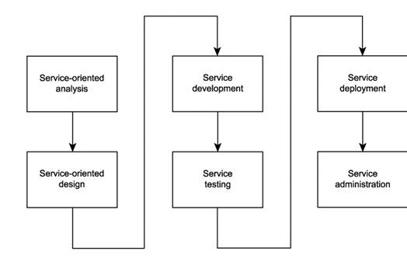

Service-oriented analysis
It is in this initial stage that we determine the potential scope of our SOA. Service layers are mapped out, and individual services are modeled as service candidates that comprise a preliminary SOA.

Service-oriented design
Service-oriented design is a heavily standards-driven phase that incorporates industry conventions and service-orientation principles into the service design process. This phase, therefore, deal with service designers with key decisions that establish the hard logic boundaries encapsulated by services. The service layers designed during this stage can include the orchestration layer, which results in a formal business process definition.

Service development
It is the actual construction phase. Here development platform-specific issues come into play, regardless of service type. Specifically, the choice of programming language and development environment will determine the physical form services and orchestrated business processes take, in accordance with their designs.

Service testing
Given their generic nature and potential to be reused and composed in unforeseeable situations, services are required to undergo rigorous testing prior to deployment into a production environment.

Service deployment
The implementation stage brings with it the joys of installing and configuring distributed components, service interfaces, and any associated middleware products onto production servers.

Service administration
After services are deployed, standard application management issues come to the forefront. These are similar in nature to the administration concerns for distributed, component-based applications, except that they also may apply to services as a whole (as opposed to services belonging to a specific application environment).
  - SOA delivery strategies
Here we need to organize how the process that can be exhibited :
- accommodate our preferences with regards to which types of service layers we want to deliver
- coordinate the delivery of application, business, and process services
- support a transition toward a standardized SOA while helping us fulfill immediate, project-specific requirements
However, the success of a project delivering a service-oriented solution generally is measured by the extent to which the solution fulfills expected requirements within a given budget and timeline.
To address this problem, we need a strategy. This strategy must be based on an organization's priorities to establish the correct balance between the delivery of long-term migration goals with the fulfillment of short-term requirements. Three common strategies have emerged, each addressing this problem in a different manner.
- top-down
- bottom-up
- agile (or meet-in-the-middle)

The top-down strategy
This strategy is very much an "analysis first" approach that requires not only business processes to become service-oriented, but also promotes the creation (or realignment) of an organization's overall business model. This process is therefore closely tied to or derived from an organization's existing business logic. The top-down strategy supports the creation of numerous reusable business and application services.

Process
The top-down approach will typically contain some or all of the steps illustrated and described in Figure 5.2. Note that this process assumes that business requirements have already been collected and defined.

Figure 5.2. Common top-down strategy process steps.
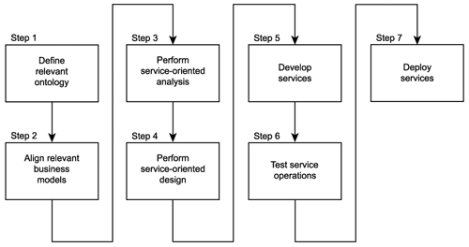

Step 1: Define relevant enterprise-wide ontology
Ontology establishes is a classification of information sets processed by an organization. This results in a common vocabulary, as well as a definition of how these information sets relate to each other. Larger organizations with multiple business areas can have several ontologies, each governing a specific division of business. It is expected that these specialized ontologies all align to support an enterprise-wide ontology.

Step 2: Align relevant business models (including entity models) with new or revised ontology
After the ontology is established, existing business models may need to be adjusted (or even created) to properly represent the vocabulary provided by the ontology in business modeling terms. Entity models in particular are of importance, as they can later be used as the basis for entity-centric business services.

Step 3: Perform service-oriented analysis

Step 4: Perform service-oriented design

Step 5: Develop the required services

Step 6: Test the services and all service operations
The testing stage requires that all service operations undergo necessary quality assurance checks. This typically exceeds the amount of testing required for the automation logic being implemented because reusable services will likely need to be subjected to testing beyond the immediate scope of the solution.

Step 7: Deploy the services
The solution is finally deployed into production. An implementation consideration beyond those we originally identified as part of this step is the future reuse potential of the service. To facilitate multiple service requestors, highly reusable services may require extra processing power and may have special security and accessibility requirements that will need to be accommodated.

Pros and cons
Pros
- Results in a high quality service architecture.
- The design and parameters around each service are thoroughly analyzed, maximizing reusability potential and opportunities for streamlined compositions
- Lays the groundwork for a standardized and federated enterprise where services maintain a state of adaptability, while continuing to unify existing heterogeneity.

The bottom-up strategy
This approach essentially encourages the creation of services as a means of fulfilling application-centric requirements. Web services are built on an "as needed" basis and modeled to encapsulate application logic to best serve the immediate requirements of the solution. Integration is the primary motivator for bottom-up designs, where the need to take advantage of the open SOAP communications framework can be met by simply appending services as wrappers to legacy systems.

Process
A typical bottom-up approach follows a process similar to the one explained in Figure 5.3. Note that this process assumes that business requirements have already been collected and defined.

Figure 5.3. Common bottom-up strategy process steps.
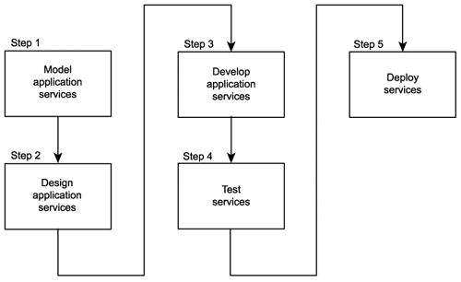

Step 1: Model required application services
This step results in the definition of application requirements that can be fulfilled through the use of Web services. Typical requirements include the need to establish point-to-point integration channels between legacy systems or B2B solutions. Other common requirements emerge out of the desire to replace traditional remote communication technology with the SOAP messaging communications framework.
For solutions that employ the bottom-up strategy to deliver highly service-centric solutions, application services also will be modeled to include specific business logic and rules. In this case, it is likely that two application service layers will emerge, consisting of hybrid and utility services. Those services classified as reusable may act as generic application endpoints for integration purposes, or they may be composed by parent hybrid services.

Step 2: Design the required application services
Some of the application services modeled in Step 1 may be delivered by purchasing or leasing third-party wrapper services or perhaps through the creation of auto-generated proxy services. These services may provide little opportunity for additional design. Custom application services, though, will need to undergo a design process wherein existing design standards are applied to ensure a level of consistency.

Step 3: Develop the required application services
Application services are developed according to their respective service descriptions and applicable design specifications.

Step 4: Test the services
Services, their associated solution environment, and underlying legacy logic are tested to ensure that processing requirements can be met. Performance and stress testing measures often are used to set the processing parameters of legacy systems exposed via wrapper services. Security testing is also an important part of this stage.

Step 5: Deploy the services
The solution and its application services are deployed into production. Implementation considerations for application services frequently include performance and security requirements.

Pros and cons

Pros
  - The primary reason behind this is that organizations simply add Web services to their existing application environments to leverage the Web services technology set.
  - The architecture within which Web services are added remains unchanged, and service-orientation principles are therefore rarely considered.
Cons
- The bottom-up strategy is really not a strategy at all. Nor is it a valid approach to achieving contemporary SOA.
- This is a realization that will hit many organizations as they begin to take service-orientation, as an architectural mode.

The agile strategy
The challenge remains to find an acceptable balance between incorporating service-oriented design principles into business analysis environments without having to wait before integrating Web services technologies into technical environments. For many organizations it is therefore useful to view these two approaches as extremes and to find a suitable middle ground.
This is possible by defining a new process that allows for the business-level analysis to occur concurrently with service design and development. Also known as the meet-in-the-middle approach, the agile strategy is more complex than the previous two simply because it needs to fulfill two opposing sets of requirements.

Process
The process steps shown in Figure 3.4 demonstrate an example of how an agile strategy can be used to reach the respective goals of the top-down and bottom-up approaches.

Step 1: Begin the top-down analysis, focusing first on key parts of the ontology and related business entities
The standard top-down analysis begins but with a narrower focus. The parts of the business models directly related to the business logic being automated receive immediate priority.

Step 2: When the top-down analysis has sufficiently progressed, perform service-oriented analysis
After the top-down analysis has sufficiently progressed, model business services to best represent the business model with whatever analysis results are available. This is a key decision point in this process. It may require an educated judgment call to determine whether the on-going top-down analysis is sufficiently mature to proceed with the creation of business service models. This consideration must then be weighed against the importance and urgency of pending project requirements.

Step 3: Perform service-oriented design

Steps 4, 5, and 6: Develop, test, and deploy the services
Develop the services and submit them to the standard testing and deployment procedures.

Step 7: As the top-down analysis continues to progress, revisit business services
Perform periodic reviews of all business services to compare their design against the current state of the business models. Make a note of discrepancies and schedule a redesign for those services most out of alignment. This typically will require an extension to an existing service for it to better provide the full range of required capabilities. When redesigned, a service will need to again undergo standard development, testing, and deployment steps.
To preserve the integrity of services produced by this approach, the concept of immutable service contracts needs to be strictly enforced. After a contract is published, it cannot be altered. Unless revisions to services result in extensions that impose no restrictions on an existing contract (such as the addition of new operations to a WSDL definition), Step 7 of this process likely will result in the need to publish new contract versions and the requirement for a version management system.

Figure 5.4. A sample agile strategy process.
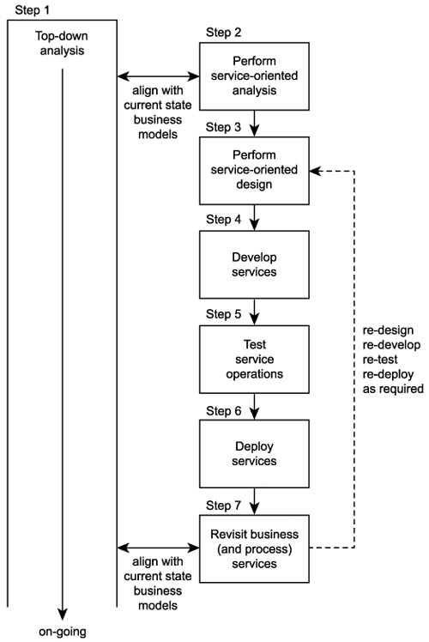

Pros and cons

Pros
  - Best of both worlds and combines it into an approach for realizing SOA that meets immediate requirements without jeopardizing the integrity of an organization's business model and the service-oriented qualities of the architecture.
  - Fulfills both short and long-term needs, the net result of employing this strategy is increased effort associated with the delivery of every service.
  - The fact that services may need to be revisited, redesigned, redeveloped, and redeployed will add up proportionally to the amount of services subjected to this retasking step.
Cons
This approach imposes maintenance tasks that are required to ensure that existing services are actually kept in alignment with revised business models. Even with a maintenance process in place, services still run the risk of misalignment with a constantly changing business model.

Introduction to service-oriented analysis
The process of determining how business automation requirements can be represented through service-orientation is the domain of the service-oriented analysis.

Objectives of service-oriented analysis
The overall goals of performing a service-oriented analysis are as follows:
- Define a preliminary set of service operation candidates.
- Group service operation candidates into logical contexts. These contexts represent service candidates.
- Define preliminary service boundaries so that they do not overlap with any existing or planned services.
- Identify encapsulated logic with reuse potential.
- Ensure that the context of encapsulated logic is appropriate for its intended use.
- Define any known preliminary composition models.

The service-oriented analysis process
The service-oriented analysis process is a sub-process of the overall SOA delivery lifecycle. The steps shown in Figure 3.5 are common tasks associated with this phase and are described further in the following sections.

Figure 5.5 A high-level service-oriented analysis process.
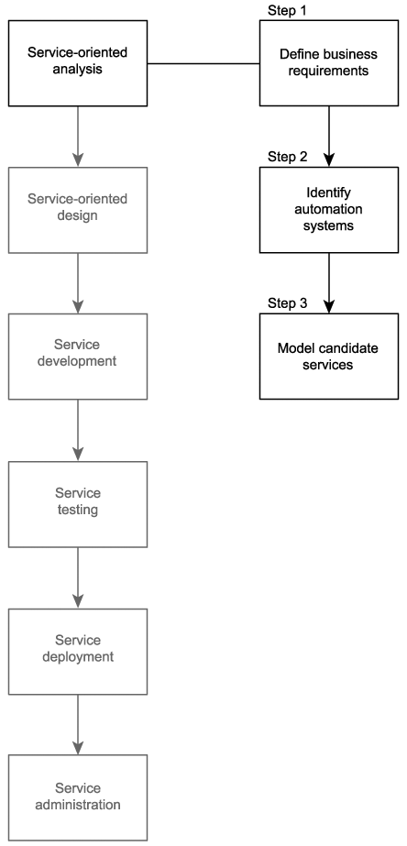

Note that Steps 1 and 2 essentially represent information gathering tasks that are carried out in preparation for the modeling process described in Step 3.

Step 1: Define business automation requirements
Through whatever means business requirements are normally collected, their documentation is required for this analysis process to begin. Given that the scope of our analysis centers around the creation of services in support of a service-oriented solution, only requirements related to the scope of that solution should be considered.

Step 2: Identify existing automation systems
Existing application logic that is already, to whatever extent, automating any of the requirements identified in Step 1 needs to be identified. While a service-oriented analysis will not determine how exactly Web services will encapsulate or replace legacy application logic, it does assist us in scoping the potential systems affected.

Step 3: Model candidate services
A service-oriented analysis introduces the concept of service modelinga process by which service operation candidates are identified and then grouped into a logical context. These groups eventually take shape as service candidates that are then further assembled into a tentative composite model representing the combined logic of the planned service-oriented application.

Example for service oriented analaysis
Here is the familiar list of RailCo services:
- Invoice Submission Service
- Order Fulfillment Service
- TLS Subscription Service
Although their use has allowed RailCo to establish a Web services extension to their legacy solution environment, these three services do not constitute a true SOA. The construction of these services was based purely on a bottom-up approach, resulting in the creation of what we've termed "hybrid" application services (application services that also contain business logic, intended for narrowly focused business tasks).
These services were assembled quickly to accommodate a single client. However, because that client has now formed a partnership with another air brake vendor, RailCo is only receiving a subset of its original revenue stream. This new reality has turned into a driving motivation for RailCo to commit to and invest in the standardization of a service-oriented architecture.
After a preliminary analysis of its existing Web services, it is quickly determined that there is little benefit in trying to build upon the services produced so far. Instead, it is decided to start from scratch and build a set of new services.
The agile delivery strategy is chosen as the approach by which these new services will be delivered. It is further determined that only application and business service layers will be modeled because RailCo is not in a position to invest in the middleware required to implement an orchestration layer.
As RailCo proceeds with its service-oriented analysis, it is able to identify some tangible benefits that an SOA can realize. These benefits appear to provide the potential to fulfill key business goals of the organization.
Specifically, preliminary analysis results indicate that:
- The application of service-orientation principles and the standardization introduced by SOA will allow a single set of services to accommodate interaction with different online partners. This would free RailCo from its ties to TLS and allow it to pursue new customers without necessarily having to build a new set of services each time.
- SOA facilitates the integration of internal legacy systems by establishing standardized application endpoints. In particular, the abstraction provided by service layers will enable RailCo to create integration channels that do not need to be removed if underlying legacy technology is replaced. This gives RailCo the ability to connect its accounting and contact management solutions knowing full well that the latter will likely need to be replaced in the future.
  - Introduction to service-oriented design
Service-oriented design is the process by which concrete physical service designs are derived from logical service candidates and then assembled into abstract compositions that implement a business process.
    - Objectives of service-oriented design
The overall goals of performing a service-oriented design are as follows:
- Determine the core set of architectural extensions.
- Set the boundaries of the architecture.
- Identify required design standards.
- Define abstract service interface designs.
- Identify potential service compositions.
- Assess support for service-orientation principles.
- Explore support for characteristics of contemporary SOA.
    - The service-oriented design process
As with the service-oriented analysis, we first establish a parent process that begins with some preparatory work. This leads to a series of iterative processes that govern the creation of different types of service designs and, ultimately, the design of the overall solution workflow (Figure 3.22).

Step 1: Compose SOA
A fundamental quality of SOA is that each instance of a service-oriented architecture is uniquely composable. Although most SOAs will implement a common set of shared technologies based on key XML and first-generation Web services specifications, the modular nature of the WS-* specification landscape allows for extensions to this core architecture to be added as required.
This step consists of the following three further steps :
1. Choose service layers.
2. Position core SOA standards.
3. Choose SOA extensions.

Steps 2 to 4: Design services
These steps are represented by the following three separate processes:
- Entity-centric business service design process.
- Application service design process.
- Task-centric business service design process.

Step 5: Design service-oriented business process
Upon establishing an inventory of service designs, we proceed to create our orchestration layerthe glue that binds our services with business process logic. This step results in the formal, executable definition of workflow logic, which translates into the creation of a WS-BPEL process definition

Figure 5.6. A high-level service-oriented design process.
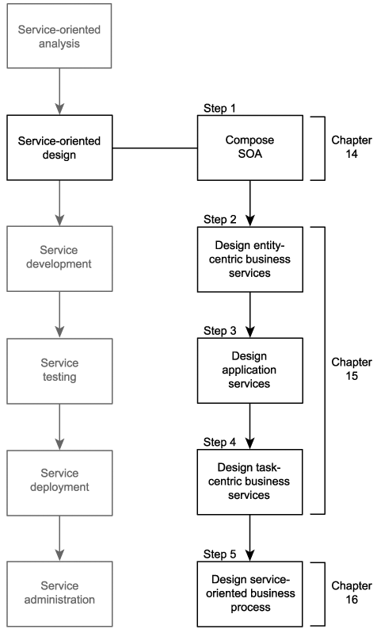

    - Prerequisites to be considered
Before we get into the details of the service-oriented design process, we should make sure that we have a sufficient understanding of key parts of the languages required to design services.

Figure 5.7. Three core specifications associated with service design.
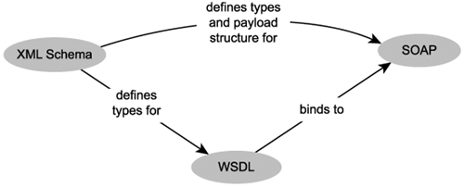

Benefits of a business-centric SOA
Business services, on the other hand, often need some justification. Many still resistor are even unaware ofthe benefits of introducing service-oriented principles into the domain of business analysis. It is easy to ignore service-oriented business modeling and simply focus on service-orientation as it applies to technology and technical architecture. The common rationale for this approach is that whatever business processes need to be automated can be divided up into physical Web services as required.
There are very good reasons for taking the time to model and build business services. In this section we list a series of benefits for incorporating service-orientation into the business process level.

Business services build agility into business models
Service-orientation brings to business process models a structure that can significantly improve the flexibility and alertness with which processes can be remodeled in response to changes. When properly designed, business services can establish a highly responsive information technology environment; responsive in that changes in an organization's business areas can be efficiently accommodated through re-composition of both a business process and its supporting technology architecture (as expressed by the application services layer).
As business-driven as SOAs are, there are often real world restrictions (infrastructure, security constraints, budget constraints) that require the technology side to push back. This can shift the burden of adaptation over to the business process models. This type of alertness requirement can be met by the business service layer, as it allows business services to adjust to requirement changes originating from an organization's technical environments.
In other words, applying service layer abstraction to both business and technology ends establishes the potential for an enterprise to achieve a form of two-way agility (Figure 5.8).

Figure 5.8 Changes originating in the business logic domain are accommodated by the application logic domain and vice versa.
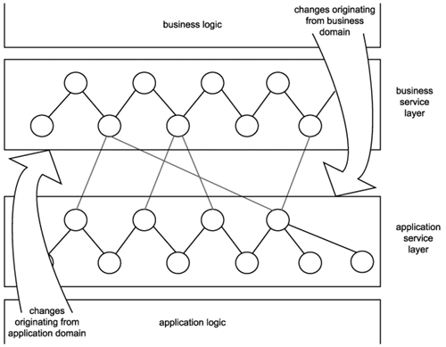

Business services prepare a process for orchestration
Whether or not you will be moving to an orchestration-based service-oriented environment anytime soon, it is becoming increasingly important to be ready for this transition. Orchestration brings with it concepts that, when implemented, lie at the core of SOA. Therefore, modeling current processes so that they eventually can be more easily migrated to an orchestration-driven environment is recommended.

Business services enable reuse
The creation of a business service layer promotes reuse in both business and application services, as follows:
- By modeling business logic as distinct services with explicit boundaries, business process-level reuse can be achieved. Atomic sub-process logic or even entire processes can be reused as part of other process logic or as part of a compound process (which translates into a service composition in its own right).
- By taking the time to properly align business models with business service representation, the resulting business service layer ends up freeing the entire application service layer from assuming task or activity-specific processing functions. This allows application services to be positioned as and to evolve into pure, reusable utility services that facilitate business services across solution boundaries.

Only business services can realize the service-oriented enterprise
Business service modeling marries the principles of service-orientation with an organization's business model. The resulting perspective can clearly express how services relate to and embody the fulfillment of business requirements.
Applying business services forces an organization to view and reinterpret business knowledge in a service-oriented manner. Altering the perspective of how business processes can be structured, partitioned, and modeled is an essential step to achieving an environment in which service-orientation is standardized, successfully consistent, and naturally commonplace.
Though the business services layer may accurately represent a corporate business model upon implementation, it will become outdated once new and revised business requirements emerge. As long as it is kept in relative alignment with the current state of business models, it will continue to serve as a valuable view of the enterprisevaluable because it does not exist in abstract but in an implemented and operational form.

Example
RailCo has identified the following benefits of investing in extensible business services:
- Business services can be modeled in such a manner that they perform common functions for non-specific service requestors. This will allow RailCo to fulfill its first requirement of making its services available for online transactions with multiple customers.
- A separation of business and application logic will allow RailCo to wrap its legacy accounting system in one or more services. This will allow it to establish an application services layer initially consisting of an application service that will be reusable to task-specific business services.
- RailCo's second requirement also can be fulfilled by adding a service to represent the contact management system. Integration can then be achieved by again reusing the service that encapsulates the accounting service.

Deriving business services
Organizations employ different methodologies, business entity relationships, and vocabularies, resulting in vastly diverging business model structures.

Sources from which business services can be derived
The inner workings of any organization, regardless of structure or size, can be decomposed into a collection of business services. This is because a business service simply represents a logical unit of work, and appealing much anything any organization does consists of units of work.
Below are some examples of common business analysis approaches used by many organizations.

Business Process Management (BPM) models
The advent of BPM has resulted in an industry-wide flurry of process modeling and remodeling activity. Process models have therefore become a central form of business analysis documentation in many organizations. Business services can be derived from process workflow logic.

Figure 5.9. Parts of a process that can be encapsulated by a business service.

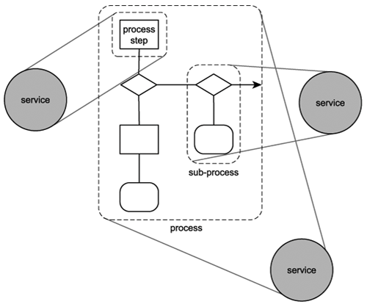
Deriving a business service from a business process requires a thorough knowledge of the underlying workflow logic. This is because defining the scope of the business logic to be represented is a judgment call that can have significant implications when the business service is implemented as part of solution environments; hence, the better the judgment, the better the quality of the service

Example
The descriptions provided here document the steps that comprise internal RailCo processes because these are the processes that eventually will be affected by the introduction of SOA.
The existing Invoice Submission Process. It consists of a series of steps that describe how invoices are generated specifically for TLS, as follows:
- Accounting clerk creates and issues an electronic invoice using the legacy accounting system.
- The save event triggers a custom script that exports an electronic copy of the invoice to a network folder.
- A custom developed component, which polls this folder at ten-minute intervals, picks up the document and transforms it into an XML document.
- The invoice XML document is then validated. If it is deemed valid, it is forwarded to the Invoice Submission Service. If validation fails, the document is rejected, and the process ends.
- Depending on when the last metadata check was performed, the service may issue a Get Metadata request to the TLS B2B solution.
- If the Get Metadata request is issued and if it determines that no changes were made to the relevant TLS service descriptions, the Invoice Submission Service transmits the invoice document to the TLS B2B solution using the ExactlyOnce delivery assurance. If the Get Metadata request identifies a change to the TLS service descriptions, the invoice is not submitted, and the process ends.
The internal Order Fulfillment Process is similar in that it establishes the same type of relationship between the accounting system and a Web serviceonly this time, the data flow is reversed, as described here:
- The RailCo Order Fulfillment Service receives a SOAP message from TLS, containing a payload consisting of a TLS purchase order document.
- The service validates the incoming document. If valid, the document is passed to a custom component. If the TLS PO fails validation, a rejection notification message is sent to TLS, and the process ends.
- The component has the XML document transformed into a purchase order that conforms to the accounting system's native document format.
- The PO then is submitted to the accounting system using its import extension.
- The PO ends up in the work queue of an accounting clerk who then processes the document.
Note that both of these processes are intentionally incomplete. The Invoice Submission Process contains additional steps related to an acknowledgement it receives from TLS upon the successful delivery of the invoice submission. The complete Order Fulfillment Process consists of several additional steps that are required to formulate a response to TLS containing back-order information, if required. The process steps that are provided are those most relevant to our study of how implementing SOA leads to improvements for RailCo.

Entity models
Primary entities represent the main business documents and transaction areas of an enterprise. For example, Invoice, Purchase Order, Customer, and Claim are all milestone entities within different types of businesses. Further, organizations model entities according to proprietary rules and business policies. This results in entities having relationships with each other.
Entity-centric services mirror the entity model by containing a set of generic operations that facilitate the different types of functions associated to the processing of the entity. Communication between different entity-centric services also can be governed by constraints relating to the inherent relationship between entities.

Example
RailCo has decided to build services centered around specific tasks and is therefore not using entity models as a source for deriving business services. However, to demonstrate the concept of entities, let's briefly look at what entities exist within the RailCo business areas we've been exploring so far.
Based on the business processes we described earlier, RailCo entities of relevance are:
- Invoice
- Purchase Order
Additional entities involved with these processes could include:
- Employee
- Order
- Back Order
- Customer
Here are some examples of how the entities described above could relate to each other:
- A Purchase Order can be related to zero or more Invoices.
- A Purchase Order can only be related to one Customer.
- An Order can be related to one or more Purchase Orders.
- A Back Order can be related to one or more Purchase Orders.
- An Invoice can only be related to one Customer.
- An Employee can be related to zero or more Invoices, Purchase Orders, Orders, Back Orders, or Customers.
Figure 5.10 illustrates this series of one-to-one and one-to-many relationships.

Figure 5.10. Relationships between RailCo entities (normally these entity symbols would contain attributes as well).
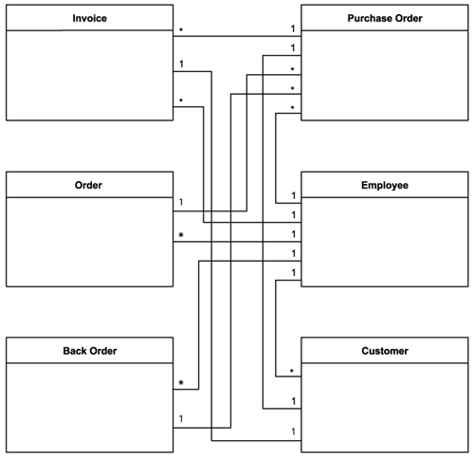

Types of derived business services
Deriving services from the two sources we just identified results in the creation of distinct types of business services.

Task-centric business services
These are Web services that have been modeled to accommodate a specific business process. Operations are grouped according to their relevance to the execution of a task in support of a process.
Typical examples of task-centric business services are:
- VerifyInvoice
- GetHistoryReport
Each of these services contains operations that relate to a particular task within the context of a process with limited reusability potential. Task-centric services usually result from modeling exercises that are focused on meeting immediate business requirements. Typical sources include use-case models and BPM process definitions.Modeling reusable task-centric business services often requires that multiple use-cases and business process models first be analyzed to identify commonality, prior to the actual modeling of the services.

Example
Although they are hybrid (application + business) in design, the following RailCo services follow a task-centric model:
- Invoice Submission Service
- Order Fulfillment Service
- TLS Subscription Service

Entity-centric business services
Entity-centric business services generally are produced as part of a long-term or on-going analysis effort to align business services with existing corporate business models. Their inherent generic nature makes them highly reusable by numerous business processes. Even though entity-centric business services often are built as part of application development projects centered around a particular business process, they differ from task-centric services in that they do not provide an interface specific to that process.
When compared to task-centric services, entity-centric services significantly increase the agility with which service-oriented processes can be remodeled. This is because task-centric services often are built to help automate one business process and can therefore get tied to that process. When the process logic changes, the context under which the services are used and composed may change as well. This may invalidate the original grouping of service operations and could result in the requirement for a redesign and redevelopment effort.
Entity-centric services do require more up-front analysis, increasing both the cost of each service and the time required to produce it. Additionally, they can be so generic in nature that they are delivered with no concept of business process logic. Their use may therefore become dependent on parent business controllers, such as process services or task-centric controller services.

Example
Having followed the top-down SOA delivery strategy, though, TLS already has a set of entity-centric business services in place (Figure 5.11).

Figure 5.11. Different organizations, different approaches to building services.
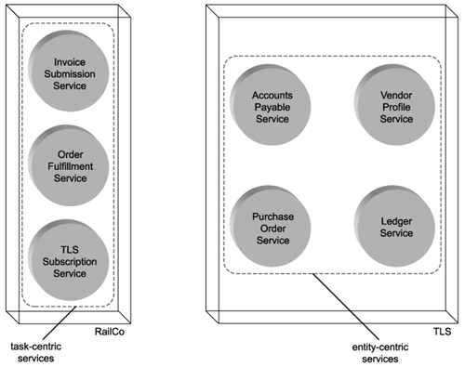

These are:
- Accounts Payable Service
- Purchase Order Service
- Ledger Service
- Vendor Profile Service
When utilized within the B2B solution, these services actually do not need to be composed by a separate task-centric or process service. The reason this parent controller layer is not required is because the Accounts Payable and Purchase Order Services are not part of a solution-specific business process. They are simply fulfilling their respective document processing roles for the accounting system, receiving valid invoices and issuing valid purchase orders. Therefore, no further workflow logic is required.

Business services and orchestration
The process service, an implementation of orchestration, also can be classified as a form of business service. It is very much "business-centric," as it resides at the top of the service layer hierarchy and is responsible for composing business services according to the rules specified in the orchestration workflow logic.
An orchestration can compose a combination of task-centric and entity-centric business services. The core business model is represented by the entity-centric services, while business logic-related tasks can be implemented in task-centric services that are designed specifically to supplement the process service.
The use of orchestration establishes the following structure in the services layer:
- Workflow logic and process-specific business rules are embedded in a process definition. Orchestration composes business services (and possibly application services) according to this definition.
- Business services compose application services to execute business logic.
- Application services interact with underlying systems to process the required functions.

Example
TLS has decided that as part of its plans to expand its existing SOA, it will introduce an orchestration service layer. It begins by introducing a process service that abstracts business rules and workflow logic from the business services already in use.
Although this requires a significant modeling effort, it is anticipated that the existing service structures and service interfaces will remain unaffected. After the workflow logic represented by the process service is finalized in the service-oriented design phase, the true impact of the orchestration service layer on the existing business services will be determined.

Service modeling (a step-by-step process)
A service modeling process is essentially an exercise in organizing the information we gathered in Steps 1 and 2 of the parent service-oriented analysis process. Sources of the information required can be diverse, ranging from various existing business model documents to verbally interviewing key personnel that may have the required knowledge of a relevant business area. As such, this process can be structured in many different ways. The process described in this section is best considered a starting point from which you can design your own to fit within your organization's existing business analysis platforms and procedures.

"Services" versus "Service Candidates"
let's first introduce an important modeling term: candidate. The primary goal of the service-oriented analysis stage is to figure out what it is we need to later design and build in subsequent project phases. It is therefore helpful to continually remind ourselves that we are not actually implementing a design at this stage. We are only performing an analysis that results in a proposed separation of logic used as input for consideration during the service-oriented design phase. In other words, we are producing abstract candidates that may or may not be realized as part of the eventual concrete design.
So, at this stage, we do not produce services; we create service candidates. Similarly, we do not define service operations; we propose service operation candidates. Finally, service candidates and service operation candidates are the end-result of a process called service modeling.

Process description
A series of 12 steps that comprise a proposed service modeling process (Figure 5.12). Specifically, this particular process provides steps for the modeling of an SOA consisting of application, business, and orchestration service layers.

Figure 512. A sample service modeling process.
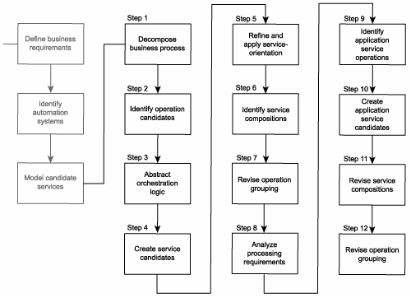

Step 1: Decompose the business process
Take the documented business process and break it down into a series of granular process steps. It is important that a process's workflow logic be decomposed into the most granular representation of processing steps, which may differ from the level of granularity at which the process steps were originally documented

Step 2: Identify business service operation candidates
Some steps within a business process can be easily identified as not belonging to the potential logic that should be encapsulated by a service candidate.
Examples include:
- Manual process steps that cannot or should not be automated.
- Process steps performed by existing legacy logic for which service candidate encapsulation is not an option.
By filtering out these parts we are left with the processing steps most relevant to our service modeling process.

Step 3: Abstract orchestration logic
If you have decided to build an orchestration layer as part of your SOA, then you should identify the parts of the processing logic that this layer would potentially abstract.
Potential types of logic suitable for this layer include:
- business rules
- conditional logic
- exception logic
- sequence logic
Note that these forms of orchestration logic may or may not be represented accurately by a step description. For example, some processing step descriptions consist of a condition and an action (if condition x occurs, then perform action y). In this case, only remove the condition and leave the action.

Step 4: Create business service candidates
Review the processing steps that remain and determine one or more logical contexts with which these steps can be grouped. Each context represents a service candidate. The contexts you end up with will depend on the types of business services you have chosen to build.
For example, task-centric business services will require a context specific to the process, while entity-centric business services will introduce the need to group processing steps according to their relation to previously defined entities. It is important that you do not concern yourself with how many steps belong to each group. The primary purpose of this exercise is to establish the required set of contexts.

Step 5: Refine and apply principles of service-orientation
This step gives us a chance to make adjustments and apply key service-orientation principles. We identified the following four key principles as those not intrinsically provided through the use of Web services:
- reusability
- autonomy
- statelessness
- discoverability
Of these four, only the first two are important to us at the service modeling stage. The latter two on this list are addressed in the service-oriented design process. Therefore, our focus in this step is also to ensure that each service operation candidate we identify is potentially reusable and as autonomous as possible.

Step 6: Identify candidate service compositions
Identify a set of the most common scenarios that can take place within the boundaries of the business process. For each scenario, follow the required processing steps as they exist now.
This accomplishes the following:
- It gives you a good idea as to how appropriate the grouping of your process steps is.
- It demonstrates the potential relationship between orchestration and business service layers.
- It identifies potential service compositions.
- It highlights any missing workflow logic or processing steps.

Step 7: Revise business service operation grouping
Based on the results of the composition exercise in Step 6, revisit the grouping of your business process steps and revise the organization of service operation candidates as necessary. It is not unusual to consolidate or create new groups (service candidates) at this point.

Step 8: Analyze application processing requirements
By the end of Step 6, you will have created a business-centric view of your services layer. This view could very well consist of both application and business service candidates, but the focus so far has been on representing business process logic.
To accomplish this, each processing step identified so far is required to undergo a mini-analysis. we determine
- What underlying application logic needs to be executed to process the action described by the operation candidate.
- Whether the required application logic already exists or whether it needs to be newly developed.
- Whether the required application logic spans application boundaries. In other words, is more than one system required to complete this action?
Note that the information we gathered during Step 2 of the parent service-oriented analysis process will be referenced at this point.

Step 9: Identify application service operation candidates
Break down each application logic processing requirement into a series of steps. Be explicit about how you label these steps so that they reference the function they are performing.

Step 10: Create application service candidates
Group these processing steps according to a predefined context. With application service candidates, the primary context is a logical relationship between operation candidates. This relationship can be based on any number of factors, including:
- association with a specific legacy system
- association with one or more solution components
- logical grouping according to type of function
Various other issues are factored in once service candidates are subjected to the service-oriented design process. For now, this grouping establishes a preliminary application service layer.

Step 11: Revise candidate service compositions
Revisit the original scenarios you identified in Step 5 and run through them again. Only, this time, incorporate the new application service candidates as well. This will result in the mapping of elaborate activities that bring to life expanded service compositions. Be sure to keep track of how business service candidates map to underlying application service candidates during this exercise.

Step 12: Revise application service operation grouping
Going through the motions of mapping the activity scenarios from Step 11 usually will result in changes to the grouping and definition of application service operation candidates. It will also likely point out any omissions in application-level processing steps, resulting in the addition of new service operation candidates and perhaps even new service candidates.

Optional Step: Keep an inventory of service candidates
So far, this process has assumed that this is the first time you are modeling service candidates. Ideally, when going through subsequent iterations of this process, you should take existing service candidates into account before creating new ones.
It can, however, be tricky to look for reuse opportunities when modeling documents. This is because so much of the verbiage used to describe service and service operation candidates gets lost when this information is later translated into concrete service designs. As a result, this step is considered optional. The service-oriented design processes also provide steps dedicated to checking for reuse opportunities.

Example for service modelling
Step 1: The scope of RailCo's service-oriented analysis includes both of the business processes we described in the Business Process Management (BPM) models.
Let's begin by decomposing the Invoice Submission Process into a series of granular steps:
- Create electronic invoice.
- Issue electronic invoice.
- Export electronic invoice to network folder.
- Poll network folder.
- Retrieve electronic invoice.
- Transform electronic invoice to XML document.
- Check validity of invoice document. If invalid, end process.
- Check if it is time to verify TLS metadata.
- If required, perform metadata check. If metadata check fails, end process.

FIGURE – 5.13 The RailCo Invoice Submission Process.

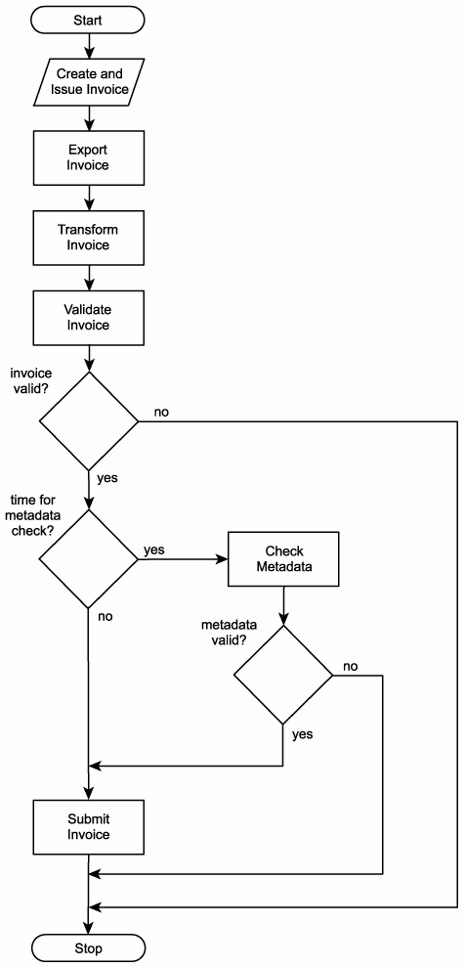
Next are the process steps of a decomposed Order Fulfillment Process Receive PO document.
- Validate PO document.
- If PO document is invalid, send rejection notification and end process.
- Transform PO XML document into native electronic PO format.
- Import electronic PO into accounting system.
- Send PO to accounting clerk's work queue.

Figure – 5.14 The RailCo Order Fulfillment Process.
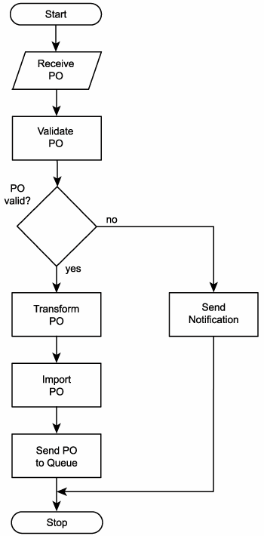

Step-2
After reviewing each of the previously identified processing steps, we remove those that we either cannot or do not want to make part of our service-oriented solution.
Invoice Submission Process:
- Create electronic invoice. (A manual step performed by the accounting clerk.)
- Issue electronic invoice. (A manual step performed by the accounting clerk.)
- Export electronic invoice to network folder. (Currently a custom developed extension of the legacy system. Could be made part of a generic service candidate.)
- Poll network folder. (Currently performed by a custom developed component. Could be made part of a service candidate.)
- Retrieve electronic invoice. (Same as previous.)
- Transform electronic invoice to XML document. (Same as previous.)
- Check validity of invoice document. If invalid, end process. (Is currently being performed as part of the Invoice Submission Service's parsing routine. No foreseeable need to change this.)
- Check if it is time to verify TLS metadata. (Is currently being performed as part of the Invoice Submission Service's parsing routine. Looks like a potentially reusable operation candidate. Could be moved to a separate service candidate.)
- If required, perform metadata check. If metadata check fails, end process. (Same as previous.)
And here are the process steps of the decomposed Order Fulfillment Process:
- Receive PO document. (Is currently being performed by the Order Fulfillment Service. No foreseeable need to change this.)
- Validate PO document. (Same as previous.)
- If PO document is invalid, send rejection notification and end process. (Same as previous.)
- Transform PO XML document into native electronic PO format. (Currently performed by a custom developed component. Could be made part of a service candidate.)
- Import electronic PO into accounting system. (Currently a custom developed extension of the legacy system. Could be made part of a generic service candidate.)
- Send PO to accounting clerk's work queue. (Same as previous.)
The result of this review is that only two processing steps were removed from the Invoice Submission Process and none from the Order Fulfillment Process.

Step-3:
Based on our two process descriptions, the workflow logic represented by a separate process service candidate would include (but not be limited to) the following:
- If the invoice document is valid, proceed with the metadata check step.
- If the invoice document is invalid, end process.
- If the interval period for performing a metadata check has completed, proceed to the perform metadata check step.
- If the interval period has not completed, skip the perform metadata check step.
- If the PO document is valid, proceed with the transform PO document step.
- If the PO document is invalid, end process.
Note that the orchestration workflow logic also would include the sequence in which the individual processing steps are executed.

Step-4:
Going through the RailCo steps we listed from both processes, here is how they could be grouped:
Legacy System Service
- Export electronic invoice to network folder.
- Import electronic PO into accounting system.
- Send PO to accounting clerk's work queue.
Invoice Processing Service
- Poll network folder for invoice.
- Retrieve electronic invoice.
- Transform electronic invoice to XML document.
- Check validity of invoice document. If invalid, end process.
PO Processing Service
- Receive PO document.
- Validate PO document.
- If PO document is invalid, send rejection notification and end process.
- Transform PO XML document into native electronic PO format.
Metadata Checking Service
- Check if it is time to verify TLS metadata.
- If required, perform metadata check. If metadata check fails, end process.
As also shown in Figure, our operation candidates are grouped according to contexts that represent service candidates.

Figure – 5.15 Our first round of service candidates.
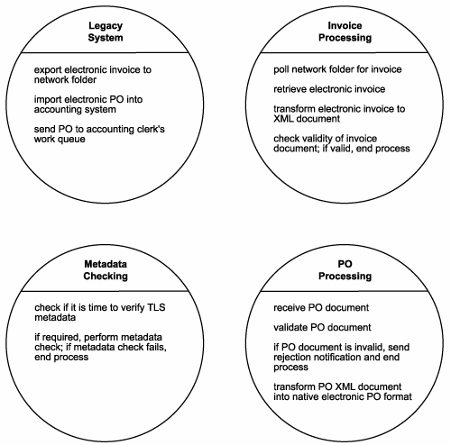

Step-5:
Within the Legacy System Service, the "Send PO to accounting clerk's work queue" action can be performed only upon the receipt of a document. This operation candidate is therefore directly dependent on the "Import electronic PO into accounting system" step.
The revised Legacy System Service list contains the following steps:
- Export document to network folder.
- Import and forward document to work queue.
Upon reviewing the Invoice Processing Service, a number of refinement opportunities arise. We determine that the "Poll network folder for invoice" action can be made more generic by turning it into an operation candidate that simply polls a given folder for different types of documents. We also decide that this action should be made part of a service candidate capable of notifying subscribers of the arrival of new documents.
Next, we decide to combine the "Retrieve electronic invoice," "Transform electronic invoice to XML document," and "Check validity of invoice document" operation candidates into a single service operation candidate called "Retrieve and transform invoice document." We don't mention the validation aspect of this action because the XML document automatically is assigned a corresponding schema. The validation of the document is therefore an intrinsic part of the transformation process.
The result of our analysis is a new context (a new service candidate), established to represent generic notification actions, as follows:
Polling Notification Service:
- Poll folder for new documents.
- If documents arrive for which there are subscribers, issue notifications.
The revised Invoice Processing Service list is left with just one step:
- Retrieve and transform invoice document.
Next, we tackle the operation candidates in the PO processing group. Though listed as such, the "Receive PO document" is not a suitable service operation candidate, as receiving a message is a natural part of service operations (and therefore not generally explicitly accounted for). We therefore remove this action from our list.
We then detect a direct dependency between the "If PO document is invalid, send rejection notification and end process" and "Validate PO document" actions. As a result we decide to combine these into a single operation candidate called "Validate PO document and send rejection notification, if required."
We move on to discover commonality between the "Transform PO XML document into native electronic PO format" action and the "Retrieve and transform invoice document" action from our Invoice Processing Service list. Both operation candidates transform accounting documents. We therefore decide to create a new service candidate that provides generic transformation. The result is a new grouping category:
Transform Accounting Documents Service:
- Transform XML documents to native format.
- Transform native documents to XML.
The revised PO Processing Service list is left with just one step:
- Validate PO document and send rejection notification, if required.
Finally, our last group of operation candidates is reviewed. The candidates themselves are still relatively suitable for what we intended. However, because we've abstracted these into a generic service candidate, we need to revise the wording to better reflect this. Specifically, we add a notification feature to our Metadata Checking Service candidate.
The revised Metadata Checking Service list contains the following steps:
- Check if it is time to verify TLS metadata. If required, perform metadata check.
- If metadata check fails, issue notification.
In this step we performed some major revisions to our original business process logic. The result is the creation of additional service candidates that succeed in abstracting logic in support of key service-orientation principles

Figure – 5.16 The revised set of RailCo service candidates.
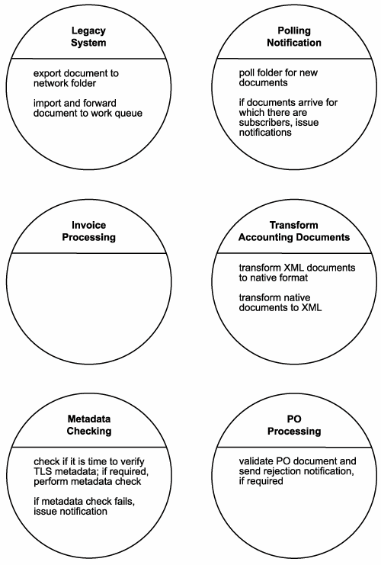

Step -6:
In Step 4 we identified a series of service candidates that form preliminary business and application service layers.
SOME OF the service candidates established so far.
- Legacy System Service
- Polling Notification Service
- Transform Accounting Documents Service
- Metadata Checking Service
Each of these service candidates represents generic, reusable, and business-agnostic logic. In other words, these can all be classified as application service candidates. Collectively they establish a preliminary application service layer.

Figure – 5.17 A sample composition representing the Invoice Submission Process.
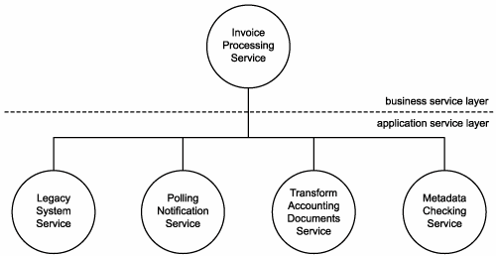

Figure- 5.18 A sample composition representing the Order Fulfillment Process.

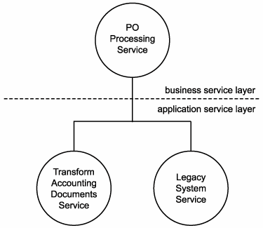
Our business process is by no means complex, and we already have identified all of the application service candidates that represent our preliminary application logic. Therefore, the remaining steps are not required for our RailCo case study.

  - . Service modeling guidelines
uidelines help ensure that your service candidates attain a balance of proper logic encapsulation and adherence to the service-orientation principles
    - Take into account potential cross-process reusability of logic being encapsulated (task-centric business service candidates)
Identifying a real opportunity for reuse is an important consideration when grouping operation candidates into service candidates. It introduces the potential of leveraging existing units of business logic and creating a modularized enterprise business model. Knowledge of other business processes in existence or in development within an enterprise is required to recognize reuse opportunities for task-centric business service candidates (Figure 5.19).

Figure 5.19. Service logic being reused across processes.
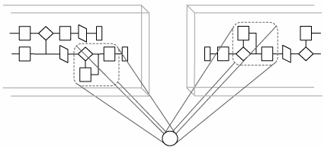
    - Consider potential intra-process reusability of logic being encapsulated (task-centric business service candidates)
Also worth mentioning is the ability for a unit of business logic to be reused within a single business process. Larger, more complex workflows sometimes repeat collections of process activities. If this redundancy is consistent and if the logic represented by these process steps is sufficiently atomic, then you can consider wrapping them into a business service candidate (Figure 5.20). Many workflow systems already accomplish this by identifying predefined processes or sub-processes.

Figure- 5.20. Service logic being reused within a process.
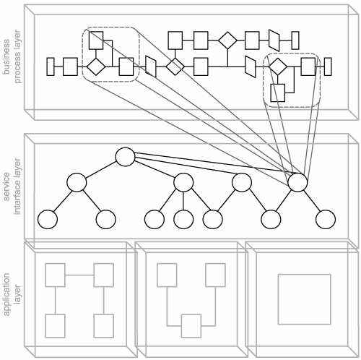

    - Factor in process-related dependencies (task-centric business service candidates)
After you've identified a set of process steps that represent the business logic you want to encapsulate, you need to ensure that you are aware of any dependencies that tie this logic to the current process or to its position within that process.
This will require a bit of analysis, in that the process will need to be broken down into granular processing steps, each of which will need to be assessed individually. What you are looking for here are any input values or parameters upon which business rules, decision points, formulas, conditional statements, or other types of workflow logic are dependent.
The extent to which a service candidate depends on external information (information external to the business service boundary) can determine its potential mobility and the degree to which it can be reused and composed.
    - Model for cross-application reuse (application service candidates)
Each business service candidate is structured to represent a specific part of the overall business model. These service candidates therefore are highly customized and carefully modeled to ensure accurate representation within a predefined business boundary.
Application service candidates typically do not need to be modeled to accommodate a specific business requirement. In fact, the more generic an application service candidate is, the more reusable it becomes. A business-agnostic design allows it to fulfill numerous potential requirements through reuse by multiple business service candidates across different solution boundaries.
The context with which application service operation candidates are grouped into service candidates is therefore completely neutral to the service-oriented solutions that will eventually use them.
    - Speculate on further decomposition requirements
It's useful to consider whether the part of a business process you've identified as a service candidate can exist as a potential service composition. In other words, even though immediate business requirements may be satisfied by your existing service candidates, it may be worth determining if the business logic you're encapsulating can be broken down into additional, more granular service candidates.
If decomposition is possible, then you can perform a speculative analysis to determine the likelihood that it may actually be required. This should give you sufficient information to decide whether or not to model a service candidate into a service composition. It also will help you properly label a service
    - Identify logical units of work with explicit boundaries
This is simply a reiteration of the service-orientation principle that dictates that services (and service candidates) need to be autonomous. We re-emphasize this principle here as a guideline because it is also the golden rule of service modeling. The logic encapsulated by a service candidate must have an explicit boundary, meaning that it must be able to exist as an atomic collection of individual tasks.
This boundary also claims a level of independence from the underlying business or application logic. It accommodates changes to business requirements by allowing service candidates without dependencies to be more easily remodeled as part of augmented business processes. It further supports the concept of reusability and service composition on a logical level.
    - Prevent logic boundary creep
As more services and service candidates are created over time, it is conceivable that some may inadvertently encapsulate business logic already contained within others. This can be prevented when services are first modeled.
Boundary creep can happen in the following circumstances:
- Services in different business processes are created at different times. The logic they encapsulate is the same.
- Services in different business processes are created at different times. The logic they encapsulate overlaps but is not the same. This is the case when different process workflows incorporate similar logic in different workflow designs.
- Services are derived from the same business process at different times. This is especially common when variations of the process exist. For example, high-level and detailed-level views of a complex process may be used by different project teams.
There are a number of steps you can take to reduce the risk of this happening:
- Check available metadata documentation of existing services prior to defining new service
- Implement a set of standards to be used by all those that model
- Raise an awareness of this issue among all of those involved with business process and service modeling.
    - Emulate process services when not using orchestration (task-centric business service candidates)
The best way to prepare task-centric services is to have them emulate the process service. This means creating and positioning parent business service candidates to act like the process services that would normally form the orchestration service layer (Figure 5.21). By creating a master controller business service that simulates a process service, you end up complementing this service with business and application services that fit nicely into the orchestration composition model.

Figure 5.21. A parent business service layer acting as an orchestration layer.
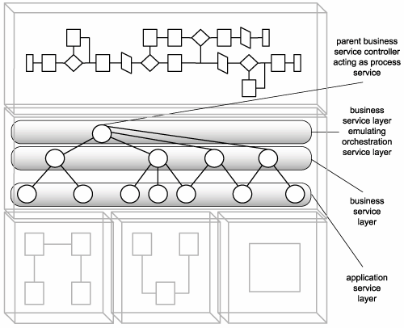

    - Target a balanced model
A fundamental goal of any service-oriented environment is for it to be properly partitioned and represented by services modeled according to:
- business requirements
- consistent standards
- industry conventions
    - Classify service modeling logic
Use a system of categorizing services based on their scope and role. Be clear on how different types of service candidates relate to each other and on how you identify and compose service candidates.
    - Allocate appropriate modeling resources
A service-oriented enterprise is further characterized by how the business end of an organization relates to the technology responsible for its automation. Service-orientation fully supports and enforces the vision of business-driven solutions, where automation technology is designed to be inherently adaptive so that it can respond to changes in the governing business logic.
Therefore, business analysts often need to get involved in the service modeling process (9Figure 5.22). Their knowledge of business models and their business process expertise usually is required to successfully model business-centric services.

Figure 5.22. This intentionally simplistic diagram highlights the type of expertise recommended for modeling service layers.
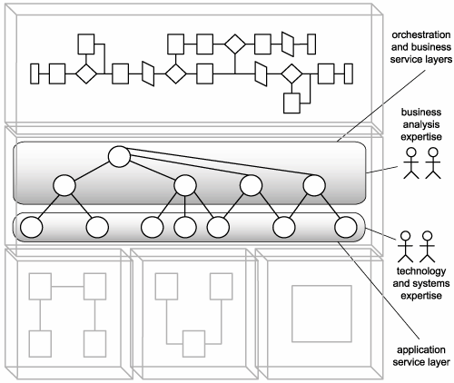
    - Create and publish business service modeling standards
The guidelines supplied by this section can only provide you with a direction on how to implement service modeling within your organization. Depending on the modeling tools and methodologies already in use, you will need to incorporate those that fit within your current business modeling environments.
  - Classifying service model logic
    - The SOE model
Let's first introduce a master view of a service-oriented enterprise, known as the SOE model (Figure 5.21). Within this view we establish our building blocks, each increasing in scope from left to right.

Figure 5.21 The SOE model.
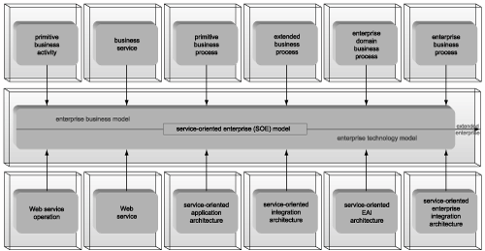

Building blocks allow us to categorize distinct units of logic for both modeling and design purposes. The first layer of this view establishes the enterprise business model, a series of building blocks used to represent modeled business logic only. The third layer provides the concrete or design building blocks that comprise the enterprise technology model. The layer in between represents the core SOE model, defined collectively by abstract (business) and concrete (technology) layers.

    - The enterprise business model
The building blocks in this first layer classify logic encapsulated by business service candidates only. They provide an abstract representation of a service-oriented enterprise's business intelligence, independent from the underlying technology platform with which it is implemented. Should we ever want to replace our technology platforms, we will be able to do so while still preserving our abstract, service-oriented perspective of enterprise business logic. For our purposes, these building blocks help us label and categorize logic that resides in the orchestration and business service layers.
    - "Building Blocks" versus "Service Models"
Building blocks are not an independent means of classifying service logic. They are complemented by existing classifications, such as the service models we introduced in previous chapters. While service models are useful for classifying the nature of logic encapsulated by a service, building blocks classify the scope of service logic.
The primary distinction is that a service model always will apply to a single service, but a building block can apply to a range of logic. In other words, a building block can also represent a subset of a service's logic or the collective logic of multiple services.
    - Basic modeling building blocks
Everything that exists within a modeled view of a service-oriented environment can be broken down into a collection of building blocks, each of which falls into one of the following three categories:
- activity
- service
- process
These terms establish an overall context. Hence, the names of our building blocks are derived from these three categories. The following represents the list of building blocks that form the enterprise business model part of the SOE model.
- primitive business activity
- primitive business service
- primitive business process
- extended business process
- enterprise domain business process
- enterprise business process
This section describes terms related to the first three (Figure 5.22), as they represent the most common and fundamental parts of our modeling environment

Figure 5.22. The three fundamental building blocks of the enterprise business model.
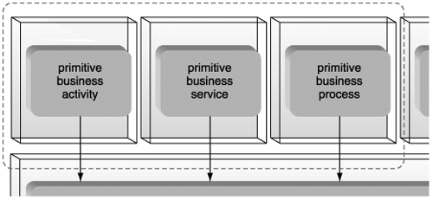

Primitive business activities
A primitive business activity represents the smallest piece of definable and executable business logic within a service-oriented environment. Typically this means that to whatever extent it makes sense to break down a business process, primitive business activities are the smallest parts. The assumption, therefore, is that its logic either cannot be decomposed or will not require further decomposition.

Process activities
Related to a primitive business activity is the process activity. A process activity is not a building block; it is simply a term used to represent an executable step within a business process's workflow logic. Unlike primitive business activities, process activities do not have a fixed scope. The range of business logic represented by a process activity is determined by the granularity of its governing business process. Therefore, a process activity may or may not be comprised of multiple primitive business activities.

Business services
The business service (or business service candidate) category represents the familiar business service candidate we've already been working with. Within the context of this classification system, each business service is comprised of one or more primitive business activities. These activities can reside atomically within the service, or they can inter-relate.

  - Steps to composing SOA
The fundamental components that typically comprise an SOA include:
- an XML data representation architecture
- Web services built upon industry standards
- a platform capable of hosting and processing XML data and Web services

Figure 5.23. The most fundamental components of an SOA.
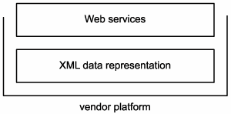
However, to support and realize the principles and characteristics we've explored as being associated with both the primitive and contemporary types of SOA requires some additional design effort.
Common questions that need to be answered at this stage include:
- What types of services should be built, and how should they be organized into service layers?
- How should first-generation standards be positioned to best support SOA?
- What features provided by available extensions are required by the SOA?
These issues lead to an exercise in composition, as we make choices that determine what technologies and architectural components are required and how these parts are best assembled.
Provided in Figure 5.24 and further described in the following sections is an informal set of steps for composing a service-oriented architecture. Depending on your goals and the nature of your technical environment, additional considerations likely will be needed.

Figure 5.24. Suggested steps for composing a preliminary SOA.
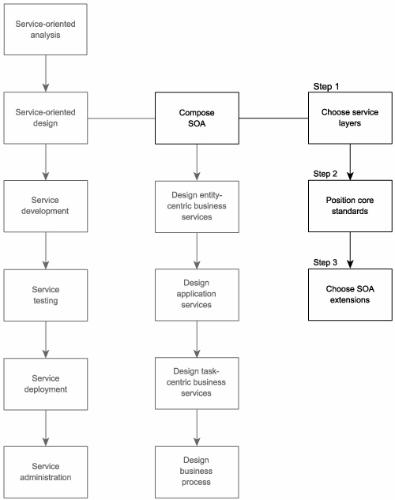

Step 1: Choose service layers
Composing an SOA requires that we first decide on a design configuration for the service layers that will comprise and standardize logic representation within our architecture.
Some high-level guidelines:
- Existing configurations If service layers already have been standardized within your enterprise, you should make every attempt to conform new service designs to these layers. The exception to this is if a need to alter the current service layer configuration has been identified. Then the scope of your project will include a change to the overall complexion of your enterprise's standard SOA.
- Required standards If you are building new types of services or service layers, ensure that these are delivered along with accompanying design standards. These standards must be written so that they apply to the services as part of this and future projects.
- Service composition performance Service compositions can impose a significant amount of processing overhead, especially when intermediary services are required to process the contents of SOAP messages. In this case, each hop between requestor and provider can result in validation, deserialization, and serialization steps. This can really add up, especially in environments not equipped with enterprise processors or accelerators. It is highly advisable to conduct performance tests prior to deciding on a multi-level service layer configuration.
- Service deployment When designing service layers that will produce solution-agnostic services, deployment can become a concern. In a highly distributed environment, reusable services that are centrally located can impose remote messaging latency on solutions that need to connect to them. Redundant deployment of services can solve this problem, but this approach also results in an administration burden. These and other deployment issues need to be assessed prior to proceeding with solution-agnostic service layers.
- Service versioning If you are planning to deliver reusable services as part of your service-oriented solution, ensure that you fully understand the extent to which future service requestors could possibly come to rely on them. After the service is deployed, extensions may be required to further complete the service's expected feature set. If these extensions result in changes to the initial interface, a versioning system will need to be in place to accommodate your solution and any other requestors that are using the service.
- Business services and XSD schema designs If your enterprise already has established a comprehensive XML data representation architecture, it is worth taking a look at your existing set of XSD schemas. These should be analyzed for potential compatibility issues with planned business services. This is especially important when considering the use of entity-centric business services, as these rely on the processing of document entities that would ideally be accompanied by entity-centric schemas.
- Business service maintenance If proceeding with the agile delivery strategy, the on-going maintenance of business services needs to be planned for. As the top-down analysis proceeds, revisiting services to keep their business logic representation in alignment introduces a separate administration process that may need to tie into the versioning system mentioned earlier.

Step 2: Position core standards
Next, we need to assess which core standards should comprise our SOA and how they should be implemented to best support the features and requirements of our service-oriented solution. The Considerations for positioning core SOA standards section provides an overview of how each of the core XML and Web services specifications commonly is affected by principles and characteristics unique to SOA.
Figure 5.25. The operational relationship between core SOA specifications
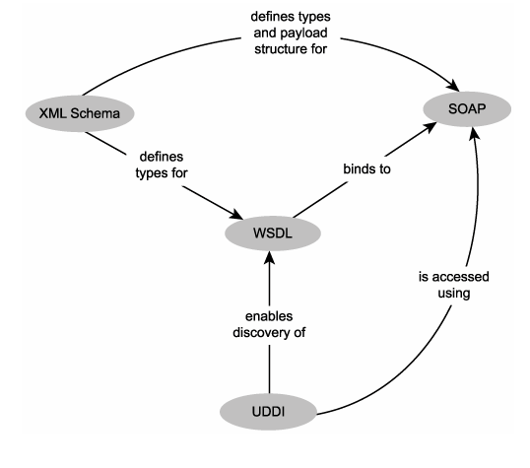

Step 3: Choose SOA extensions
This final part of our "pre-service design process" requires that we determine which contemporary SOA characteristics we want our service-oriented architecture to support. This will help us decide which of the available WS-* specifications should become part of our service-oriented environment. The Considerations for choosing SOA extensions section provides some guidelines for making these determinations.
Figure 5.26. WS-* extensions allow for individual SOAs to be uniquely composed
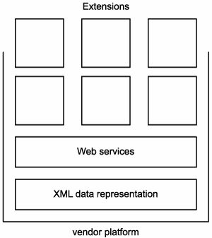
Step-1 : To determine which of these characteristics are provided by the primary influences that shape SOA, which we identified as:
- principles of service-orientation
- first-generation Web services concepts
- WS-* concepts
Step – 2 : Choosing WS-* specifications

Step- 3: WS-BPEL realizing the orchestration service sub-layer within our service layer.

Figure 5.27 : WS-BPEL realizing the orchestration service sub-layer within our service layer.
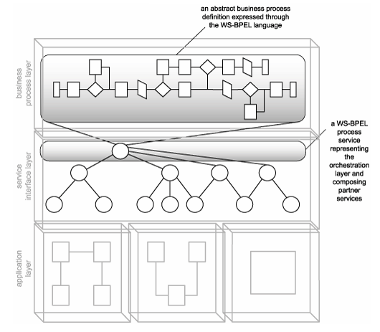

Entity-centric business service design (a step-by-step process)
Entity-centric business services represent the one service layer that is the least influenced by others. Its purpose is to accurately represent corresponding data entities defined within an organization's business models. These services are strictly solution- and business process-agnostic, built for reuse by any application that needs to access or manage information associated with a particular entity.

Figure -5.28 Entity-centric services establish the business service layer.
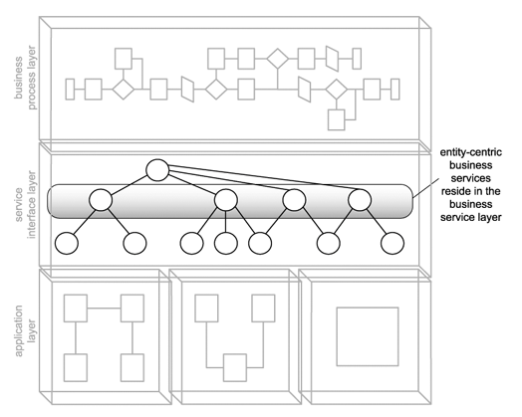

Process description
Provided next is the step-by-step process description wherein we establish a recommended sequence of detailed steps for arriving at a quality entity-centric business service interface (Figure 5.29).

Figure 5.29. The entity-centric business service design process.
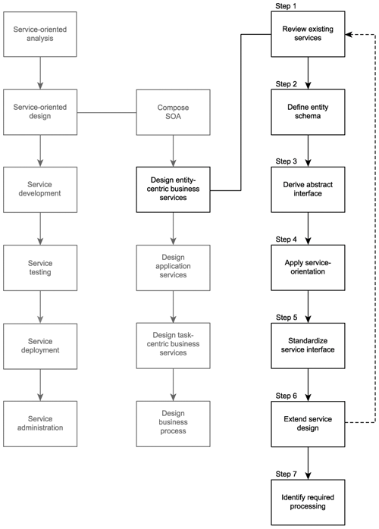

Step 1: Review existing services
Ideally, when creating entity-centric services, the modeling effort resulting in the service candidates will have taken any existing services into account. However, because service candidates tend to consist of operation candidates relevant to the business requirements that formed the basis of the service-oriented analysis, it is always worth verifying to ensure that some or all of the processing functionality represented by operation candidates does not already exist in other services.
Therefore, the first step in designing a new service is to confirm whether it is actually even necessary. If other services exist, they may already be providing some or all of the functionality identified in the operation candidatesorthey may have already established a suitable context in which these new operation candidates can be implemented

Step 2: Define the message schema types
It is useful to begin a service interface design with a formal definition of the messages the service is required to process. To accomplish this we need to formalize the message structures that are defined within the WSDL types area.
SOAP messages carry payload data within the Body section of the SOAP envelope. This data needs to be organized and typed. For this we rely on XSD schemas. A standalone schema actually can be embedded in the types construct, wherein we can define each of the elements used to represent data within the SOAP body.
In the case of an entity-centric service, it is especially beneficial if the XSD schema used accurately represents the information associated with this service's entity. This "entity-centric schema" can become the basis for the service WSDL definition, as most service operations will be expected to receive or transmit the documents defined by this schema.

Step 3: Derive an abstract service interface
Next, we analyze the proposed service operation candidate and follow these steps to define an initial service interface:
- Confirm that each operation candidate is suitably generic and reusable by ensuring that the granularity of the logic encapsulated is appropriate. Study the data structures defined in Step 2 and establish a set of operation names.
- Create the portType (or interface) area within the WSDL document and populate it with operation constructs that correspond to operation candidates.
- Formalize the list of input and output values required to accommodate the processing of each operation's logic. This is accomplished by defining the appropriate message constructs that reference the XSD schema types within the child part elements.

Step 4: Apply principles of service-orientation
Here’s we revisit the four service-orientation principles:
- service reusability
- service autonomy
- service statelessness
- service discoverability
Reusability and autonomy, the two principles we already covered in the service modeling process, are somewhat naturally part of the entity-centric design model in that the operations exposed by entity-centric business services are intended to be inherently generic and reusable (and because the use of the import statement is encouraged to reuse schemas and create modular WSDL definitions). Reusability is further promoted in Step 6, where we suggest that the design be extended to facilitate requirements beyond those identified as part of our service candidate.
Because entity-centric services often need to be composed by a parent service layer and because they rely on the application service layer to carry out their business logic, their immediate autonomy is generally well defined. Unless those services governed by an entity-centric controller have unusual processing requirements or impose dependencies in some manner, entity-centric services generally maintain their autonomy.
It is for similar reasons as those just mentioned that statelessness is also relatively manageable. Entity-centric services generally do not possess a great deal of workflow logic and for those cases in which multiple application or business services need to be invoked to carry out an operation, it is preferred that state management be deferred as much as possible (to, for example, document-style SOAP messages).
Discoverability is an important part of both the design of entity-centric services and their post-deployment utilization. As we mentioned in Step 1, we need to ensure that a service design does not implement logic already in existence. A discovery mechanism would make this determination much easier. Similarly, one measure we can take to make a service more discoverable to others is to supplement it with metadata details using the documentation element, as explained in the Document services with metadata guideline.

Step 5: Standardize and refine the service interface
Depending on your requirements, this can be a multi-faceted step involving a series of design tasks. Following is a list of recommended actions you can take to achieve a standardized and streamlined service design:
- Review existing design standards and guidelines and apply any that are appropriate. (Use the guidelines and proposed standards provided at the end of this chapter as a starting point.)
- In addition to achieving a standardized service interface design, this step also provides an opportunity for the service design to be revised in support of some of the contemporary SOA characteristics
- If your design requirements include WS-I Basic Profile conformance, then that can become a consideration at this stage. Although Basic Profile compliance requires that the entire WSDL be completed, what has been created so far can be verified.

Step 6: Extend the service design
The service modeling process tends to focus on evident business requirements. While promoting reuse always is encouraged, it often falls to the design process to ensure that a sufficient amount of reusable functionality will be built into each service. This is especially important for entity-centric business services, as a complete range of common operations typically is expected by their service requestors.
This step involves performing a speculative analysis as to what other types of features this service, within its predefined functional context, should offer.
There are two common ways to implement new functionality:
- add new operations
- add new parameters to existing operations
While the latter option may streamline service interfaces, it also can be counter-intuitive in that too many parameters associated with one operation may require that service requestors need to know too much about the service to effectively utilize it.
Adding operations is a straight-forward means of providing evident functions associated with the entity. The classic set of operations for an entity-centric service is:
- GetSomething
- UpdateSomething
- AddSomething
- DeleteSomething
Security requirements notwithstanding, establishing these standard operations builds a consistent level of interoperability into the business service layer, facilitating ad-hoc reusability and composition.

Step 7: Identify required processing
While the service modeling process from our service-oriented analysis may have identified some key application services, it may not have been possible to define them all.
Now that we have an actual design for this new business service, you can study the processing requirements of each of its operations more closely. In doing so, you should be able to determine if additional application services are required to carry out each piece of exposed functionality. If you do find the need for new application services, you will have to determine if they already exist, or if they need to be added to the list of services that will be delivered as part of this solution.

Application service design (a step-by-step process)
Application services are the workhorses of SOA. They represent the bottom sub-layer of the composed service layer (Figure 5.30), responsible for carrying out any of the processing demands dictated to them by the business and orchestration layers.

Figure 5.30. Application services establish the bottom sub-layer of the service layer.
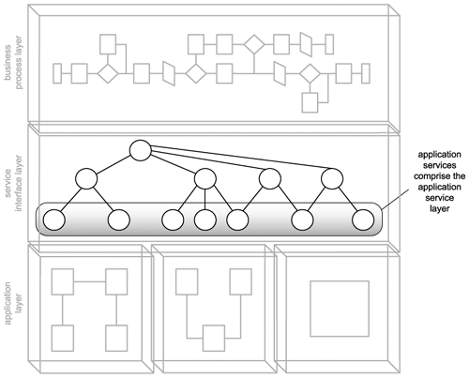

Unlike services in business-centric layers, the design of application services does not require business analysis expertise. The application service layer is a pure, service-oriented abstraction of an organization's technical environments, best defined by those who understand these environments the most.

Process description
Figure 5.31 provides a proposed service design process for creating application service interfaces. Note that all references made to "application services" in this and remaining chapters imply that they are reusable utility application services.

Figure 5.31. The application service design process.
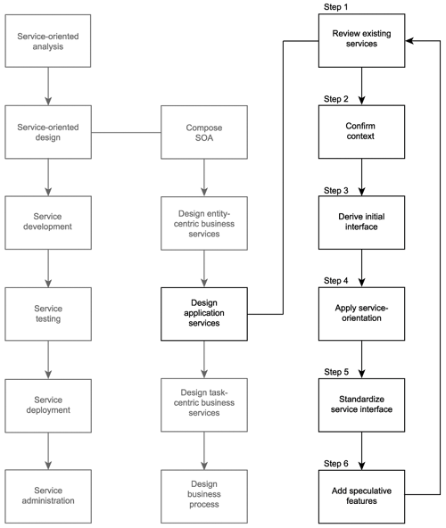

Step 1: Review existing services
More so with application services than with other types of reusable services, it is important to ensure that the functionality required, as per the application service candidate, does not, in some way, shape, or form, already exist. So it is very necessary to review your existing inventory of application services in search of anything resembling what you are about to design.
Additionally, because these services provide such generic functionality, it is worth, at this stage, investigating whether the features you require can be purchased or leased from third-party vendors. Because application services should be designed for maximum reusability, third-party Web services (which typically are built to be reusable) can make a great deal of sense, as long as required quality of service levels can be met.

Step 2: Confirm the context
When performing a service-oriented analysis it's natural to be focused on immediate business requirements. As a result, application service candidates produced by this phase will frequently not take the contexts established by existing application services into account.
Therefore, it is important that the operation candidate grouping proposed by service candidates be re-evaluated and compared with existing application service designs.

Step 3: Derive an initial service interface
Analyze the proposed service operation candidates and follow the steps below to define the first cut of the service interface:
- Using the application service candidate as your primary input, ensure that the granularity of the logic partitions represented by the operation candidates are appropriately generic and reusable.
- Document the input and output values required for the processing of each operation candidate and define message structures using XSD schema constructs (which essentially establishes the WSDL types construct).
- Complete the abstract service definition by adding the portType (or interface) area (along with its child operation constructs) and the necessary message constructs containing the part elements that reference the appropriate schema types.

Step 4: Apply principles of service-orientation
Reuse was discussed in the service modeling process and is addressed directly in Step 5, where we look at making our application service as useful to potential service requestors as possible. However, the existing operation candidates also should be reviewed to ensure they are designed to be generic and reusable.
Autonomy is of primary concern when designing application services. We must ensure that the underlying application logic responsible for executing the service operations does not impose dependencies on the service, or itself have dependencies. This is where the information we gathered in Step 2 of the service-oriented analysis process provides us with a starting point to investigate the nature of the application logic each service operation needs to invoke. Step 6 provides an analysis that covers this and other technology-related issues.

Step 5: Standardize and refine the service interface
Even though the role and purpose of application services differs from other types of services, it is important that they be designed in the same fundamental manner. We accomplish this by ensuring that the resulting application service WSDL definition is based on the same standards and conventions used by others.
Following is a list of recommended actions you can take to achieve a standardized and streamlined service design:
- Apply any existing design standards relevant to the service interface. (For a list of suggested standards, review the guidelines provided at the end of this chapter.)
- Review any of the contemporary SOA characteristics you've chosen to have your services support and assess whether it is possible to build support for this characteristic into this service design.
- Optionally incorporate WS-I Basic Profile rules and best practices to whatever extent possible.

Step 6: Outfit the service candidate with speculative features
If you are interested in delivering highly reusable application services, you can take this opportunity to add features to this service design. These new features can affect existing operations or can result in the addition of new operations. For application services, speculative extensions revolve around the type of processing that falls within the service context.
Of course, before actually adding speculative extensions to the application service, you should repeat Step 1 to confirm that no part of these new operations already exists within other services. Additionally, when adding new extensions, Steps 2 through 5 also need to be repeated to ensure that they are properly standardized and designed in alignment with the portion of the service interface we've created so far.

Step 7: Identify technical constraints
At this point we have created an ideal service interface in a bit of a vacuum. Unlike our business services, application services need to take low-level, real-world considerations into account.
The types of details we are specifically looking for are:
- The physical connection point of the particular function. (In other words, what components need to be invoked, what API functions need to be called, or which adapters need to be activated.)
- Security constraints related to any part of the processing.
- Response time of each processing function.
- Availability of the underlying system performing the processing function.
- Environmental factors relating to service deployment location.
- Technical limitations of underlying application logic (especially when exposing legacy systems).
- Administration requirements imposed by the service.
- Potential SLA requirements.

Task-centric business service design (a step-by-step process)
The process for designing task-centric services usually require less effort than the previous two design processes, simply because reuse is generally not a primary consideration. Therefore, only the service operation candidates identified as part of the service modeling process are addressed here.

Figure 5.32. Task-centric business services can comprise the business service layer, along with entity-centric neighbors.
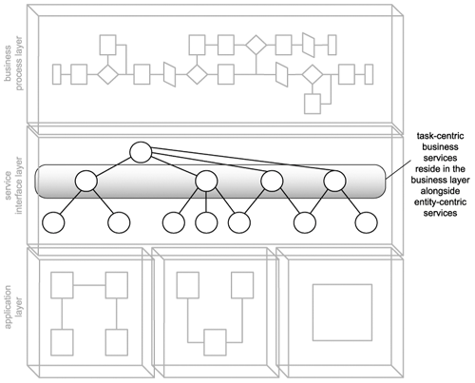

. Process description
As shown in Figure 5.33, this process starts off with a new kind of step in which workflow logic is mapped out. This is because task-centric business services are expected to contain and govern portions of business processes.

Figure 5.33 The task-centric business service design process.
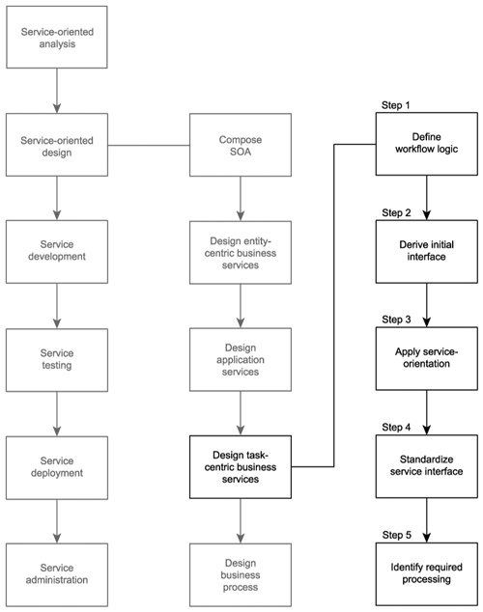

Step 1: Define the workflow logic
Task-centric services typically will contain embedded workflow logic used to coordinate an underlying service composition. Our first step, therefore, is to define this logic for every possible interaction scenario we can imagine..
Because we are designing our task-centric business service after our entity-centric and application service designs have been completed, we will need to revisit these scenario documents and turn them into concrete service interaction models.

Step 2: Derive the service interface
Follow these suggested steps to assemble an initial service interface:
1. Use the application service operation candidates to derive a set of corresponding operations.
2. Unlike previous design processes, the source from which we derive our service interface this time also includes the activity diagrams and the workflow logic we documented in Step 1. This information gives us a good idea as to what additional operations our task-centric service may require.
3. Document the input and output values required for the processing of each operation and populate the types section with XSD schema types required to process the operations.
4. Build the WSDL definition by creating the portType (or interface) area, inserting the identified operation constructs. Then add the necessary message constructs containing the part elements that reference the appropriate schema types.

Step 3: Apply principles of service-orientation
It is beneficial to take another look at the four service-orientation principles like service reusability, service autonomy, service statelessness, and service discoverability.
Reuse opportunities for task-centric services are much more rare than for entity-centric and application services. This is because task-centric services represent a portion of workflow logic specific to a business process. However, reuse still can be achieved.
The autonomy of task-centric services is generally dependent on the autonomy of the underlying child services. A consistent state of autonomy can therefore be challenging to maintain.
Task-centric services contain workflow logic that may impose processing dependencies in service compositions. This can lead to the need for state management. However, the use of document-style SOAP messages allows the service to delegate the persistence of some or all of this state information to the message itself.
It is always useful for services to be discoverable, but the need for task-centric services to be discovered is not as pressing as with other, more generically reusable services.

Step 4: Standardize and refine the service interface
Although task-centric business services will tend to have more creative operation names, existing conventions still need to be applied. Here is the standard list of recommended actions to achieve a standardized and streamlined service design:
- Incorporate existing design standards and guidelines. (A set of recommended guidelines is provided at the end of this chapter.)
- Ensure that any chosen contemporary SOA characteristics are fully supported by the service interface design.
- Take WS-I Basic Profile standards and best practices into account.

Step 5: Identify required processing
To carry out their share of a solution's process logic, task-centric services can compose application and both entity-centric and additional task-centric business services. Therefore, the implementation of a task-centric service interface requires that any needed underlying service layers are in place to support the processing requirements of its operations.
Because this is the last of our three service design processes, all required supporting application services need to be identified. They may consist of services that already existed and/or services we just designed during the previous application service design process. The design of process logic within the task-centric business service may also reveal the need for additional application services that haven't yet been considered.
  - WS-BPEL language basics
Before we can design an orchestration layer, we need to acquire a good understanding of how the operational characteristics of the process can be formally expressed. This book uses the WS-BPEL language to demonstrate how process logic can be described as part of a concrete definition (Figure 5.34) that can be implemented and executed via a compliant orchestration engine.

Figure 5.34. A common WS-BPEL process definition structure.
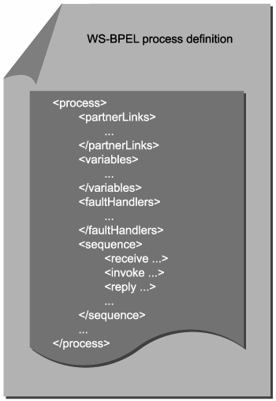

A brief history of BPEL4WS and WS-BPEL
The Business Process Execution Language for Web Services (BPEL4WS) was first conceived in July, 2002, with the release of the BPEL4WS 1.0 specification, a joint effort by IBM, Microsoft, and BEA. This document proposed an orchestration language inspired by previous variations, such as IBM's Web Services Flow Language (WSFL) and Microsoft's XLANG specification.
Joined by other contributors from SAP and Siebel Systems, version 1.1 of the BPEL4WS specification was released less than a year later, in May of 2003. This version received more attention and vendor support, leading to a number of commercially available BPEL4WS-compliant orchestration engines. Just prior to this release, the BPEL4WS specification was submitted to an OASIS technical committee so that the specification could be developed into an official, open standard.
The technical committee is in the process of finalizing the release of the next version of BPEL4WS. It has been announced that the language itself has been renamed to the Web Services Business Process Execution Language, or WS-BPEL (and assigned the 2.0 version number). The changes planned for WS-BPEL have been made publicly available on the OASIS Web site at www.oasis-open.org.

The process element
Let's begin with the root element of a WS-BPEL process definition. It is assigned a name value using the name attribute and is used to establish the process definition-related namespaces.

Example 5.1. A skeleton process definition.
<process name="TimesheetSubmissionProcess"
targetNamespace="http://www.xmltc.com/tls/process/"
xmlns=
"http://schemas.xmlsoap.org/ws/2003/03/
business-process/"
xmlns:bpl="http://www.xmltc.com/tls/process/"
xmlns:emp="http://www.xmltc.com/tls/employee/"
xmlns:inv="http://www.xmltc.com/tls/invoice/"
xmlns:tst="http://www.xmltc.com/tls/timesheet/"
xmlns:not="http://www.xmltc.com/tls/notification/">
<partnerLinks>
...
</partnerLinks>
<variables>
...
</variables>
<sequence>
...
</sequence>
...
</process>

The process construct contains a series of common child elements explained in the following sections.

The partnerLinks and partnerLink elements
A partnerLink element establishes the port type of the service (partner) that will be participating during the execution of the business process. Partner services can act as a client to the process, responsible for invoking the process service. Alternatively, partner services can be invoked by the process service itself.
The contents of a partnerLink element represent the communication exchange between two partnersthe process service being one partner and another service being the other. Depending on the nature of the communication, the role of the process service will vary. For instance, a process service that is invoked by an external service may act in the role of "TimesheetSubmissionProcess." However, when this same process service invokes a different service to have an invoice verified, it acts within a different role, perhaps "InvoiceClient." The partnerLink element therefore contains the myRole and partnerRole attributes that establish the service provider role of the process service and the partner service respectively.

Example 5.2. The partnerLinks construct containing one partnerLink element in which the process service is invoked by an external client partner and four partnerLink elements that identify partner services invoked by the process service.
<partnerLinks>
<partnerLink name="client"
partnerLinkType="tns:TimesheetSubmissionType"
myRole="TimesheetSubmissionServiceProvider"/>
<partnerLink name="Invoice"
partnerLinkType="inv:InvoiceType"
partnerRole="InvoiceServiceProvider"/>
<partnerLink name="Timesheet"
partnerLinkType="tst:TimesheetType"
partnerRole="TimesheetServiceProvider"/>
<partnerLink name="Employee"
partnerLinkType="emp:EmployeeType"
partnerRole="EmployeeServiceProvider"/>
<partnerLink name="Notification"
partnerLinkType="not:NotificationType"
partnerRole="NotificationServiceProvider"/>
</partnerLinks>

The partnerLinkType element
For each partner service involved in a process, partnerLinkType elements identify the WSDL portType elements referenced by the partnerLink elements within the process definition. Therefore, these constructs typically are embedded directly within the WSDL documents of every partner service (including the process service).
The partnerLinkType construct contains one role element for each role the service can play, as defined by the partnerLink myRole and partnerRole attributes. As a result, a partnerLinkType will have either one or two child role elements.

Example- A WSDL definitions construct containing a partnerLinkType construct.
<definitions name="Employee"
targetNamespace="http://www.xmltc.com/tls/employee/wsdl/"
xmlns="http://schemas.xmlsoap.org/wsdl/"
xmlns:plnk=
"http://schemas.xmlsoap.org/ws/2003/05/partner-link/"
...
>
...
<plnk:partnerLinkType name="EmployeeServiceType" xmlns=
"http://schemas.xmlsoap.org/ws/2003/05/partner-link/">
<plnk:role name="EmployeeServiceProvider">
<portType name="emp:EmployeeInterface"/>
</plnk:role>
</plnk:partnerLinkType>
...
</definitions>

The variables element
WS-BPEL process services commonly use the variables construct to store state information related to the immediate workflow logic. Entire messages and data sets formatted as XSD schema types can be placed into a variable and retrieved later during the course of the process. The type of data that can be assigned to a variable element needs to be predefined using one of the following three attributes: messageType, element, or type.
The messageType attribute allows for the variable to contain an entire WSDL-defined message, whereas the element attribute simply refers to an XSD element construct. The type attribute can be used to just represent an XSD simpleType, such as string or integer.

Example -. The variables construct hosting only some of the child variable elements used later by the Timesheet Submission Process.
<variables>
<variable name="ClientSubmission"
messageType="bpl:receiveSubmitMessage"/>
<variable name="EmployeeHoursRequest"
messageType="emp:getWeeklyHoursRequestMessage"/>
<variable name="EmployeeHoursResponse"
messageType="emp:getWeeklyHoursResponseMessage"/>
<variable name="EmployeeHistoryRequest"
messageType="emp:updateHistoryRequestMessage"/>
<variable name="EmployeeHistoryResponse"
messageType="emp:updateHistoryResponseMessage"/>
...
</variables>

Typically, a variable with the messageType attribute is defined for each input and output message processed by the process definition. The value of this attribute is the message name from the partner process definition.

The getVariableProperty and getVariableData functions
WS-BPEL provides built-in functions that allow information stored in or associated with variables to be processed during the execution of a business process.

getVariableProperty(variable name, property name)
This function allows global property values to be retrieved from variables. It simply accepts the variable and property names as input and returns the requested value.

getVariableData(variable name, part name, location path)
Because variables commonly are used to manage state information, this function is required to provide other parts of the process logic access to this data. The getVariableData function has a mandatory variable name parameter and two optional arguments that can be used to specify a part of the variable data.
In our examples we use the getVariableData function a number of times to retrieve message data from variables.

Example - Two getVariableData functions being used to retrieve specific pieces of data from different variables.
getVariableData ('InvoiceHoursResponse',
'ResponseParameter')

getVariableData ('input','payload',
'/tns:TimesheetType/Hours/...')

The sequence element
The sequence construct allows you to organize a series of activities so that they are executed in a predefined, sequential order. WS-BPEL provides numerous activities that can be used to express the workflow logic within the process definition. The remaining element descriptions in this section explain the fundamental set of activities used as part of our upcoming Example examples.

Example - A skeleton sequence construct containing only some of the many activity elements provided by WS-BPEL.
<sequence>
<receive>
...
</receive>
<assign>
...
</assign>
<invoke>
...
</invoke>
<reply>
...
</reply>
</sequence>

Note that sequence elements can be nested, allowing you to define sequences within sequences.

The invoke element
This element identifies the operation of a partner service that the process definition intends to invoke during the course of its execution. The invoke element is equipped with five common attributes, which further specify the details of the invocation.

Table - invoke element attributes
Attribute | Description
partnerLink | This element names the partner service via its corresponding partnerLink.
portType | The element used to identify the portType element of the partner service.
operation | The partner service operation to which the process service will need to send its request.
inputVariable | The input message that will be used to communicate with the partner service operation. Note that it is referred to as a variable because it is referencing a WS-BPEL variable element with a messageType attribute.
outputVariable | This element is used when communication is based on the request-response MEP. The return value is stored in a separate variable element.

Example - . The invoke element identifying the target partner service details.
<invoke name="ValidateWeeklyHours"
partnerLink="Employee"
portType="emp:EmployeeInterface"
operation="GetWeeklyHoursLimit"
inputVariable="EmployeeHoursRequest"
outputVariable="EmployeeHoursResponse"/>

The receive element
The receive element allows us to establish the information a process service expects upon receiving a request from an external client partner service. In this case, the process service is viewed as a service provider waiting to be invoked.
The receive element contains a set of attributes, each of which is assigned a value relating to the expected incoming communication

Table - receive element attributes
Attribute | Description
partnerLink | The client partner service identified in the corresponding partnerLink construct.
portType | The process service portType that will be waiting to receive the request message from the partner service.
operation | The process service operation that will be receiving the request.
variable | The process definition variable construct in which the incoming request message will be stored.
createInstance | When this attribute is set to "yes," the receipt of this particular request may be responsible for creating a new instance of the process.

Example - . The receive element used in the Timesheet Submission Process definition to indicate the client partner service responsible for launching the process with the submission of a timesheet document.
<receive name="receiveInput"
partnerLink="client"
portType="tns:TimesheetSubmissionInterface"
operation="Submit"
variable="ClientSubmission"
createInstance="yes"/>

The reply element
Where there's a receive element, there's a reply element when a synchronous exchange is being mapped out. The reply element is responsible for establishing the details of returning a response message to the requesting client partner service. Because this element is associated with the same partnerLink element as its corresponding receive element, it repeats a number of the same attributes
Table - reply element attributes
Attribute | Description
partnerLink | The same partnerLink element established in the receive element.
portType | The same portType element displayed in the receive element.
operation | The same operation element from the receive element.
variable | The process service variable element that holds the message that is returned to the partner service.
messageExchange | It is being proposed that this optional attribute be added by the WS-BPEL 2.0 specification. It allows for the reply element to be explicitly associated with a message activity capable of receiving a message (such as the receive element).

Example - A potential companion reply element to the previously displayed receive element.
<reply partnerLink="client"
portType="tns:TimesheetSubmissionInterface"
operation="Submit"

. The switch, case, and otherwise elements
These three structured activity elements allow us to add conditional logic to our process definition, similar to the familiar select case/case else constructs used in traditional programming languages. The switch element establishes the scope of the conditional logic, wherein multiple case constructs can be nested to check for various conditions using a condition attribute. When a condition attribute resolves to "true," the activities defined within the corresponding case construct are executed.

Example - A skeleton case element wherein the condition attribute uses the getVariableData function to compare the content of the EmployeeResponseMessage variable to a zero value.
<switch>
<case condition=
"getVariableData('EmployeeResponseMessage',
'ResponseParameter')=0">
...
</case>
<otherwise>
...
</otherwise>
</switch>

The assign, copy, from, and to elements
This set of elements simply gives us the ability to copy values between process variables, which allows us to pass around data throughout a process as information is received and modified during the process execution.

Example - Within this assign construct, the contents of the TimesheetSubmissionFailedMessage variable are copied to two different message variables.
<assign>
<copy>
<from variable="TimesheetSubmissionFailedMessage"/>
<to variable="EmployeeNotificationMessage"/>
</copy>
<copy>
<from variable="TimesheetSubmissionFailedMessage"/>
<to variable="ManagerNotificationMessage"/>
</copy>
</assign>

faultHandlers, catch, and catchAll elements
This construct can contain multiple catch elements, each of which provides activities that perform exception handling for a specific type of error condition. Faults can be generated by the receipt of a WSDL-defined fault message, or they can be explicitly triggered through the use of the throw element. The faultHandlers construct can consist of (or end with) a catchAll element to house default error handling activities.

Example - The faultHandlers construct hosting catch and catchAll child constructs.
<faultHandlers>
<catch faultName="SomethingBadHappened"
faultVariable="TimesheetFault">
...
</catch>
<catchAll>
...
</catchAll>
</faultHandlers>

Other WS-BPEL elements
The following table provides brief descriptions of other relevant parts of the WS-BPEL language.
Element | Description
compensationHandler | A WS-BPEL process definition can define a compensation process that kicks in a series of activities when certain conditions occur to justify a compensation. These activities are kept in the compensationHandler construct. (For more information about compensations, see the Business activities section in Chapter 6.)
correlationSets | WS-BPEL uses this element to implement correlation, primarily to associate messages with process instances. A message can belong to multiple correlationSets. Further, message properties can be defined within WSDL documents.
Empty | This simple element allows you to state that no activity should occur for a particular condition.
eventHandlers | The eventHandlers element enables a process to respond to events during the execution of process logic. This construct can contain onMessage and onAlarm child elements that trigger process activity upon the arrival of specific types of messages (after a predefined period of time, or at a specific date and time, respectively).
Exit | See the terminate element description that follows.
Flow | A flow construct allows you to define a series of activities that can occur concurrently and are required to complete after all have finished executing. Dependencies between activities within a flow construct are defined using the child link element.
Pick | Similar to the eventHandlers element, this construct also can contain child onMessage and onAlarm elements but is used more to respond to external events for which process execution is suspended.
scope | Portions of logic within a process definition can be sub-divided into scopes using this construct. This allows you to define variables, faultHandlers, correlationSets, compensationHandler, and eventHandlers elements local to the scope.
Terminate | This element effectively destroys the process instance. The WS-BPEL 2.0 specification proposes that this element be renamed exit.
Throw | WS-BPEL supports numerous fault conditions. Using the tHRow element allows you to explicitly trigger a fault state in response to a specific condition.
Wait | The wait element can be set to introduce an intentional delay within the process. Its value can be a set time or a predefined date.
While | This useful element allows you to define a loop. As with the case element, it contains a condition attribute that, as long as it continues resolving to "true," will continue to execute the activities within the while construct.

  - WS-Coordination overview
The overall coordination mechanism consists of the activation service, the registration service, a coordinator, and participants that implement specific protocols. It is likely that these underlying context management services will be automatically governed by the orchestration engine platform for which you are creating a WS-BPEL process definition.
In terms of the WS-Coordination language and its two protocol documents, what may be of interest to you is the actual CoordinationContext header that is inserted into SOAP messages. You may encounter this header if you are monitoring messages or if you need to perform custom development associated with the coordination context.

. The CoordinationContext element
This parent construct contains a series of child elements that each house a specific part of the context information being relayed by the header.

Example - A skeleton CoordinationContext construct.
<Envelope
xmlns="http://schemas.xmlsoap.org/soap/envelope/"
xmlns:wsc=
"http://schemas.xmlsoap.org/ws/2002/08/wscoor"
xmlns:wsu=
"http://schemas.xmlsoap.org/ws/2002/07/utility">
<Header>
<wsc:CoordinationContext>
<wsu:Identifier>
...
</wsu:Identifier>
<wsu:Expires>
...
</wsu:Expires>
<wsc:CoordinationType>
...
</wsc:CoordinationType>
<wsc:RegistrationService>
...
</wsc:RegistrationService>
</wsc:CoordinationContext>
</Header>
<Body>
...
</Body>
</Envelope>

The activation service returns this CoordinationContext header upon the creation of a new activity. As described later, it is within the CoordinationType child construct that the activity protocol (WS-BusinessActivity, WS-AtomicTransaction) is carried. Vendor-specific implementations of WS-Coordination can insert additional elements within the CoordinationContext construct that represent values related to the execution environment.

The Identifier and Expires elements
These two elements originate from a utility schema used to provide reusable elements. WS-Coordination uses the Identifier element to associate a unique ID value with the current activity. The Expires element sets an expiry date that establishes the extent of the activity's possible lifespan.

Example - . Identifier and Expires elements containing values relating to the header.
<Envelope
...
xmlns:wsu=
"http://schemas.xmlsoap.org/ws/2002/07/utility">
...
<wsu:Identifier>
http://www.xmltc.com/ids/process/33342
</wsu:Identifier>
<wsu:Expires>
2008-07-30T24:00:00.000
</wsu:Expires>
...
</Envelope>

The CoordinationType element
This element is described shortly in the WS-BusinessActivity and WS-AtomicTransaction coordination types section.

The RegistrationService element
The RegistrationService construct simply hosts the endpoint address of the registration service. It uses the Address element also provided by the utility schema.

Example - The RegistrationService element containing a URL pointing to the location of the registration service.
<wsc:RegistrationService>
<wsu:Address>
http://www.xmltc.com/bpel/reg
</wsu:Address>
</wsc:RegistrationService>

Designating the WS-BusinessActivity coordination type
The specific protocol(s) that establishes the rules and constraints of the activity are identified within the CoordinationType element. The URI values that are placed here are predefined within the WS-BusinessActivity and WS-AtomicTransaction specifications.
This first example shows the CoordinationType element containing the WS-BusinessActivity coordination type identifier. This would indicate that the activity for which the header is carrying context information is a potentially long-running activity.

Example- . The CoordinationType element representing the WS-BusinessActivity protocol.
<wsc:CoordinationType>
http://schemas.xmlsoap.org/ws/2004/01/wsba
</wsc:CoordinationType>

Designating the WS-AtomicTransaction coordination type
In the next example, the CoordinationType element is assigned the WS-AtomicTransaction coordination type identifier, which communicates the fact that the header's context information is part of a short running transaction.

Example - The CoordinationType element representing the WS-AtomicTransaction protocol.
<wsc:CoordinationType>
http://schemas.xmlsoap.org/ws/2003/09/wsat
</wsc:CoordinationType>

WS-Policy language basics
The WS-Policy framework establishes a means of expressing service metadata beyond the WSDL definition. Specifically, it allows services to communicate rules and preferences in relation to security, processing, or message content. Policies can be applied to a variety of Web resources, positioning this specification as another fundamental part of the WS-* extensions discussed in this chapter (Figure 5.35).

Figure 5.35 How WS-Policy relates to the other WS-* specifications discussed in this chapter.
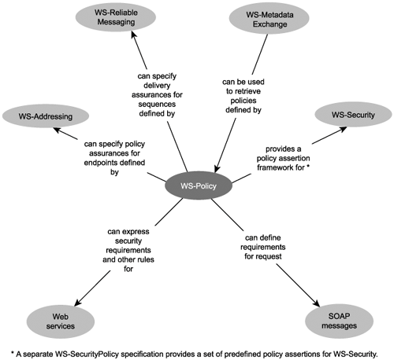
The WS-Policy framework is comprised of the following three specifications:
- WS-Policy
- WS-PolicyAssertions
- WS-PolicyAttachments
These collectively provide the following elements covered in this section, which demonstrate how policies are formulated and attached to element or document-level subjects:
- Policy element
- TextEncoding, Language, SpecVersion, and MessagePredicate assertions
- ExactlyOne element
- All element
- Usage and Preference attributes
- PolicyReference element
- PolicyURIs attribute
- PolicyAttachment element

The Policy element and common policy assertions
The Policy element establishes the root construct used to contain the various policy assertions that comprise the policy. The WS-PolicyAssertions specification supplies the following set of common, predefined assertion elements:
- TextEncoding Dictates the use of a specific text encoding format.
- Language Expresses the requirement or preference for a particular language.
- SpecVersion Communicates the need for a specific version of a specification.
- MessagePredicate Indicates message processing rules expressed using XPath statements.
These elements represent assertions that can be used to structure basic policies around common requirements. Policy assertions also can be customized, and other WS-* specifications may provide supplemental assertions.
Each assertion can indicate whether its use is required or not via the value assigned to its Usage attribute. A value of "Required" indicates that its conditions must be met. Additionally, the use of the Preference attribute allows an assertion to communicate its importance in comparison to other assertions of the same type.

The ExactlyOne element
This construct surrounds multiple policy assertions and indicates that there is a choice between them, but that one must be chosen.

Example
TLS initially produced a policy definition giving partner requestors the option of sending bulk invoice submission messages that comply to one of two versions of the WS-ReliableMessaging specifications.
Following is a sample policy definition that uses the ExactlyOnce construct to communicate the SpecVersion policy alternative. The SpecVersion element's Preference attribute expresses TLS's preferred option.

Example - . The ExactlyOne construct housing two alternative policy assertions, one of which must be used.
<wsp:Policy
xmlns:wsp="http://schemas.xmlsoap.org/ws/2002/12/policy">
<wsp:ExactlyOne>
<wsp:SpecVersion wsp:Usage="wsp:Required"
wsp:Preference="10" wsp:URI=
"http://schemas.xmlsoap.org/ws/2004/03/rm"/>
<wsp:SpecVersion wsp:Usage="wsp:Required"
wsp:Preference="1" wsp:URI=
"http://schemas.xmlsoap.org/ws/2003/02/rm"/>
</wsp:ExactlyOne>
</wsp:Policy>

The All element
The All construct introduces a rule that states that all of the policy assertions within the construct must be met. This element can be combined with the ExactlyOne element, where collections of policy assertions can each be grouped into All constructs that are then further grouped into a parent ExactlyOne construct. This indicates that the policy is offering a choice of assertions groups but that the assertions in any one of the alternative All groups must be met.

Example
TLS later expands its original policy definition to enforce a standard text encoding format. It adds the same TextEncoding assertion to each of its policy alternatives and groups the assertions using the All construct, as shown here:

Example 5.18. The All and ExactlyOne constructs used together to provide two alternative policy groups.
<wsp:Policy
xmlns:wsp="http://schemas.xmlsoap.org/ws/2002/12/policy">
<wsp:ExactlyOne ID="Invoice1">
<wsp:All>
<wsp:SpecVersion wsp:Usage="wsp:Required"
wsp:Preference="10" wsp:URI=
"http://schemas.xmlsoap.org/ws/2004/03/rm"/>
<wsp:TextEncoding wsp:Usage="wsp:Required"
Encoding="iso-8859-5"/>
</wsp:All>
<wsp:All ID="Invoice2">
<wsp: SpecVersion wsp:Usage="wsp:Required"
wsp:Preference="1" wsp:URI=
"http://schemas.xmlsoap.org/ws/2003/02/rm"/>
<wsp:TextEncoding wsp:Usage="wsp:Required"
Encoding="iso-8859-5"/>
</wsp:All>
</wsp:ExactlyOne>
</wsp:Policy>

Note that a separate OneOrMore construct can also be used to group policy assertions much like the All construct, except that one (or more) of the policy assertions must be met.

The Usage attribute
As you've seen in the previous examples, a number of WS-Policy assertion elements contain a Usage attribute to indicate whether a given policy assertion is required. This attribute is a key part of the WS-Policy framework as its values form part of the overall policy rules. The Usage attribute actually has a number of settings worth knowing about,

Table - . Possible settings for the Usage attribute.
Attribute Value | Description
Required | The assertion requirements must be met, or an error will be generated.
Optional | The assertion requirements may be met, but an error will not be generated if they are not met.
Rejected | The assertion is unsupported.
Observed | The assertion applies to all policy subjects.
Ignored | The assertion will intentionally be ignored.

The Preference attribute
Policy assertions can be ranked in order of preference using this attribute. This is especially relevant if a service provider is flexible enough to provide multiple policy alternatives to potential service requestors.
The Preference attribute is assigned an integer value. The higher this value, the more preferred the assertion. When this attribute is not used, a default value of "0" is assigned to the policy assertion.

. The PolicyReference element
The PolicyReference element is one way to simply link an element with one or more policies. Each PolicyReference element contains a URI attribute that points to one policy document or a specific policy assertion within the document. (The ID attribute of the policy or grouping construct is referenced via the value displayed after the "#" symbol.)
If multiple PolicyReference elements are used within the same element, the policy documents are merged at runtime.

Example
If TLS wanted to place policies relating to its Employee Service documents in separate definitions it could do so by using the PolicyReference elements, as shown here:

Example - Separate PolicyReference elements referencing two policy documents.
<Employee ...>
<wsp:PolicyReference URI=
"http://www.xmltc.com/tls/policy1.xml#Employee1"/>
<wsp:PolicyReference URI=
"http://www.xmltc.com/tls/policy2.xml#Employee2"/>
</Employee>

The PolicyURIs attribute
Alternatively, the PolicyURIs attribute also can be used to link to one or more policy documents. The attribute is added to an element and can be assigned multiple policy locations. As with PolicyReference, these policies are then merged at runtime.

Example
TLS could also reference its employee policy definitions by using the PolicyURIs attribute, as shown here:

Example - The PolicyURIs attribute referencing two policy documents.
<Employee wsp:PolicyURIs=
"http://www.xmltc.com/tls/policy1.xml#Employee1"
"http://www.xmltc.com/tls/policy2.xml#Employee2"/>

The PolicyAttachment element
Another way of associating a policy with a subject is through the use of the PolicyAttachment construct. The approach taken here is that the child AppliesTo construct is positioned as the parent of the subject elements. The familiar PolicyReference element then follows the AppliesTo construct to identify the policy assertions that will be used.

Example
Finally, TLS can embed the policy assertion reference using the PolicyAttachment and AppliesTo constructs. In the following example, the policy assertion is attached to a specific endpoint reference.

Example - The PolicyAttachment construct using the child AppliesTo construct to associate a policy with a WS-Addressing EndpointReference construct.
<wsp:PolicyAttachment>
<wsp:AppliesTo>
<wsa:EndpointReference
xmlns:emp="http://www.xmltc.com/tls/employee">
<wsa:Address>
http://www.xmltc.com/tls/ep1
</wsa:Address>
<wsa:PortType>
emp:EmployeeInterface
</wsa:PortType>
<wsa:ServiceName>
emp:Employee
</wsa:ServiceName>
</wsa:EndpointReference>
</wsp:AppliesTo>
<wsp:PolicyReference URI=
"http://www.xmltc.com/EmployeePolicy.xml"/>
</wsp:PolicyAttachment>

Additional types of policy assertions
It is important to note that policy assertions can be utilized and customized beyond the conventional manner in which they are displayed in the preceding examples.
For example:
- Policy assertions can be incorporated into WSDL definitions through the use of a special set of policy subjects that target specific parts of the definition structure. A separate UsingPolicy element is provided for use as a WSDL extension.
- WS-ReliableMessaging defines and relies on WS-Policy assertions to enforce some of its delivery and acknowledgement rules.
- WS-Policy assertions can be created to communicate that a Web service is capable of participating in a business activity or an atomic transaction.
- A policy assertion can be designed to express a service's processing requirements in relation to other WS-* specifications.
- WS-Policy assertions commonly are utilized within the WS-Security framework to express security requirements.

WS-Security language basics
The WS-Security framework provides extensions that can be used to implement message-level security measures. These protect message contents during transport and during processing by service intermediaries. Additional extensions implement authentication and authorization control, which protect service providers from malicious requestors. WS-Security is designed to work with any of the WS-* specifications we discuss in this chapter, as shown in Figure 5.36.

Figure 5.36. How WS-Security relates to the other WS-* specifications discussed in this chapter.

The WS-Security framework is comprised of numerous specifications, many in different stages of acceptance and maturation. In this book we've concentrated on some of the more established ones, namely:
- WS-Security
- XML-Encryption
- XML-Signature

The Security element (WS-Security)
This construct represents the fundamental header block provided by WS-Security. The Security element can have a variety of child elements, ranging from XML-Encryption and XML-Signature constructs to the token elements provided by the WS-Security specification itself.

The UsernameToken, Username, and Password elements (WS-Security)
The UsernameToken element provides a construct that can be used to host token information for authentication and authorization purposes. Typical children of this construct are the Username and Password child elements, but custom elements also can be added.

The BinarySecurityToken element (WS-Security)
Tokens stored as binary data, such as certificates, can be represented in an encoded format within the BinarySecurityToken element.

The SecurityTokenReference element (WS-Security)
This element allows you to provide a pointer to a token that exists outside of the SOAP message document.

Example
For each invoice generated by RailCo's Invoice Submission Service, it must provide a standard Username and Password token pair in the SOAP message header, as shown here:

Example - The Security SOAP header used by RailCo to provide user name and password values.
<Envelope
xmlns="http://schemas.xmlsoap.org/soap/envelope/">
<Header>
<wsse:Security xmlns:wsse=
"http://schemas.xmlsoap.org/ws/2002/12/secext">
<wsse:UsernameToken>
<wsse:Username>
rco-3342
</wsse:Username>
<wsse:Password Type="wsse:PasswordDigest">
93292348347
</wsse:Password>
</wsse:UsernameToken>
</wsse:Security>
</Header>
<Body>
...
</Body>
</Envelope>

The EncryptedData element (XML-Encryption)
This is the parent construct that hosts the encrypted portion of an XML document. If located at the root of an XML document, the entire document contents are encrypted.
The EncryptedData element's Type attribute indicates what is included in the encrypted content.

The CipherData, CipherValue, and CipherReference elements (XML-Encryption)
The CipherData construct is required and must contain either a CipherValue element hosting the characters representing the encrypted text or a CipherReference element that provides a pointer to the encrypted values.

Example
RailCo designed a task-centric business service that uses an XSD schema to represent a small, custom invoice document as part of its transmission. This schema was imported and established a construct with a root InvoiceType element.
Following is an example of an XML document instance of this schema.
<InvoiceType>
<Number>
2322
</Number>
<Total>
$32,322.73
</Total>
<Date>
07.5.05
</Date>
</InvoiceType>

To comply with TLS's security requirements, RailCo is required to apply encryption to any dollar amounts in business documents exchanged via the TLS B2B system. Shown in the following code example is the same XML fragment but with XML-Encryption elements representing the Total element and value.

Example - . An XML document within a SOAP message containing an encrypted element.
<InvoiceType>
<Number>
2322
</Number>
<EncryptedData
xmlns="http://www.w3.org/2001/04/xmlenc#"
Type="http://www.w3.org/2001/04/xmlenc#Element">
<CipherData>
<CipherValue>
R5J7UUI78
</CipherValue>
</CipherData>
</EncryptedData>
<Date>
07.5.05
</Date>
</InvoiceType>

XML-Signature elements
A digital signature is a complex piece of information comprised of specific parts that each represent an aspect of the document being signed. Therefore, numerous elements can be involved when defining the construct that hosts the digital signature information.

Table - XML-Signature elements
Element | Description
CanonicalizationMethod | This element identifies the type of "canonicalization algorithm" used to detect and represent subtle variances in the document content (such as the location of white space).
DigestMethod | Identifies the algorithm used to create the signature.
DigestValue | Contains a value that represents the document being signed. This value is generated by applying the DigestMethod algorithm to the XML document.
KeyInfo | This optional construct contains the public key information of the message sender.
Signature | The root element, housing all of the information for the digital signature.
SignatureMethod | The algorithm used to produce the digital signature. The digest and canonicalization algorithms are taken into account when creating the signature.
SignatureValue | The actual value of the digital signature.
SignedInfo | A construct that hosts elements with information relevant to the SignatureValue element, which resides outside of this construct.
Reference | Each document that is signed by the same digital signature is represented by a Reference construct that hosts digest and optional transformation details.

Example
TLS further requires that all invoices submitted with a total of over $30,000 must also be digitally signed. RailCo therefore inserts an XML-Signature compliant signature in the SOAP header of its invoice submission message, as shown here:

Example - . A SOAP message header containing a digital signature.
<Envelope ...>
<Header>
<wsse:Security xmlns:wsse=
"http://schemas.xmlsoap.org/ws/2002/12/secext">
<Signature Id="RailCo333" xmlns=
"http://www.w3.org/2000/09/xmldsig#">
<SignedInfo>
<CanonicalizationMethod Algorithm=
"http://www.w3.org/TR/2001/
REC-xml-c14n-20010315"/>
<SignatureMethod Algorithm=
"http://www.w3.org/2000/09/
xmldsig#dsa-sha1"/>
<Reference URI=
"http://www.w3.org/TR/2000/
REC-xhtml1-20000126/">
<DigestMethod Algorithm=
"http://www.w3.org/2000/09/
xmldsig#sha1"/>
<DigestValue>
LLSFK032093548=
</DigestValue>
</Reference>
</SignedInfo>
<SignatureValue>
9879DFSS3=
</SignatureValue>
<KeyInfo>
...
</KeyInfo>
</Signature>
</wsse:Security>
</Header>
<Body>
...invoice document with total exceeding $30,000...
</Body>
</Envelope>

SOA support in J2EE
The Java 2 Platform Enterprise Edition (J2EE) is one of the two primary platforms currently being used to develop enterprise solutions using Web services. This section briefly introduces parts of the J2EE platform relevant to SOA. We then proceed to revisit the service-orientation principles and primary primitive and contemporary SOA characteristics established earlier in this book to discuss how these potentially can be realized using the previously explained parts of J2EE.

Platform overview
The Java 2 Platform is a development and runtime environment based on the Java programming language. It is a standardized platform that is supported by many vendors that provide development tools, server runtimes, and middleware products for the creation and deployment of Java solutions.
The Java 2 Platform is divided into three major development and runtime platforms, each addressing a different type of solution. The Java 2 Platform Standard Edition (J2SE) is designed to support the creation of desktop applications, while the Micro Edition (J2ME) is geared toward applications that run on mobile devices. The Java 2 Platform Enterprise Edition (J2EE) is built to support large-scale, distributed solutions. J2EE has been in existence for over five years and has been used extensively to build traditional n-tier applications with and without Web technologies.
Figure 5.37 does not illustrate the relationship between J2EE platform components. It only shows the underlying layers provided by the J2EE platform that support a J2EE service-oriented solution.

Figure 5.37. Relevant layers of the J2EE platform as they relate to SOA.
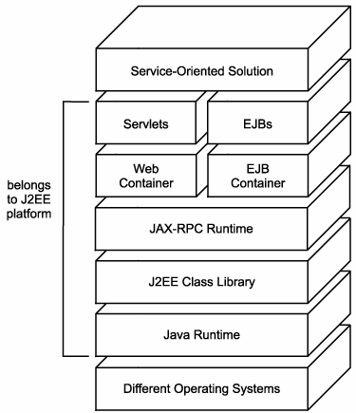

The components shown in Figure 5.37 inter-relate with other parts of the overall J2EE environment (as shown in Figure 5.38) to provide a platform capable of realizing SOA.

Figure 5.38. How parts of the J2EE platform inter-relate.
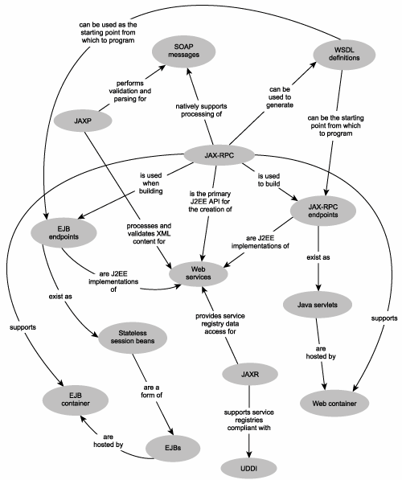

Overview of some key J2EE specifications
There are many J2EE standards published by Sun Microsystems that establish the parts of the J2EE architecture to which vendors that implement and build products around this environment must conform. Three of the more significant specifications that pertain to SOA are listed here:
- Java 2 Platform Enterprise Edition Specification This important specification establishes the distributed J2EE component architecture and provides foundation standards that J2EE product vendors are required to fulfill in order to claim J2EE compliance.
- Java API for XML-based RPC (JAX-RPC) This document defines the JAX-RPC environment and associated core APIs. It also establishes the Service Endpoint Model used to realize the JAX-RPC Service Endpoint, one of the primary types of J2EE Web services (explained later).
- Web Services for J2EE The specification that defines the vanilla J2EE service architecture and clearly lays out what parts of the service environment can be built by the developer, implemented in a vendor-specific manner, and which parts must be delivered according to J2EE standards.

Architecture components
J2EE solutions inherently are distributed and therefore componentized. The following types of components can be used to build J2EE Web applications:
- Java Server Pages (JSPs) Dynamically generated Web pages hosted by the Web server. JSPs exist as text files comprised of code interspersed with HTML.
- Struts An extension to J2EE that allows for the development of Web applications with sophisticated user-interfaces and navigation.
- Java Servlets These components also reside on the Web server and are used to process HTTP request and response exchanges. Unlike JSPs, servlets are compiled programs.
- Enterprise JavaBeans (EJBs) The business components that perform the bulk of the processing within enterprise solution environments. They are deployed on dedicated application servers and can therefore leverage middleware features, such as transaction support.
While the first two components are of more relevance to establishing the presentation layer of a service-oriented solution, the latter two commonly are used to realize Web services.

Runtime environments
The J2EE environment relies on a foundation Java runtime to process the core Java parts of any J2EE solution. In support of Web services, J2EE provides additional runtime layers that, in turn, supply additional Web services specific APIs (explained later). Most notable is the JAX-RPC runtime, which establishes fundamental services, including support for SOAP communication and WSDL processing.
Additionally, implementations of J2EE supply two types of component containers that provide hosting environments geared toward Web services-centric applications that are generally EJB or servlet-based.
- EJB container This container is designed specifically to host EJB components, and it provides a series of enterprise-level services that can be used collectively by EJBs participating in the distributed execution of a business task. Examples of these services include transaction management, concurrency management, operation-level security, and object pooling.
- Web container A Web container can be considered an extension to a Web server and is used to host Java Web applications consisting of JSP or Java servlet components. Web containers provide runtime services geared toward the processing of JSP requests and servlet instances.

Programming languages
As its name implies, the Java 2 Platform Enterprise Edition is centered around the Java programming language. Different vendors offer proprietary development products that provide an environment in which the standard Java language can be used to build Web services.
Examples of currently available development tools are Rational Application Developer from IBM, Java Studio from Sun Microsystems, and JDeveloper from Oracle.

APIs
J2EE contains several APIs for programming functions in support of Web services. The classes that support these APIs are organized into a series of packages. Here are some of the APIs relevant to building SOA.
- Java API for XML Processing (JAXP) This API is used to process XML document content using a number of available parsers. Both Document Object Model (DOM) and Simple API for XML (SAX) compliant models are supported, as well as the ability to transform and validate XML documents using XSLT stylesheets and XSD schemas. Example packages include:
  - javax.xml.parsersA package containing classes for different vendor-specific DOM and SAX parsers.
  - org.w3c.dom and org.xml.saxThese packages expose the industry standard DOM and SAX document models.
  - javax.xml.transformA package providing classes that expose XSLT transformation functions.
- Java API for XML-based RPC (JAX-RPC) The most established and popular SOAP processing API, supporting both RPC-literal and document-literal request-response exchanges and one-way transmissions. Example packages that support this API include:
  - javax.xml.rpc and javax.xml.rpc.serverThese packages contain a series of core functions for the JAX-RPC API.
  - javax.xml.rpc.handler and javax.xml.rpc.handler.soapAPI functions for runtime message handlers are provided by these collections of classes. (Handlers are discussed shortly in the Service agents section.)
  - javax.xml.soap and javax.xml.rpc.soapAPI functions for processing SOAP message content and bindings.
- Java API for XML Registries (JAXR) An API that offers a standard interface for accessing business and service registries. Originally developed for ebXML directories, JAXR now includes support for UDDI.
  - javax.xml.registryA series of registry access functions that support the JAXR API.
  - javax.xml.registry.infomodelClasses that represent objects within a registry.
- Java API for XML Messaging (JAXM) An asynchronous, document-style SOAP messaging API that can be used for one-way and broadcast message transmissions (but can still facilitate synchronous exchanges as well).
- SOAP with Attachments API for Java (SAAJ) Provides an API specifically for managing SOAP messages requiring attachments. The SAAJ API is an implementation of the SOAP with Attachments (SwA) specification.
- Java Architecture for XML Binding API (JAXB) This API provides a means of generating Java classes from XSD schemas and further abstracting XML-level development.
- Java Message Service API (JMS) A Java-centric messaging protocol used for traditional messaging middleware solutions and providing reliable delivery features not found in typical HTTP communication.
Of these APIs, the two most commonly used for SOA are JAX-RPC to govern SOAP messaging and JAXP for XML document processing. The two other packages relevant to building the business logic for J2EE Web services are javax.ejb and javax.servlet, which provide fundamental APIs for the development of EJBs and servlets.

Service providers
J2EE Web services are typically implemented as servlets or EJB components. Each option is suitable to meet different requirements but also results in different deployment configurations, as explained here:
- JAX-RPC Service Endpoint When building Web services for use within a Web container, a JAX-RPC Service Endpoint is developed that frequently is implemented as a servlet by the underlying Web container logic. Servlets are a common incarnation of Web services within J2EE and most suitable for services not requiring the features of the EJB container.
- EJB Service Endpoint The alternative is to expose an EJB as a Web service through an EJB Service Endpoint. This approach is appropriate when wanting to encapsulate existing legacy logic or when runtime features only available within an EJB container are required. To build an EJB Service Endpoint requires that the underlying EJB component be a specific type of EJB called a Stateless Session Bean.
A frequent point of confusion is the naming of the JAX-RPC Service Endpoint and the JAX-RPC runtime. Many initially assume that the JAX-RPC runtime is associated only with the JAX-RPC Service Endpoint and the Web container. However, because JAX-RPC establishes a standardized service processing layer that spans both Web and EJB containers, its runtime applies to both JAX-RPC Service Endpoints and EJB Service Endpoints.
- Service Endpoint Interface (SEI) A Java-based interpretation of the WSDL definition that is required to follow the JAX-RPC WSDL-to-Java mapping rules to ensure consistent representation.
- Service Implementation Bean A class that is built by a developer to house the custom business logic of a Web service. The Service Implementation Bean can be implemented as an EJB Endpoint (Stateless Session Bean) or a JAX-RPC Endpoint (servlet). For an EJB Endpoint, it is referred to as an EJB Service Implementation Bean and therefore resides in the EJB container. For the JAX-RPC Endpoint, it is called a JAX-RPC Service Implementation Bean and is deployed in the Web container.
Figure 5.37 illustrates how the J2EE components fit into our familiar service provider model.

Figure 5.37. A typical J2EE service provider.
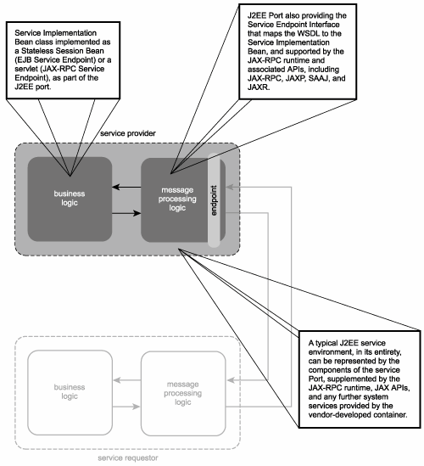

Service requestors
The JAX-RPC API also can be used to develop service requestors. It provides the ability to create three types of client proxies, as explained here:
- Generated stub The generated stub (or just "stub") is the most common form of service client. It is auto-generated by the JAX-RPC compiler (at design time) by consuming the service provider WSDL, and producing a Java-equivalent proxy component. Specifically, the compiler creates a Java remote interface for every WSDL portType which exposes methods that mirror WSDL operations. It further creates a stub based on the WSDL port and binding constructs. The result is a proxy component that can be invoked as any other Java component. JAX-RPC takes care of translating communication between the proxy and the requesting business logic component into SOAP messages transmitted to and received from the service provider represented by the WSDL.
- Dynamic proxy and dynamic invocation interface Two variations of the generated stub are also supported. The dynamic proxy is similar in concept, except that the actual stub is not created until its methods are invoked at runtime. Secondly, the dynamic invocation interface bypasses the need for a physical stub altogether and allows for fully dynamic interaction between a Java component and a WSDL definition at runtime.
Figure 5.38 explains how J2EE technologies work together within the service requestor model.

Figure 5.38. A typical J2EE service requestor.

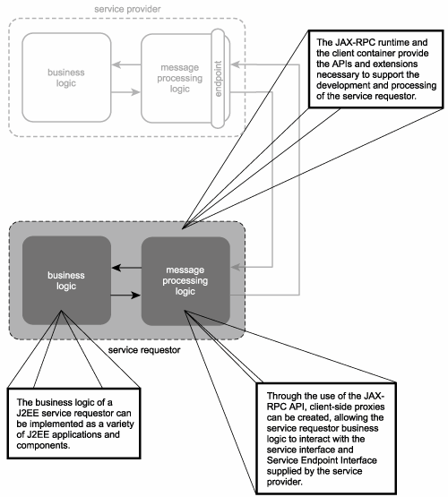

Service agents
Vendor implementations of J2EE platforms often employ numerous service agents to perform a variety of runtime filtering, processing, and routing tasks. A common example is the use of service agents to process SOAP headers.
To support SOAP header processing, the JAX-RPC API allows for the creation of specialized service agents called handlers (Figure 5.38)runtime filters that exist as extensions to the J2EE container environments. Handlers can process SOAP header blocks for messages sent by J2EE service requestors or for messages received by EJB Endpoints and JAX-RPC Service Endpoints.

Figure 5.39 J2EE handlers as service agents.
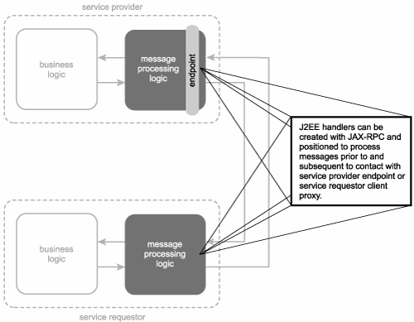

Multiple handlers can be used to process different header blocks in the same SOAP message. In this case the handlers are chained in a predetermined sequence (appropriately called a handler chain).

Platform extensions
Different vendors that implement and build around the J2EE platform offer various platform extensions in the form of SDKs that extend their development tool offering. The technologies supported by these toolkits, when sufficiently mature, can further support contemporary SOA. Following are two examples of currently available platform extensions.
- IBM Emerging Technologies Toolkit A collection of extensions that provide prototype implementations of a number of fundamental WS-* extensions, including WS-Addressing, WS-ReliableMessaging, WS-MetadataExchange, and WS-Resource Framework.
- Java Web Services Developer Pack A toolkit that includes both WS-* support as well as the introduction of new Java APIs. Examples of the types of extensions provided include WS-Security (along with XML-Signature), and WS-I Attachments.
- The WS-Resource Framework consists of a collection of specifications (WS-ResourceProperties, WS-ResourceLifetime, WS-BaseFaults, and WS-Service-Group) that establish a means of managing state information associated with Web services. For more information, visit www.specifications.ws.

Primitive SOA support
The J2EE platform provides a development and runtime environment through which all primitive SOA characteristics can be realized, as follows.

Service encapsulation
The distributed nature of the J2EE platform allows for the creation of independent units of processing logic through Enterprise Java Beans or servlets. EJBs or servlets can contain small or large amounts of application logic and can be composed so that individual units comprise the processing requirements of a specific business task or an entire solution.
Both EJBs and servlets can be encapsulated using Web services. This turns them into EJB and JAX-RPC Service Endpoints, respectively. The underlying business logic of an endpoint can further compose and interact with non-endpoint EJB and servlet components. As a result, well-defined services can be created in support of SOA.

Loose coupling
The use of interfaces within the J2EE platform allows for the abstraction of metadata from a component's actual logic. When complemented with an open or proprietary messaging technology, loose coupling can be realized. EJB and JAX-RPC Endpoints further establish a standard WSDL definition, supported by J2EE HTTP and SOAP runtime services. Therefore, loose coupling is a characteristic that can be achieved in support of SOA.

Messaging
Prior to the acceptance of Web services, the J2EE platform supported messaging via the JMS standard, allowing for the exchange of messages between both servlets and EJB components. With the arrival of Web services support, the JAX-RPC API provides the means of enabling SOAP messaging over HTTP.
Availability of the SOAP over JMS extension, which supports the delivery of SOAP messages via the JMS protocol as an alternative to HTTP. The primary benefit here is that this approach to data exchange leverages the reliability features provided by the JMS framework. Within SOA this extension can be used by the business logic of a Web service, allowing SOAP messages to be passed through from the message process logic (which generally will rely on HTTP as the transport protocol). Either way, the J2EE platform provides the required messaging support for primitive SOA.

Support for service-orientation principles

Autonomy
For a service to be fully autonomous, it must be able to independently govern the processing of its underlying application logic. A high level of autonomy is more easily achieved when building Web services that do not need to encapsulate legacy logic. JAX-RPC Service Endpoints exist as standalone servlets deployed within the Web container and are generally built in support of newer SOA environments.
EJB Service Endpoints are required to exist as Stateless Session Beans, which supports autonomy within the immediate endpoint logic. However, because EJB Service Endpoints are more likely to represent existing legacy logic (or a combination of new and legacy EJB components), retaining a high level of autonomy can be challenging.

Reusability
The advent of Enterprise Java Beans during the rise of distributed solutions over the past decade established a componentized application design model that, along with the Java programming language, natively supports object-orientation. As a result, reusability is achievable on a component level. Because service-orientation encourages services to be reusable and because a service can encapsulate one or more new or existing EJB components, reusability on a service level comes down to the design of a service's business logic and endpoint.

Statelessness
JAX-RPC Service Endpoints can be designed to exist as stateless servlets, but the JAX-RPC API does provide the means for the servlet to manage state information through the use of the HTTPSession object. It is therefore up to the service designer to ensure that statelessness is maximized and session information is only persisted in this manner when absolutely necessary.
One of the requirements for adapting an EJB component into an EJB Service Endpoint is that it be completely stateless. In the J2EE world, this means that it must be designed as a Stateless Session Bean, a type of EJB that does not manage state but that may still defer state management to other types of EJB components (such as Stateful Session Beans or Entity Beans).

Discoverability
To make a service discoverable, the emphasis is on the endpoint design, in that it must be as descriptive as possible.
Service discovery as part of a J2EE SOA is directly supported through JAXR, an API that provides a programmatic interface to XML-based registries, including UDDI repositories. The JAXR library consists of two separate APIs for publishing and issuing searches against registries.
Note that even if JAXR is used to represent a UDDI registry, it does so by exposing an interface that differs from the standard UDDI API.

Contemporary SOA support
How J2EE standards either automatically support these characteristics or how they can be fulfilled through deliberate application of J2EE technologies is explained.

Based on open standards
The Web services subset of the J2EE platform supports industry standard Web services specifications, including WSDL, SOAP, and UDDI. Further, the API specifications that comprise the J2EE platform are themselves open standards, which further promotes vendor diversity

Supports vendor diversity
Java application logic can be developed with one tool and then ported over to another. Similarly, Java components can be designed for deployment mobility across different J2EE server products.
Further, by designing services to be WS-I Basic Profile compliant, vendor diversity beyond J2EE platforms is supported. For example, an organization that has built an SOA based on J2EE technology may choose to build another using the .NET framework. Both environments can interoperate if their respective services conform to the same open standards. This also represents vendor diversity.

Intrinsically interoperable
Interoperability is, to a large extent, a quality deliberately designed into a Web service. Aside from service interface design characteristics, conformance to industry-standard Web services specifications is critical to achieving interoperable SOAs, especially when interoperability is required across enterprise domains.
As of version 1.1, the JAX-RPC API is fully capable of creating WS-I Basic Profile-compliant Web services
IBM's Rational Application Developer provides built-in support for building WS-I compliant Web services. Further, the Wscompile tool, which is part of the J2EE SDK from Sun Microsystems, allows for the auto-generation of WS-I Basic Profile compliant WSDL definitions.

Promotes federation
Strategically positioned services coupled with adapters that expose legacy application logic can establish a degree of federation. Building integration architecture with custom business services and legacy wrapper services can be achieved using basic J2EE APIs and features. Supplementing such an architecture with an orchestration server (and an accompanying orchestration service layer) further increases the potential of unifying and standardizing integrated logic
Also worth taking into consideration is the J2EE Connector Architecture (JCA), a structured, adapter-centric integration architecture through which resource adapters are used to bridge gaps between J2EE platforms and other environments. As with JMS, JCA is traditionally centered around the use of proprietary messaging protocols and platform-specific adapters.

Architecturally composable
Given the modular nature of supporting API packages and classes and the choice of service-specific containers, the J2EE platform is intrinsically composable. This allows solution designers to use only the parts of the platform required for a particular application. For example, a Web services solution that only consists of JAX-RPC Service Endpoints will likely not have a need for the JMS class packagesora J2EE SOA that does not require a service registry will not implement any part of the JAXR API.

Extensibility
As with any service-oriented solution, those based on the J2EE platform can be designed with services that support the notion of future extensibility. This comes down to fundamental design characteristics that impose conventions and structure on the service interface level.
Because J2EE environments are implemented by different vendors, extensibility can sometimes lead to the use of proprietary extensions. While still achieving extensibility within the vendor environment, this can limit the portability and openness of Java solutions.

Supports service-oriented business modeling
This is primarily because the concept of orchestration is not a native part of the J2EE platform. Instead, orchestration services and design tools are provided by vendors to supplement the J2EE Web services development and runtime environment. Service-oriented business modeling and the service layers we've discussed in this book can therefore be created with the right vendor tools.

Logic-level abstraction
JAX-RPC Service Endpoints and EJB Service Endpoints can be designed into service layers that abstract application-specific or reusable logic. Depending on the vendor server platform used, some limitations may be encountered when building service compositions that require message-level security measures. These limitations may inhibit the extent of feasible logic-level abstraction.

Organizational agility and enterprise-wide loose coupling
The creation of these service layers is possible with the help of a vendor-specific orchestration server. Although the orchestration offering is proprietary, the fact that other Web services are J2EE standardized further promotes an aspect of agility realized through the vendor diverse nature of the J2EE marketplace.
For example, if a vendor server platform is not satisfying current business needs and requires replacement, application, entity-centric, and task-centric services likely will be sufficiently mobile so that they can be used in the replacement environment. The orchestration logic may or may not be portable, depending on whether a common orchestration language, such as WS-BPEL, was used to express the process logic.
To attain a state where business and technology domains of an enterprise are loosely coupled and achieve full, two-way agility, requires the fulfillment of a number of contemporary SOA characteristics identified in this book. The J2EE platform provides a foundation upon which to build a standardized and extensible SOA. Enterprise features offered by vendor platforms need to be incorporated to add layers on top of this foundation necessary to driving service-orientation across the enterprise.

