UNIT III SERVICE ORIENTED ARCHITECTURE
Characteristics of SOA, Comparing SOA with Client-Server and Distributed architectures – Benefits of SOA -- Principles of Service orientation – Service layers.
Introduction to SOA
- Service-oriented architecture (SOA) is a flexible set of design principles used during the phases of systems development and integration in computing
- SOA also generally provides a way for consumers of services, such as web-based applications, to be aware of available SOA-based services. XML is commonly used for interfacing with SOA services, though this is not required.
- SOA defines how to integrate widely dissimilar applications for a Web-based environment and uses multiple implementation platforms. An endpoint is the entry point for such a SOA implementation.
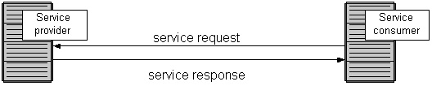

- Service-orientation requires loose coupling of services with operating systems, and other technologies that underlie applications.
- The SOA implementations rely on a mesh of software services. Services comprise unassociated, loosely coupled units of functionality that have no calls to each other embedded in them. Each service implements one action, such as filling out an online application for an account, or viewing an online bank statement, or placing an online booking or airline ticket order.
- SOA developers associate individual SOA objects by using orchestration (coordination). In the process of orchestration the developer associates software functionality (the services) in a non-hierarchical arrangement using a software tool that contains a complete list of all available services, their characteristics, and the means to build an application utilizing these sources.
- Programmers have made extensive use of XML in SOA to structure data that they wrap in a nearly exhaustive description-container. The Web Services Description Language (WSDL) typically describes the services themselves, while the SOAP protocol describes the communications protocols.
- The metadata should come in a form that software systems can use to configure dynamically by discovery and incorporation of defined services, and also to maintain coherence and integrity. For example, metadata could be used by other applications, like a catalogue, to perform auto discovery of services without modifying the functional contract of a service.
- SOA aims to allow users to string together fairly large portions of functionality to form ad hoc applications that are built almost entirely from existing software services. Programmers develop the services themselves using traditional languages like java C++, C#, Visual Basic, COBOL, or PHP.

- Explain the General Principles of SOA (8 marks)
- Standardized Service Contract – Services adhere to a communications agreement, as defined collectively by one or more service-description documents.
- Service Loose Coupling – Services maintain a relationship that minimizes dependencies and only requires that they maintain an awareness of each other.
- Service Abstraction – Beyond descriptions in the service contract, services hide logic from the outside world.
- Service Reusability – Logic is divided into services with the intention of promoting reuse.
- Service Autonomy – Services have control over the logic they encapsulate.
- Service Granularity – A design consideration to provide optimal scope and right granular level of the business functionality in a service operation.
- Service Statelessness - Services minimize resource consumption by deferring the management of state information when necessary
- Service Discoverability – Services are supplemented with communicative meta data by which they can be effectively discovered and interpreted.
- Service Composability – Services are effective composition participants, regardless of the size and complexity of the composition.
- Service Normalization – Services are decomposed and/or consolidated to a level of normal form to minimize redundancy. In some cases, services are denormalized for specific purposes, such as performance optimization, access, and aggregation.
- Service Optimization – All else equal, high-quality services are generally preferable to low-quality ones.
- Service Relevance – Functionality is presented at a granularity recognized by the user as a meaningful service.
- Service Encapsulation – Many services are consolidated for use under the SOA. Often such services were not planned to be under SOA.
- Service Location Transparency – This refers to the ability of a service consumer to invoke a service regardless of its actual location in the network. This also recognizes the discoverability property (one of the core principle of SOA) and the right of a consumer to access the service. Often, the idea of service virtualization also relates to location transparency. This is where the consumer simply calls a logical service while a suitable SOA-enabling runtime infrastructure component, commonly a service bus, maps this logical service call to a physical service.
Web services approach
Web services can implement a service-oriented architecture. Web services make functional building-blocks accessible over standard Internet protocols independent of platforms and programming languages. These services can represent either new applications or just wrappers around existing legacy systems to make them network-enabled.

- Explain the SOA building blocks(8marks)
Each SOA building block can play one or both of two roles:
Service Provider –
- The service provider creates a web service and possibly publishes its interface and access information to the service registry. Each provider must decide which services to expose, how to make trade-offs between security and easy availability, how to price the services, or (if no charges apply) how/whether to exploit them for other value.
- The provider also has to decide what category the service should be listed in for a given broker service and what sort of trading partner agreements are required to use the service. It registers what services are available within it, and lists all the potential service recipients.
- The implementer of the broker then decides the scope of the broker. Public brokers are available through the Internet, while private brokers are only accessible to a limited audience, for example, users of a company intranet. Some brokers catalog other brokers. Depending on the business model, brokers can attempt to maximize look-up requests, number of listings for accuracy of the listings.
- The Universal Description Discovery and Integration (UDDI) specification defines a way to publish and discover information about Web services. Other service broker technologies include (for example) ebXML (Electronic Business using eXtensible Markup Language) and those based on the ISO/IEC 11179 Metadata Registry(MDR) standard.
Service consumer
- The service consumer or web service client locates entries in the broker registry using various find operations and then binds to the service provider in order to invoke one of its web services. Whichever service the service-consumers need, they have to take it into the brokers, then bind it with respective service and then use it. They can access multiple services if the service provides multiple services.
- Architectures can operate independently of specific technologies.
- Designers can implement SOA using a wide range of technologies, including:
- SOAP - SOAP is an acronym for Simple Object Access Protocol. It is an XML-based messaging protocol for exchanging information among computers. SOAP is an application of the XML specification.
- RPC - Remote Procedure Call (RPC) is a protocol that one program can use to request a service from a program located in another computer in a network without having to understand network details. (A procedure call is also sometimes known as a function call or a subroutine call.) RPC uses the client/server model.
- REST - REpresentational State Transfer is a decoupled architecture, and lighter weight communications between producer and consumer, make REST a popular building style for cloud-based APIs, such as those provided by Amazon, Microsoft, and Google. When Web services use REST architecture, they are called RESTful APIs (Application Programming Interfaces) or REST APIs. REST architecture involves reading a designated Web page that contains an XML file. The XML file describes and includes the desired content. Once dynamically defined, consumers may access the interface. REST, which typically runs over HTTP (Hypertext Transfer Protocol), has several architectural constraints:
- DCOM - Distributed Component Object Model is a set of Microsoft concepts and program interfaces in which client program object s can request services from server program objects on other computers in a network. DCOM is based on the Component Object Model (COM), which provides a set of interfaces allowing clients and servers to communicate within the same compute
- CORBA -The Common Object Request Broker Architecture (CORBA) is a standard defined by the Object Management Group (OMG) designed to facilitate the communication of systems that are deployed on diverse platforms.
- Web Services
- DDS - The Data Distribution Service for Real-Time Systems (DDS) is an Object Management Group (OMG) machine-to-machine middleware "m2m" standard that aims to enable scalable, real-time, dependable, high-performance and interoperable data exchanges between publishers and subscribers. DDS addresses the needs of applications like financial trading, air-traffic control, smart grid management, and other big data applications. The standard is used in applications such as smartphone operating systems, transportation systems and vehicles, software-defined radio, and by healthcare providers. DDS may also be used in certain implementations of the Internet of Things.
- WCF (Microsoft's implementation of Web Services now forms a part of WCF) -Windows Communication Foundation (WCF) is a framework for building service-oriented applications. Using WCF, you can send data as asynchronous messages from one service endpoint to another. A service endpoint can be part of a continuously available service hosted by IIS, or it can be a service hosted in an application.
- Implementations can use one or more of these protocols and, for example, might use a file-system mechanism to communicate data conforming to a defined interface-specification between processes conforming to the SOA concept. The key is independent services with defined interfaces that can be called to perform their tasks in a standard way, without a service having foreknowledge of the calling application, and without the application having or needing knowledge of how the service actually performs its tasks.
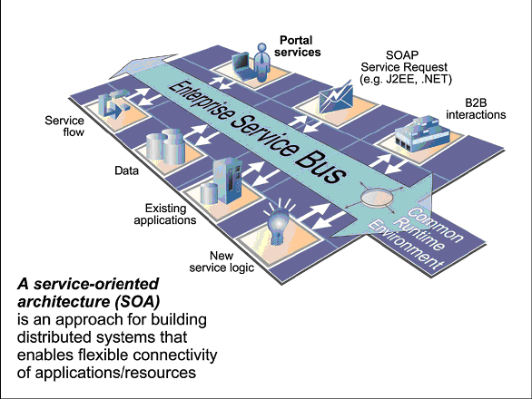

- What are the Elements of SOA (8marks)
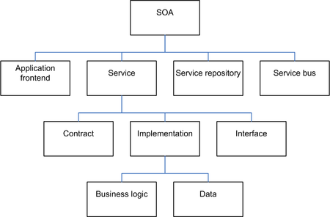
SOA Meta Model
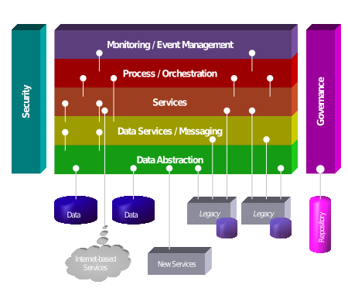

What are the Characteristics of SOA ( 2 marks)

Services are discoverable and dynamically bound.

Services are self-contained and modular.

Services stress interoperability.

Services are loosely coupled.

Services have a network-addressable interface.

Services have coarse-grained interfaces.

Services are location-transparent

Services are composable.

Service-oriented architecture supports self-healing.

- Explain the common characteristic of contemporary SOA (IT2401/MAY/JUN/2012) (16 marks)
Contemporary SOA represents an open, extensible, federated, composable architecture that promotes service-orientation and is comprised of autonomous, QoS-capable, vendor diverse, interoperable, discoverable, and potentially reusable services, implemented as Web services.
The following primary characteristics:
- Contemporary SOA is at the core of the service-oriented computing platform.
- Contemporary SOA increases quality of service.
- Contemporary SOA is fundamentally autonomous.
- Contemporary SOA is based on open standards.
- Contemporary SOA supports vendor diversity.
- Contemporary SOA fosters intrinsic interoperability.
- Contemporary SOA promotes discovery.
- Contemporary SOA promotes federation.
- Contemporary SOA promotes architectural composability.
- Contemporary SOA fosters inherent reusability.
- Contemporary SOA emphasizes extensibility.
- Contemporary SOA supports a service-oriented business modeling paradigm.
- Contemporary SOA implements layers of abstraction.
- Contemporary SOA promotes loose coupling throughout the enterprise.
- Contemporary SOA promotes organizational agility.
- Contemporary SOA is a building block.
- Contemporary SOA is an evolution.
- Contemporary SOA is still maturing.
- Contemporary SOA is an achievable ideal.

- Contemporary SOA is at the core of the service-oriented computing platform.
  - Contemporary SOA represents an architecture that promotes service-orientation through the use of Web services.
- Contemporary SOA increases quality of service.
- There is a need to bring SOA to a point where it can implement enterprise-level functionality as safely and reliably as the more established distributed architectures already do.
- The ability for tasks to be carried out in a secure manner, protecting the contents of a message, as well as access to individual services.
- Allowing tasks to be carried out reliably so that message delivery or notification of failed delivery can be guaranteed.
- Performance requirements to ensure that the overhead imposed by SOAP message and XML content processing does not inhibit the execution of a task.
- Transactional capabilities to protect the integrity of specific business tasks with a guarantee that should the task fail, exception logic is executed.
- Contemporary SOA is fundamentally autonomous.
  - Requires that individual services be as independent and self-contained as possible with respect to the control they maintain over their underlying logic.
  - This is further realized through message-level autonomy where messages passed between services are sufficiently intelligence-heavy that they can control the manner in which they are processed by recipient services.
  - SOA builds upon and expands this principle by promoting the concept of autonomy throughout solution environments and the enterprise
- Contemporary SOA is based on open standards.

Significant characteristic of Web services is the fact that data exchange is governed by open standards.

After a message is sent from one Web service to another it travels via a set of protocols that is globally standardized and accepted. i.e. the message itself is standardized, both in format and in how it represents its payload.

Figure-3.1. Standard open technologies are used within and outside of solution boundaries.
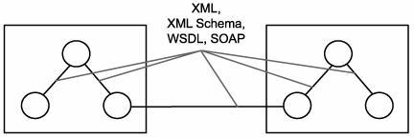
- Contemporary SOA supports vendor diversity.

The open communications framework has significant implications for bridging much of the heterogeneity within (and between) corporations, but it also allows organizations to choose best-of-breed environments for specific applications
- For example, regardless of how proprietary a development environment is, as long as it supports the creation of standard Web services, it can be used to create a non-proprietary service interface layer, opening up interoperability opportunities with other, service-capable applications (shown in Figure)

Figure-3.2. Dissimilar technology platforms do not prevent service-oriented solutions from interoperating.
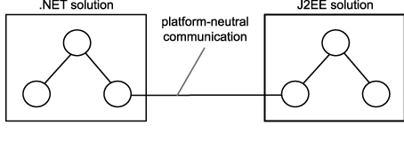
- Contemporary SOA promotes discovery.
  - The first generation of Web services standards included UDDI, few of the early implementations actually used service registries as part of their environments.
  - This may have to do with the fact that not enough Web services were actually built to warrant a registry.
  - When utilized within traditional distributed architectures, Web services were more often employed to facilitate point-to-point solutions. Therefore, discovery was not a common concern.
  - SOA supports and encourages the advertisement and discovery of services throughout the enterprise and beyond. A serious SOA will likely rely on some form of service registry or directory to manage service descriptions
Figure-3.3. Registries enable a mechanism for the discovery of services. 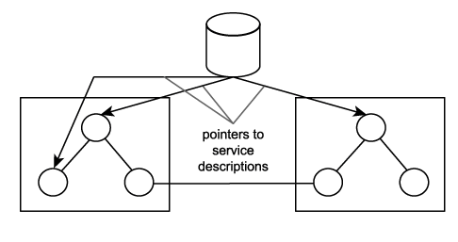
- Contemporary SOA fosters intrinsic interoperability.
- An application actually has immediate integration requirements.
- Design principles can be applied to outfit services with characteristics that naturally promote interoperability.
- When building an SOA application from the ground up, services with intrinsic interoperability become potential integration endpoints (Figure).
- When properly standardized, this leads to service-oriented integration architectures wherein solutions themselves achieve a level of intrinsic interoperability.
- Fostering this characteristic can significantly alleviate the cost and effort of fulfilling future cross-application integration requirements
Figure-3.4. intrinsically interoperable services enable unforeseen integration opportunities.
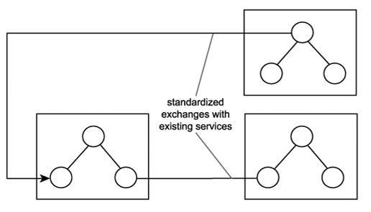
- Contemporary SOA promotes federation.
  - One of the most attractive aspects of this architecture is its ability to introduce unity across previously non-federated environments. While Web services enable federation, SOA promotes this cause by establishing and standardizing the ability to encapsulate legacy and non-legacy application logic and by exposing it via a common, open, and standardized communications framework (also supported by an extensive adapter technology marketplace).
  - However, the key aspect is that the communication channels achieved by this form of service-oriented integration are all uniform and standardized (Figure-3.5).

Figure-3.5 Services enable standardized federation of disparate legacy systems.
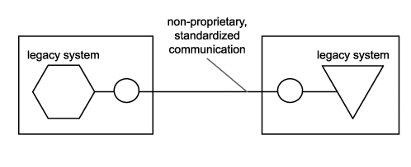
- Contemporary SOA promotes architectural composability.
  - Composability is a deep-rooted characteristic of SOA that can be realized on different levels.
  - SOA supports the automation of flexible and highly adaptive business processes. Services exist as independent units of logic. A business process can therefore be broken down into a series of services, each responsible for executing a portion of the process.
  - A broader example of composability is represented by the second-generation Web services framework that is evolving out of the release of the numerous WS-* specifications. The modular nature of these specifications allows an SOA to be composed of only the functional building blocks it requires.
  - Individual specifications consist of modular extensions that provide one or more specific features. As the offering of WS-* extensions supported by a given vendor platform grows, the flexibility to compose allows you to continue building solutions that only implement the features you actually need (Figure 3.6).
  - In other words, the WS-* platform allows for the creation of streamlined and optimized service-oriented architectures, applications, services, and even messages.

Figure-3.6. Different solutions can be composed of different extensions and can continue to interoperate as long as they support the common extensions required.
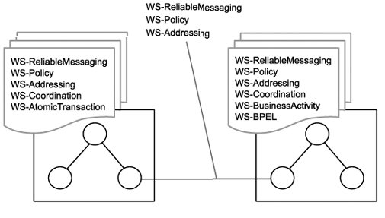
- Contemporary SOA fosters inherent reusability.
  - SOA establishes an environment that promotes reuse on many levels. For example, services designed according to service-orientation principles are encouraged to promote reuse, even if no immediate reuse requirements exist. Collections of services that form service compositions can themselves be reused by larger compositions.
  - The emphasis placed by SOA on the creation of services that are agnostic to both the business processes and the automation solutions that utilize them leads to an environment in which reuse is naturally realized as a side benefit to delivering services for a given project. Thus, inherent reuse can be fostered when building service-oriented solutions (Figure-3.7).

Figure-3.7 Inherent reuse accommodates unforeseen reuse opportunities.
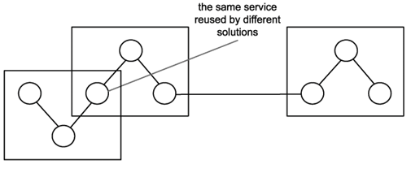
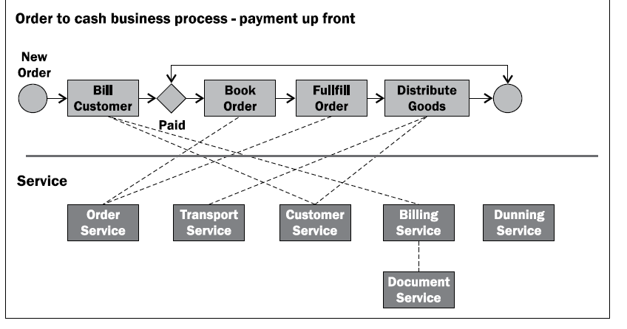
- Contemporary SOA emphasizes extensibility.
  - SOA encourages you to think beyond immediate, point-to-point communication requirements. When service logic is properly partitioned via an appropriate level of interface granularity, the scope of functionality offered by a service can sometimes be extended without breaking the established interface (Figure-3.8).

Figure-3.8. Extensible services can expand functionality with minimal impact.
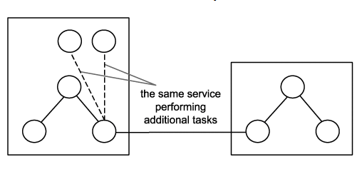
  - Extensibility is also a characteristic that is promoted throughout SOA as a whole. Extending entire solutions can be accomplished by adding services or by merging with other service-oriented applications (which also, effectively, "adds services"). Because the loosely coupled relationship fostered among all services minimizes inter-service dependencies, extending logic can be achieved with significantly less impact.
- Contemporary SOA supports a service-oriented business modeling paradigm.
  - Partitioning business logic into services that can then be composed has significant implications as to how business processes can be modeled (Figure 1.9).
  - Analysts can leverage these features by incorporating an extent of service-orientation into business processes for implementation through SOAs. In other words, services can be designed to express business logic. BPM models, entity models, and other forms of business intelligence can be accurately represented through the coordinated composition of business-centric services

Figure-3.9. A collection (layer) of services encapsulating business process logic.
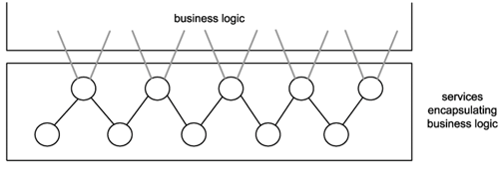
- Contemporary SOA implements layers of abstraction.
  - One of the characteristics that tends to evolve naturally through the application of service-oriented design principles is that of abstraction. Typical SOAs can introduce layers of abstraction by positioning services as the sole access points to a variety of resources and processing logic.
  - When applied through proper design, abstraction can be targeted at business and application logic. For example, by establishing a layer of endpoints that represent entire solutions and technology platforms, all of the proprietary details associated with these environments disappear (Figure-3.10).

Figure-3.10. Application logic created with proprietary technology can be abstracted through a dedicated service layer.
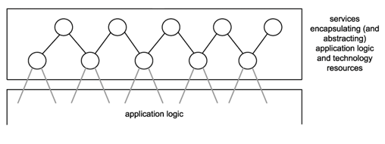
- Contemporary SOA promotes loose coupling throughout the enterprise.
  - Within an organization where service-orientation principles are applied to both business modeling and technical design, the concept of loose coupling is amplified.
  - By implementing standardized service abstraction layers, a loosely coupled relationship also can be achieved between the business and application technology domains of an enterprise (Figure-3.11).
  - Each end only requires an awareness of the other, therefore allowing each domain to evolve more independently. The result is an environment that can better accommodate business and technology-related change quality known as organizational agility.

Figure-3.11. through the implementation of service layers that abstract business and application logic, the loose coupling paradigm can be applied to the enterprise as a whole.
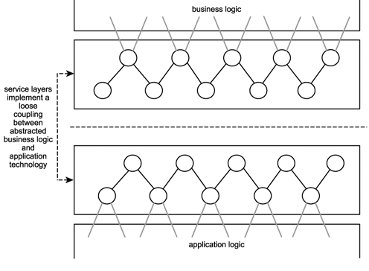
- Contemporary SOA promotes organizational agility.
  - Change in an organization's business logic can impact the application technology that automates it. Change in an organization's application technology infrastructure can impact the business logic automated by this technology. The more dependencies that exist between these two parts of an enterprise, the greater the extent to which change imposes disruption and expense.
  - By influencing service business representation, service abstraction, and the loose coupling between business and application logic provided through the use of service layers, SOA offers the potential to increase organizational agility (Figure 3.12).

Figure 3.12. A loosely coupled relationship between business and application technology allows each end to more efficiently respond to changes in the other.
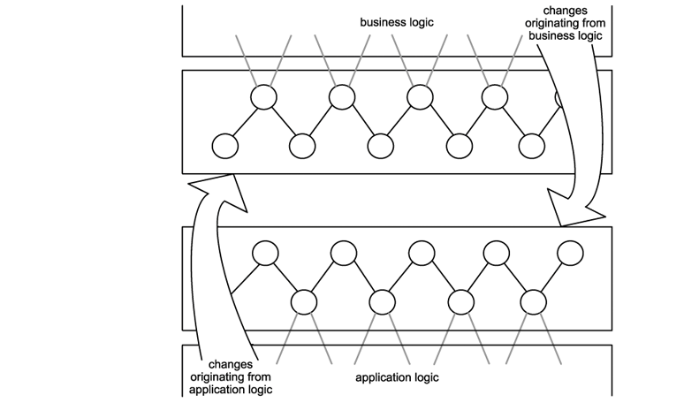
- Contemporary SOA is a building block.
  - A service-oriented application architecture will likely be one of several within an organization committed to SOA as the standard architectural platform.
  - Organizations standardizing on SOA work toward an ideal known as the service-oriented enterprise (SOE), where all business processes are composed of and exist as services, both logically and physically.
  - SOAs can be augmented to change the nature of their automation, or they can be pulled into service-oriented integration architectures that require the participation of multiple applications.
  - An SOA consists of services within services within services, to the point that a solution based on SOA itself is one of many services within an SOE.
  - SOA can establish an abstraction of business logic and technology that may introduce changes to business process modeling and technical architecture, resulting in a loose coupling between these models. These changes foster service-orientation in support of a service-oriented enterprise
- Contemporary SOA is an evolution.
  - SOA defines an architecture that is related to but still distinct from its predecessors. It differs from traditional client-server and distributed environments in that it is heavily influenced by the concepts and principles associated with service-orientation and Web services. It is similar to previous platforms in that it preserves the successful characteristics of its predecessors and builds upon them with distinct design patterns and a new technology set.
  - For example, SOA supports and promotes reuse, as well as the componentization and distribution of application logic. These and other established design principles that are commonplace in traditional distributed environments are still very much a part of SOA.
- Contemporary SOA is still maturing.
  - Even though SOA is being positioned as the next standard application computing platform, this transition is not yet complete. Despite the fact that Web services are being used to implement a great deal of application functionality, the support for a number of features necessary for enterprise-level computing is not yet fully available.
  - When SOA platforms and tools reach an adequate level of maturity, the utilization of Web services can be extended to support the creation of enterprise SOA solutions, making the ideal of a service-oriented enterprise attainable.
- Contemporary SOA is an achievable ideal.
  - A standardized enterprise-wide adoption of SOA is a state to which many organizations would like to fast-forward. The reality is that the process of transitioning to this state demands an enormous amount of effort, discipline, and, depending on the size of the organization, a good amount of time. Every technical environment will undergo changes during such a migration, and various parts of SOA will be phased in at different stages and to varying extents.
  - As companies adopt SOA during this evolution, many will need to retrofit their environments (and their standards) to accommodate changes and innovations as SOA-related specifications, standards, and products continue to mature.
- Defining SOA (2 marks)
- Contemporary SOA represents an open, agile, extensible, federated, composable architecture comprised of autonomous, QoS-capable, vendor diverse, interoperable, discoverable, and potentially reusable services, implemented as Web services.
- SOA can establish an abstraction of business logic and technology that may introduce changes to business process modeling and technical architecture, resulting in a loose coupling between these models.
- SOA is a form of technology architecture that adheres to the principles of service-orientation. When realized through the Web services technology platform, SOA establishes the potential to support and promote these principles throughout the business process and automation domains of an enterprise.
- Compare SOA to client server and distributed architecture(IT2401/NOV/DEC/2011) (IT2401/NOV/DEC/2012) (IT2401/MAY/JUN/2013) (IT2401/NOV/DEC/2014) (16 marks)

What is architecture?
The software architecture of a system is the set of structures needed to reason about the system, which comprise software elements, relations among them, and properties of both. The term also refers to documentation of a system's software architecture. Documenting software architecture facilitates communication between stakeholders, documents early decisions about high-level design, and allows reuse of design components and patterns between project

Application architecture
Application architecture is to an application development team what a blueprint is to a team of construction workers. Different organizations document different levels of application architecture. A single architecture document typically represents a distinct solution environment. For example, an organization that houses both .NET and J2EE solutions would very likely have separate application architecture specifications for each.
A key part of any application-level architecture is that it reflects immediate solution requirements, as well as long-term, strategic IT goals

Enterprise architecture
In larger IT environments, the need to control and direct IT infrastructure is critical. When numerous, disparate application architectures co-exist and sometimes even integrate, the demands on the underlying hosting platforms can be complex and onerous. Therefore, it is common for a master specification to be created, providing a high-level overview of all forms of heterogeneity that exist within an enterprise, as well as a definition of the supporting infrastructure.

Service-oriented architecture
Service-oriented architecture spans both enterprise and application architecture domains. The benefit potential offered by SOA can only be truly realized when applied across multiple solution environments. This is where the investment in building reusable and interoperable services based on a vendor-neutral communications platform can fully be leveraged.
An SOA can refer to application architecture or the approach used to standardize technical architecture across the enterprise. Because of the composable nature of SOA (meaning that individual application-level architectures can be comprised of different extensions and technologies), it is absolutely possible for an organization to have more than one SOA.

Client-server architecture:
- It has three functional units:
  - Presentation logic or user interface (for example, ATM machines)
  - Business logic (for example software that enables a customer to request an account balance)
  - Data (for example, records of customer accounts)
- Functional units can reside on the client or on multiple servers
- Middleware is the software that connects / communicates between client and server
Figure-3.13 A typical single-tier client-server architecture.
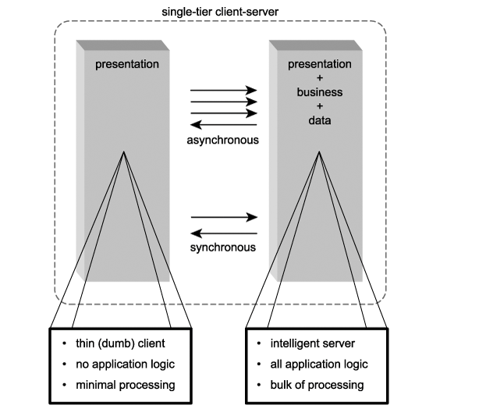
The Mainframes have thin Dumb Terminals. And all processing/data storage on mainframe computer. It has large number of users and also more expensive Mainframe systems natively supported both synchronous and asynchronous communication. Here it allows the server to continuously receive characters from the terminal in response to individual key-strokes.
The concept of delegating (hand over) logic and processing duties onto individual workstations, resulting in the birth of the fat client. Further supported by the innovation of the graphical user-interface (GUI), two-tier client-server was considered. The common configuration of this architecture consisted of multiple fat clients, each with its own connection to a database on a central server. Client-side software performed the bulk of the processing, including all presentation-related and most data access logic (Figure-3.14). One or more servers facilitated these clients by hosting scalable RDBMSs.

Figure-3.14 A typical two-tier client-server architecture.
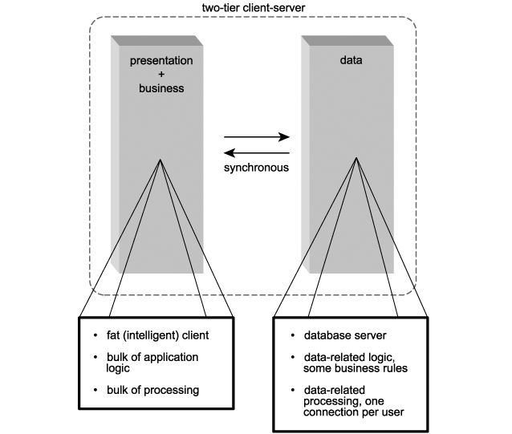

Characteristics of the two-tier client-server architecture\

Asymmetrical protocols

Encapsulation of services

Location transparency

Message-based exchanges

Modular, Extensible design

Platform Independence

Scalability

Separation of Client/Server Functionality

Shared resources

Comparison of SOA with Client Server Architecture

- Application Logic
  - The Client Server architecture include fat client that does bulk of processing and data-related logic and database server lying on the server.
  - In the case of SOA options exist regarding where the application logic can reside and how it is distributed.
Application Processing
  - The Client Server architecture follow 80/20 where bulk of processing is done by the client and other database access and connection pooling is done by the server .
  - In case of SOA, each service has a explicit functional boundary and resource requirement.
Technology
  - Client Server Architecture make use of 4GL programming languages and for performance reasons make use of 3GL programming languages. They also use vendor based RDBMS packages.
  - In case of SOA, XML data representation architecture along with SOAP message framework. It makes use of HTML, CSS,HTTP etc.
Security
  - In case of the client server, the security is centralized at the server side. But security can also be realized on the client side.
  - SOA heavily depends on WS-security framework for security.
Administration
- In client server architecture, the maintenance cost are high and administration problems are also involved.
- SOA is also not that immune to client-side maintenance challenges.

Distributed Internet architecture:
Distributing application logic among multiple components (some residing on the client, others on the server) reduced deployment headaches by centralizing a greater amount of the logic on servers. Server-side components, now located on dedicated application servers, would then share and manage pools of database connections, alleviating the burden of concurrent usage on the database server (Figure-3.15). A single connection could easily facilitate multiple users.

Figure-3.15. A typical multi-tier client-server architecture.
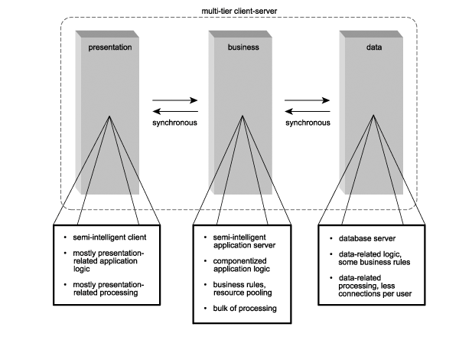
Replacing client-server database connections was the client-server remote procedure call (RPC) connection. RPC technologies such as CORBA and DCOM allowed for remote communication between components residing on client workstations and servers. Issues similar to the client-server architecture problems involving resources and persistent connections emerged. Adding to this was an increased maintenance effort resulting from the introduction of the middleware layer. For example, application servers and transaction monitors required significant attention in larger environments. The multi-tiered client-server environments began incorporating Internet technology. (Figure-3.16).

Figure-3.16. A typical distributed Internet architecture.
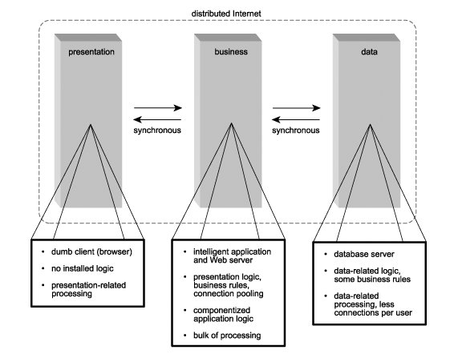
Distributed Internet architecture also introduced a new physical tier, the Web server. This resulted in HTTP replacing proprietary RPC protocols used to communicate between the user's workstation and the server. The role of RPC was limited to enabling communication between remote Web and application servers.

Comparison of SOA with Distributed Internet Architecture
- Distributed architecture consists of many components but it reduces problem of centralization on server. It provides a dedicated server which shares and manages database connections. Distributed architecture introduces a new physical tier web server, which replaced HTTP by RPC protocol to communicate between remote web and application server
Application Logic:
Distributed Internet applications place all of their application logic on the server side. Even client-side scripts intended to execute in response to events on a Web page are downloaded from the Web server upon the initial HTTP request. With none of the logic existing on the client workstation, the entire solution is centralized
- The importance is therefore on:
- how application logic should be partitioned
- where the partitioned units of processing logic should reside
- how the units of processing logic should interact

Figure-3.17. Components rely on proxy stubs for remote communication.
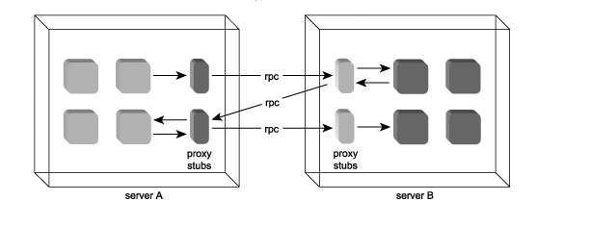

SOA is similar to distributed architecture provider logic lies in server side but difference lies in principles.

Components are tight coupled and processing is wasted to locate component at runtime whereas web services are loosely coupled thus it introduces opportunity for reuse and extensibility.

Application processing

Distributed architecture promotes proprietary protocols like DCOM and CORBA for remote data exchange.

It supports creation of stateful and stateless components.

SOA relies on message based communication, it involves serialization and deserialization of SOAP messages containing XML document payloads

Technology

Distributed computing consists of components, server side scripts and web technologies like HTML and HTTP.

SOA consists of distributed objects using Xml and web services.

Security
- Traditional security architectures includes approaches like delegation and impersonation, encryption to HTTP protocol.
- SOA rely heavily extension and concepts provided by WS-Security framework,
- SOA emphasize on security logic.
- SOAP messages provide header in security logic can be stored.

Administration
- Distributed architecture introduces web server and physical environment using HTTP.
- SOA requires additional runtime administration.
- Problems with messaging framework can go undetected than with RPC based data exchange

Explain SOA vs. hybrid Web service architecture (8 marks)
- Or
- Explain briefly about web services as component wrappers(IT2401/NOV/DEC/2013) (IT2401/MAY/JUN/2015) (IT2401/MAY/JUN/2016)

Web services as component wrappers
The primary role of Web services in this context has been to introduce an integration layer that consists of wrapper services that enable synchronous communication via SOAP-compliant integration channels (Figure-3.18). In fact, the initial release of the SOAP specification and the first generation of SOAP servers were specifically designed to duplicate RPC-style communication using messages.

Figure-3.18. Wrapper services encapsulating components.
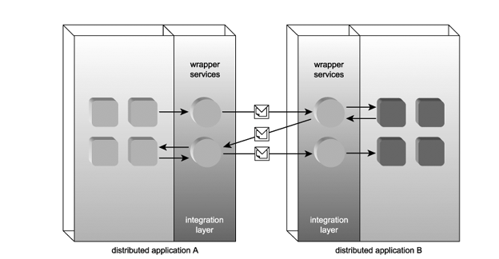
These integration channels are primarily utilized in integration architectures to facilitate communication with other applications or outside partners. They also are used to enable communication with other (more service-oriented) solutions and to take advantage of some of the features offered by third-party utility Web services
Instead of mirroring component interfaces and establishing point-to-point connections with Web services, SOA provides strong support for a variety of messaging models (based on both synchronous and asynchronous exchanges). Additionally, Web services within SOAs are subject to specific design requirements, such as those provided by service-orientation principles. These and other characteristics support the pursuit of consistent loose coupling. Once achieved, a single service is never limited to point-to-point communication; it can accommodate any number of current and future requestors.

Web services within SOA
- SOAs are built with a set of Web services designed to collectively automate (or participate in the automation of) one or more business processes and that SOA promotes the organization of these services into specialized layers that abstract specific parts of enterprise automation logic.
- Web services contain one or more operations.
- Each operation governs the process of a specific function the web service is capable of performing.
- Figure 8.5 gives an example of an operation sending and receiving SOAP messages

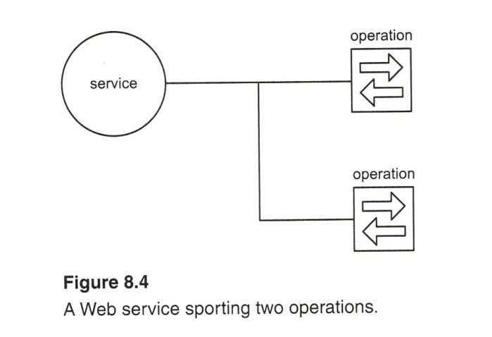
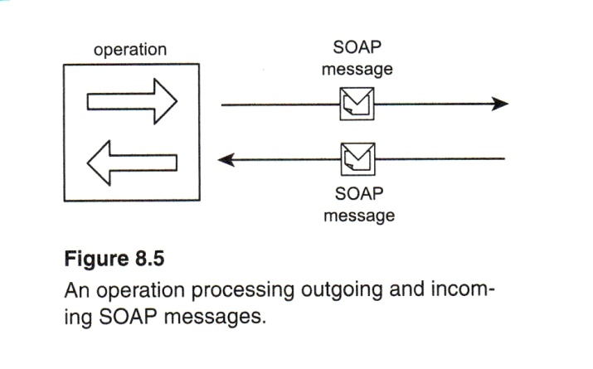
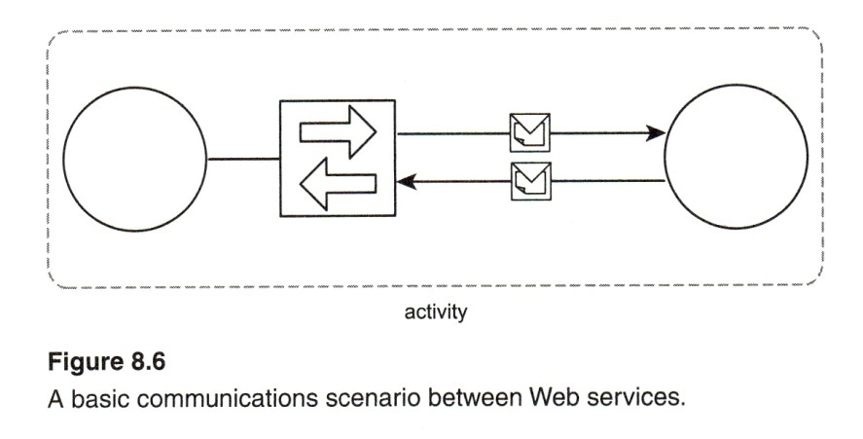

Messages = units of communication

Operations = units of work

Services = units of processing logic

Processes = units of automation logic
The purpose of these views is to express the process, services and operations. Is also provides a flexible means of partitioning and modularizing the logic. These are the most basic concepts that underlie service-orientation.
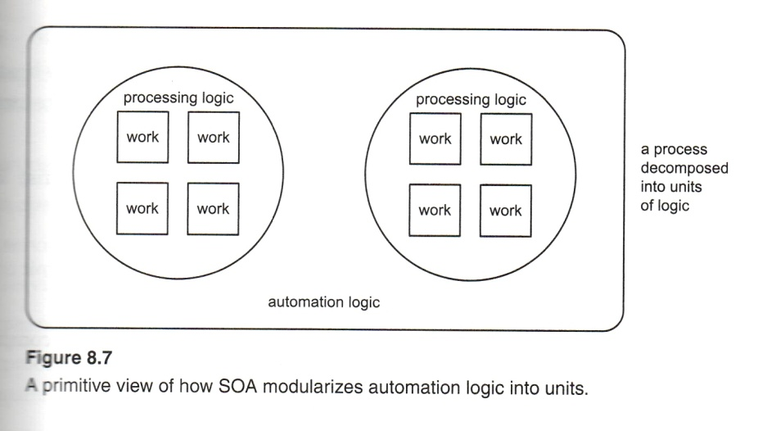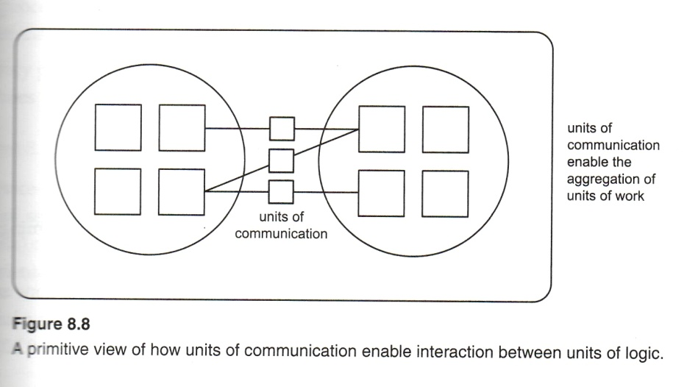

Case Study-1
The TLS accounting system consists of a large, distributed component-based solution. Some 50 odd components host and execute various parts of the application logic. For performance and security reasons, some components have been deployed on separate application servers.
Overall, the execution of a typical accounting task will involve four to five physical layers consisting of:
- A Web server hosting server-side scripts that relay HTTP requests to components on application servers and then relay responses from those components back to the browser clients.
- An application server hosting a controller component that generates a transaction context and manages more specialized components.
- A possible second application server hosting two or more business components that enforce specific business rules and perform various functions related to a particular business context. This server also may host one or more data components that encapsulate the data access logic required to interact with application repositories.
- A database server hosting a complete RDBMS environment.
This enterprise solution has undergone many changes and enhancements over the past few years. Some of the primary issues that have arisen include:
- Initially, many components were custom developed to alter or extend existing functionality. Each redevelopment project has become increasingly expensive. This trend is being blamed on the overhead associated with the amount of testing and redeployment effort required to ensure that all pre-existing dependencies are not affected by any modification to a component's functionality.
- Because state management was never standardized, a design disparity has emerged. Some components manage state information by caching data in memory, while others use application server-deployed databases. This became an issue when XML was first introduced as a standard data format. Permanent state management designs already had a relational storage format in place that was incompatible with the required XML document structures.
- Explain in detail about SOA components and how they are they interrelate (IT2401/NOV/DEC/2012)

Components of an SOA
The components establish a level of enterprise logic abstraction, as follows:
- A message represents the data required to complete some or all parts of a unit of work.
- An operation represents the logic required to process messages in order to complete a unit of work (Figur-1.26).

Figure-3.26 The scope of an operation within a process.
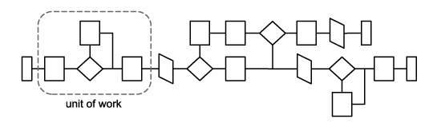
- A service represents a logically grouped set of operations capable of performing related units of work.
- A process contains the business rules that determine which service operations are used to complete a unit of automation. In other words, a process represents a large piece of work that requires the completion of smaller units of work (Figure-3.27).

Figure-3.27. Operations belonging to different services representing various parts of process logic.
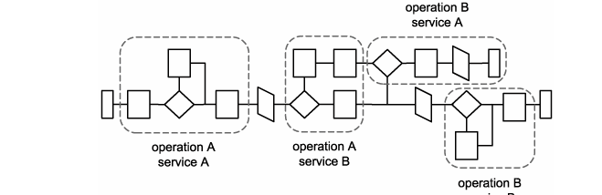

How components in an SOA inter-relate
Having established the core characteristics of our SOA components, let's now look at how these components are required to relate to each other:
- An operation sends and receives messages to perform work.
- An operation is therefore mostly defined by the messages it processes.
- A service groups a collection of related operations.
- A service is therefore mostly defined by the operations that comprise it.
- A process instance can compose services.
- A process instance is not necessarily defined by its services because it may only require a subset of the functionality offered by the services.
- A process instance invokes a unique series of operations to complete its automation.
- Every process instance is therefore partially defined by the service operations it uses. The following Figures -1.28 and 1.29further illustrate these relationships.

Figure-3.28. How the components of a service-oriented architecture relate.
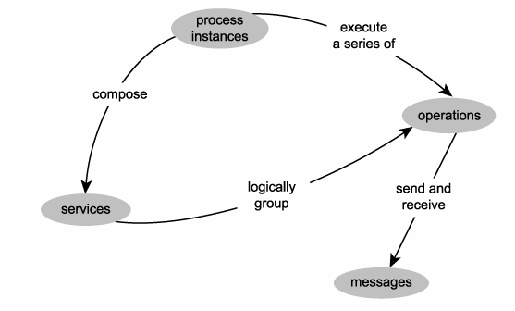

Figure-3.29 How the components of a service-oriented architecture define each other.
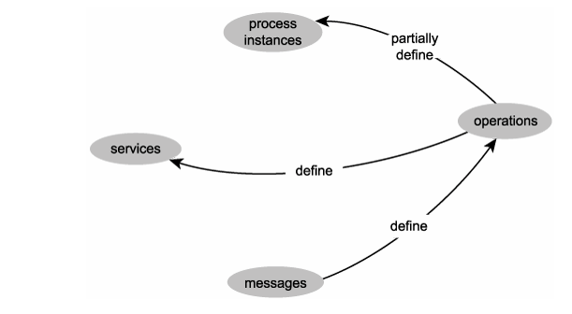
A service-oriented architecture is an environment standardized according to the principles of service-orientation in which a process that uses services (a service-oriented process) can execute.
- Explain the common principles of service orientation in detail with case study (IT2401/NOV/DEC/2011) (IT2401/MAY/JUN/2013) (IT2401/MAY/JUN/2015) (IT2401/MAY/JUN/2016)

Common principles of service-orientation
Service-orientation is said to have its roots in a software engineering theory known as "separation of concerns." The principles of service-orientation provide a means of supporting this theory while achieving a foundation paradigm upon which many contemporary SOA characteristics can be built.

Services are reusable
Service-orientation encourages reuse in all services, regardless if immediate requirements for reuse exist.
- Regardless of whether immediate reuse opportunities exist, services are designed to support potential reuse.
- Service-oriented encourages reuse in all services.
- By applying design standards that require reuse accommodate future requirements with less development effort.

Figure-3.30. A reusable service exposes reusable operations.
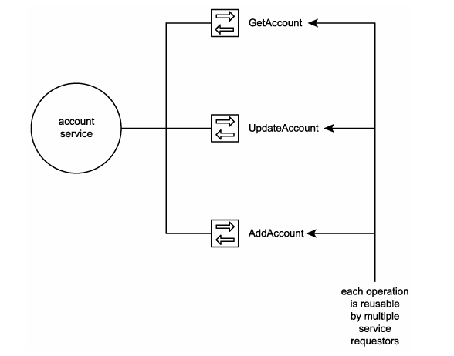
Messaging also indirectly supports service reusability through the use of SOAP headers. These allow for messages to become increasingly self-reliant by grouping metadata details with message content into a single package (the SOAP envelope). Messages can be equipped with processing instructions and business rules that allow them to dictate to recipient services how they should be processed.

Case Study
RailCo delivered the Invoice Submission Service for the sole purpose of being able to connect to TLS's new B2B system. This Web service's primary function therefore is to send electronic invoice documents to the TLS Accounts Payable Service. The service contains the following two operations: SubmitInvoice and GetTLSMetadata (Figure-3.31).

Figure-3.31 The RailCo Invoice Submission Service and its operations.
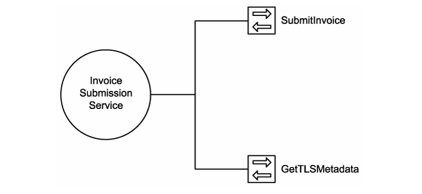
- The SubmitInvoice operation simply initiates the transmission of the invoice document. An operation was added to periodically check the TLS Accounts Payable Service for changes to its service description. This new operation is GetTLSMetadata.Because they were built to meet immediate and specific business requirements, these operations have no real reuse potential. The SubmitInvoice operation is designed to forward SOAP messages containing specific headers required by TLS and containing an invoice XML document structured according to a schema also defined by TLS. By its very name, the GetTLSMetadata operation identifies itself as existing for one reason: to query a specific endpoint for new metadata information.
- The TLS Accounts Payable Service, on the other hand, provides a series of generic operations related to the processing of accounts payable transactions. This service is therefore used by different TLS systems, one of which is the abovementioned B2B solution.

Services share a formal contract
- For services to interact, they need not share anything but formal contract that describe each service and define the terms of information exchange.
- Service contracts provide a formal definition of:
  - The service endpoint
  - Each service operation
  - Every input and output message supported by each operation
  - Rules and characteristics of the service and its operations
- Service contacts define almost all of the primary parts of an SOA.

Figure-3.32. Service contracts formally define the service, operation, and message components of a service-oriented architecture.
Message
Operatione
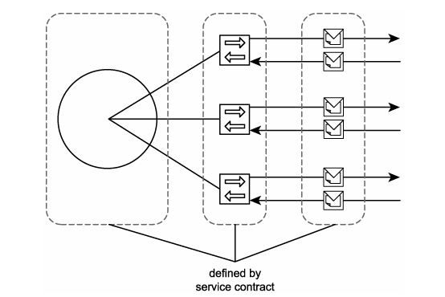
Service

Case Study
- From the onset, RailCo and TLS agreed to each other's service contracts, which enabled these two companies to interact via the TLS B2B system. The rules of the contract and the definition of associated service description documents all are provided by TLS to ensure a standardized level of conformance that applies to each of its online vendors.
- One day, RailCo is informed that TLS has revised the policy published with the Accounts Payable Service. A new rule has been added where TLS is offering better payment terms to vendors in exchange for larger discounts. RailCo has the choice to continue pricing their products at the regular amounts and face a payment term of 60 days for their invoices or reduce their prices to get a payment term of 30 days.
- Both of these options are acceptable contract conditions published by TLS. After some evaluation, RailCo decides not to take advantage of the reduced payment terms and therefore does not adjust its product prices.
- Services are loosely coupled

Figure-3.33. Services limit dependencies to the service contract, allowing underlying provider and requestor logic to remain loosely coupled.
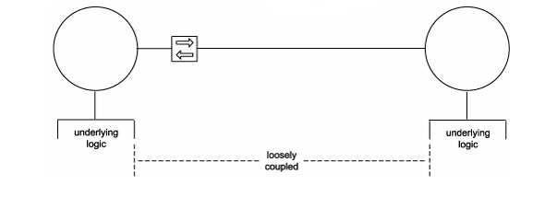
Loose coupling is a condition wherein a service acquires knowledge of another service while still remaining independent of that service. Loose coupling is achieved through the use of service contracts that allow services to interact within predefined parameters.

Case Study
- TLS services are designed to facilitate multiple B2B partners, as well as internal reuse and composition requirements. This makes TLS services very loosely coupled from any of its service requestors.
- RailCo's services, on the other hand, are designed specifically to interact with designated TLS services that are part of the overall TLS B2B solution. No attempt was made to make these services useful for any other service requestors. RailCo services are therefore considered less loosely coupled than TLS services.
- Services abstract underlying logic
This principle that allows services to act as black boxes, hiding their details from the outside world. The scope of logic represented by a service significantly influences the design of its operations and its position within a process.

The only part of a service that is visible to the outside world is what is exposed via the service contract.

Underlying logic, beyond what is expressed in the descriptions that comprise the contract, is invisible and irrelevant to service requestors

Figure-3.34. Service operations abstract the underlying details of the functionality they expose.
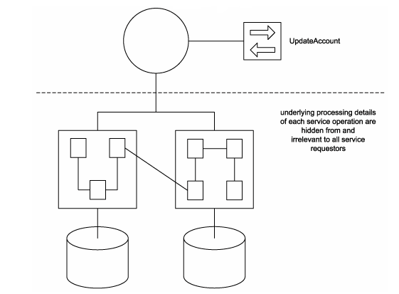
Operation granularity is therefore a primary design consideration that is directly related to the range and nature of functionality being exposed by the service. Service interface-level abstraction is one of the inherent qualities provided by Web services. The loosely coupled communications structure requires that the only piece of knowledge services need to interact is each others' service descriptions.

Case Study
- Because both RailCo and TLS employ Web services to communicate, each environment successfully implements service interface-level abstraction. On RailCo's end, this abstraction hides the legacy systems involved with generating electronic invoice documents and processing incoming purchase orders. On the TLS side, services hide service compositions wherein processing duties are delegated to specialized services as part of single activities (Figure-3.35).

Figure-3.35. Neither of RailCo's or TLS's service requestors require any knowledge of what lies behind the other's service providers.

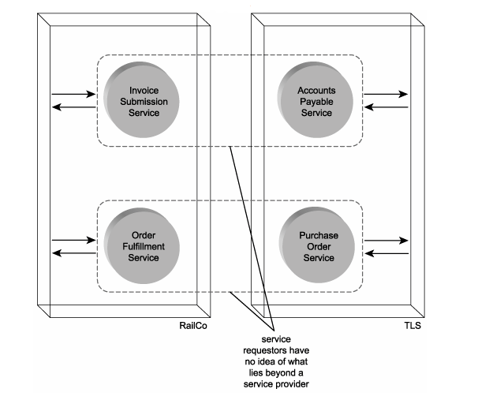

- Services are composable
- A common SOA extension that underlines composability is the concept of orchestration(coordination).
- Services may be composing other services.
- This allows logic to be represented at different levels of granularity and promotes reusability and the creation of abstraction layers.
- Figure-3.36. The UpdateEverything operation encapsulating a service composition.
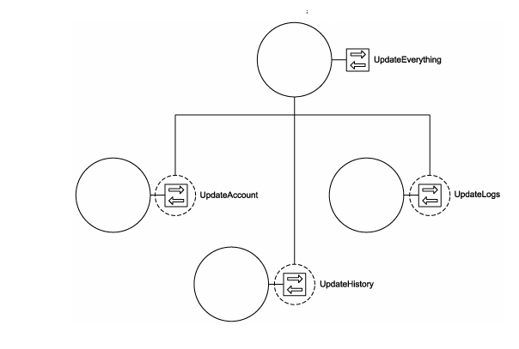

Case Study
- As with RailCo's Invoice Submission Service, its Order Fulfillment Service was created to meet a specific requirement in support of communication with TLS's B2B solution.
- The Order Fulfillment Service contains just one public operation called ProcessTLSPO (Figure 1.36). This operation is designed in compliance with TLS vendor service specifications so that it is fully capable of receiving POs submitted by the TLS Purchase Order Service. Part of this compliance requires the operation to be able to process custom SOAP headers containing proprietary security tokens.

Figure-3.36. The RailCo Order Fulfillment Service with its one operation.
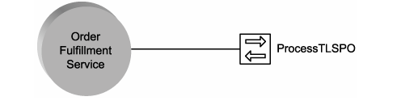
- Though the Order Fulfillment Service is capable of acting as a composition member, its potential for being useful to any future compositions is limited. Composition support is similar to reusability in that generic functionality exposed by operations make a service more composable. This RailCo service provides one operation that performs a very specialized function, customized to processing a specific document from a specific source. It will likely not be a suitable composition member, but it can act as a controller service, composing other services to complete its PO processing tasks.
- The TLS Accounts Payable Service already establishes a well-defined composition, wherein it acts as a controller service that composes the Vendor Profile and Ledger Services (Figure-3.37). Because they each expose a complete set of generic operations, all three of these services are capable of participating in other composition configurations.

Figure-3.37. The TLS Accounts Payable Service composition.
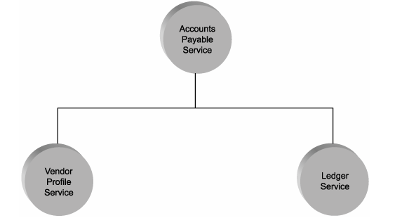

- Services are autonomous
Autonomy (independence) requires that the range of logic exposed by a service exist within an explicit boundary. This allows the service to execute self-governance of all its processing. It also eliminates dependencies on other services, which frees a service from ties that could inhibit its deployment and evolution (Figure-3.38). Service autonomy is a primary consideration when deciding how application logic should be divided up into services and which operations should be grouped together within a service context.

Figure-3.38. Autonomous services have control over underlying resources.
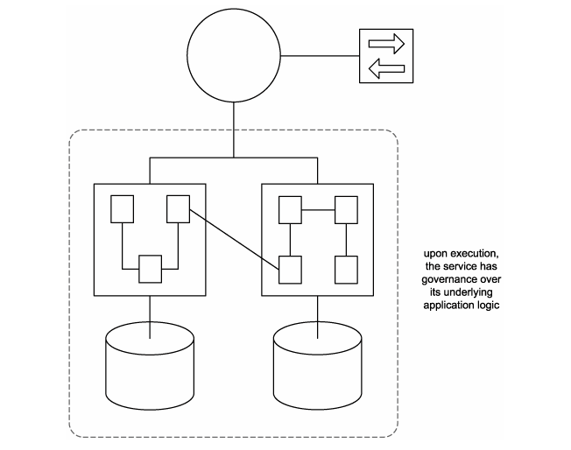
We therefore can make a distinction between two types of autonomy.
- Service-level autonomy Service boundaries are distinct from each other, but the service may share underlying resources. For example, a wrapper(binding , Packages) service that encapsulates a legacy environment that also is used independently from the service has service-level autonomy. It governs the legacy system but also shares resources with other legacy clients.
- Pure autonomy The underlying logic is under complete control and ownership of the service. This is typically the case when the underlying logic is built from the ground up in support of the service.

Case Study
- Given the distinct tasks they perform, the following three RailCo services all are autonomous:
- Invoice Submission Service
- Order Fulfillment Service
- TLS Subscription Service
- Each represents a specific boundary of application logic that does not overlap with the boundary of any other services.
- Autonomy in RailCo's services was achieved inadvertently. No alert effort was made to avoid application overlap, as the services were delivered to simply meet specific connectivity requirements.
- As shown in Figure-3.39, the Invoice Processing and Order Fulfillment Services encapsulate legacy logic. The legacy accounting system also is used by clients independently from the services, which makes this service-level autonomy. The TLS Notification Service achieves pure autonomy, as it represents a set of custom components created only in support of this service.
Figure-3.39. RailCo's services luckily encapsulate explicit portions of legacy and newly added application logic
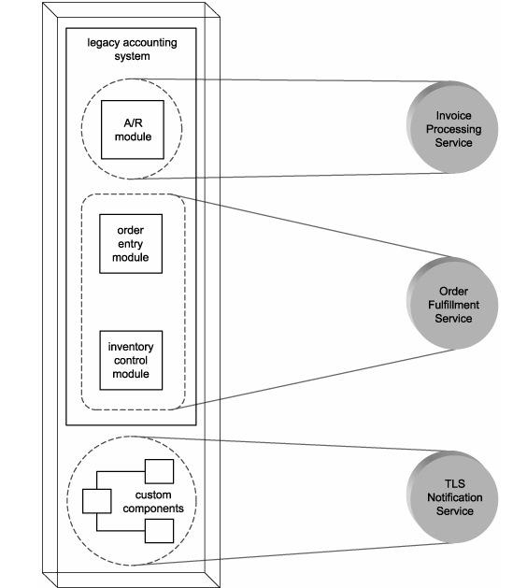

Services are stateless
Services should minimize the amount of state information they manage and the duration for which they hold it. State information is data-specific to a current activity. While a service is processing a message, for example, it is temporarily stateful (Figure-3.40). If a service is responsible for retaining state for longer periods of time, its ability to remain available to other requestors will be impeded.

Figure-3.40. Stateless and stateful stages a service passes through while processing a message.
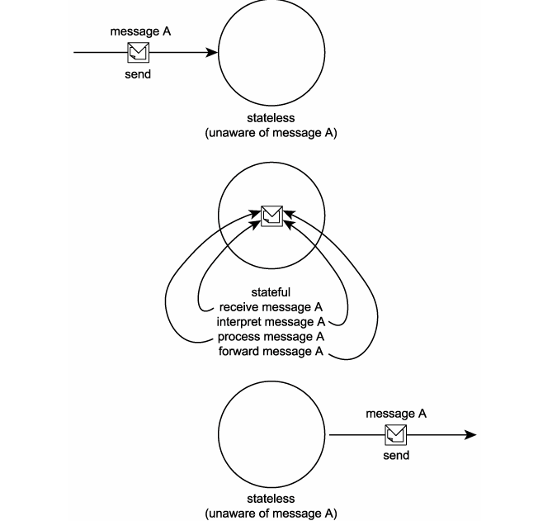
Statelessness is a preferred condition for services and one that promotes reusability and scalability. For a service to retain as little state as possible, its individual operations need to be designed with stateless processing considerations.

Case Study
As with loose coupling, statelessness is a quality that can be measured in degrees. The RailCo Order Fulfillment Service is required to perform extra runtime parsing and processing of various standard SOAP header blocks to successfully receive a purchase order document submitted by the TLS Purchase Order Service. This processing ties up the Order Fulfillment Service longer than, say, the Invoice Submission Service, which simply forwards a predefined SOAP message to the TLS Accounting Service.
- Services are discoverable
Discovery helps avoid the accidental creation of redundant services or services that implement redundant logic. Because each operation provides a potentially reusable piece of processing logic, metadata attached to a service needs to sufficiently describe not only the service's overall purpose, but also the functionality offered by its operations.
On an SOA level, discoverability refers to the architecture's ability to provide a discovery mechanism, such as a service registry or directory. This effectively becomes part of the IT infrastructure and can support numerous implementations of SOA. On a service level, the principle of discoverability refers to the design of an individual service so that it can be as discoverable as possible.

Case Study
- RailCo provides no means of discovery for its services, either internally or to the outside world. Though outfitted with its own WSDL definition and fully capable of acting as a service provider, the Invoice Submission Service is primarily utilized as a service requestor and currently expects no communication outside of the TLS Accounts Payable Service
- Similarly, the RailCo Order Fulfillment Service was registered manually with the TLS B2B solution so that it would be placed on the list of vendors that receive purchase orders. This service provides no reusable functionality and is therefore considered to have no immediate requirement for discovery.
- Due to the reusable nature of TLS services and because of the volume of services that are expected to exist in TLS technical environments, an internal service registry was established (as shown in Figure 1.41 ). This piece of TLS infrastructure promotes discoverability and prevents accidental redundancy. It further leverages the existing design standards used by TLS that promote the creation of descriptive metadata documents in support of service discoverability.

Figure-3.41. RailCo's services are not discoverable, but TLS's inventory of services are stored in an internal registry.
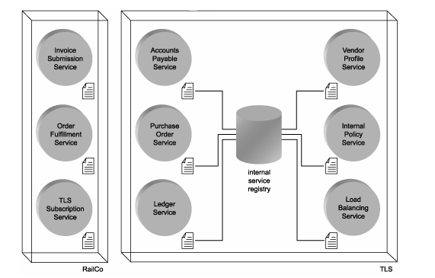
TLS is not interested in making its services publicly discoverable, which is why it does not register them with a public service registry. Vendors that participate in the TLS B2B system only are allowed to do so after a separate negotiation, review, and registration process.

How service-orientation principles inter-relate (16 marks)
We abbreviate the original names we assigned each principle, as follows:
- Services are reusable = service reusability
- Services share a formal contract = service contract
- Services are loosely coupled = service loose coupling
- Services abstract underlying logic = service abstraction
- Services are composable = service composability
- Services are autonomous = service autonomy
- Services are stateless = service statelessness
- Services are discoverable = service discoverability
- Service reusability
When a service encapsulates logic that is useful to more than one service requestor, it can be considered reusable. The concept of reuse is supported by a number of complementary service principles, as follows.
- Service autonomy establishes an execution environment that facilitates reuse because the service has independence and self-governance. The less dependencies a service has, the broader the applicability of its reusable functionality.
- Service statelessness supports reuse because it maximizes the availability of a service and typically promotes a generic service design that defers activity-specific processing outside of service logic boundaries.
- Service abstraction fosters reuse because it establishes the black box concept, where processing details are completely hidden from requestors. This allows a service to simply express a generic public interface.
- Service discoverability promotes reuse, as it allows requestors (and those that build requestors) to search for and discover reusable services.
- Service loose coupling establishes an inherent independence that frees a service from immediate ties to others. This makes it a great deal easier to realize reuse
- Service composability is primarily possible because of reuse. The ability for one service to compose an activity around the utilization of a collection of services is feasible when those services being composed are built for reuse.
Figure-3.42. Service reusability and its relationship with other service-orientation principles.
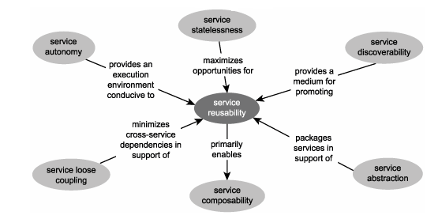

Service contract
A service contract is a representation of a service's collective metadata. It standardizes the expression of rules and conditions that need to be fulfilled by any requestor wanting to interact with the service.Service contracts represent a basis principle in service-orientation and therefore support other principles in various ways, as follows:
- Service abstraction is realized through a service contract, as it is the metadata expressed in the contract that defines the only information made available to service requestors. All additional design, processing, and implementation details are hidden behind this contract.
- Service loose coupling is made possible through the use of service contracts. Processing logic from different services do not need to form tight dependencies; they simply need an awareness of each other's communication requirements, as expressed by the service description documents that comprise the service contract.
- Service composability is indirectly enabled through the use of service contracts. It is via the contract that a controller service enlists and uses services that act as composition members.
- Service discoverability is based on the use of service contracts. While some registries provide information supplemental to that expressed through the contract, it is the service description documents that are primarily searched for in the service discovery process.

Figure-3.43. The service contract and its relationship with other service-orientation principles.
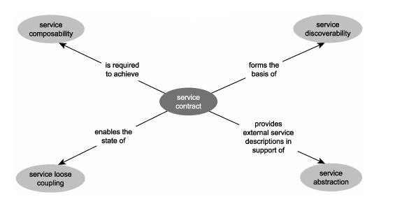

Service loose coupling
Loose coupling is a state that supports a level of independence between services (or between service providers and requestors). Therefore, the principle of persisting loose coupling across services supports the following other service-orientation principles:
- Service reusability is supported through loose coupling because services are freed from tight dependencies on others. This increases their availability for reuse opportunities.
- Service composability is fostered by the loose coupling of services, especially when services are dynamically composed.
- Service statelessness is directly supported through the loosely coupled communications framework established by this principle.
- Service autonomy is made possible through this principle, as it is the nature of loose coupling that minimizes cross-service dependencies.
- Service contracts are what enable loose coupling between services, as the contract is the only piece of information required for services to interact.

Figure-3.44. Service loose coupling and its relationship with other service-orientation principles.
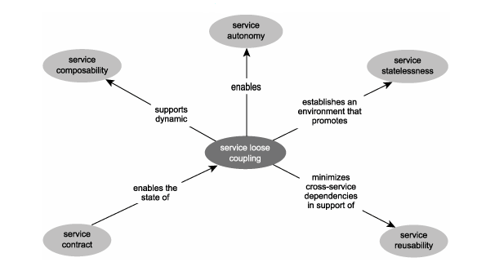

Service abstraction
Part of building solutions with independent services is allowing those services to encapsulate potentially complex processing logic and exposing that logic through a generic and descriptive interface. This is the primary benefit of service abstraction, a principle that is related to others, as explained here:
- Service contracts, in a manner, implement service abstraction by providing the official description information that is made public to external service requestors.
- Service reusability is supported by abstraction, as long as what is being abstracted is actually reusable.

Figure-3.45. Service abstraction and its relationship with other service-orientation principles.
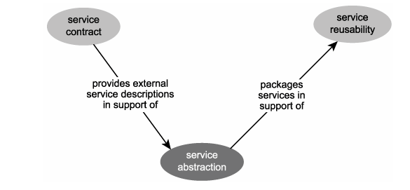

Service composability
Service composability therefore is tied to service-orientation principles that support the concept of service composition, as follows:
- Service reusability is what enables one service to be composed by numerous others. It is expected that reusable services can be incorporated within different compositions or reused independently by other service requestors.
- Service loose coupling establishes a communications framework that supports the concept of dynamic service composition. Because services are freed from many dependencies, they are more available to be reused via composition.
- Service statelessness supports service composability, especially in larger compositions. A service composition is reliant on the design quality and commonality of its collective parts. If all services are stateless (by, for example, deferring activity-specific logic to messages), the overall composition executes more harmoniously.
- Service autonomy held by composition members strengthens the overall composition, but the autonomy of the controller service itself actually is decreased due to the dependencies on its composition members.
- Service contracts enable service composition by formalizing the runtime agreement between composition members.

Figure-3.46 Service composability and its relationship with other service-orientation principles.
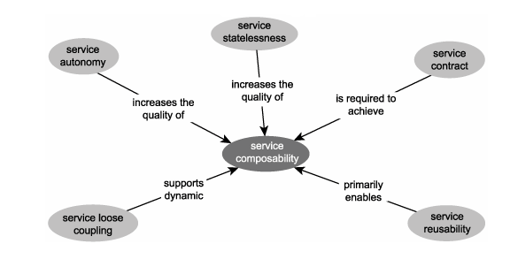

Service autonomy
This principle applies to a service's underlying logic. By providing an execution environment over which a service has complete control, service autonomy relates to several other principles, as explained here:
- Service reusability is more easily achieved when the service offering reusable logic has self-governance over its own logic. Service Level Agreement (SLA) type requirements that come to the forefront for utility services with multiple requestors, such as availability and scalability, are fulfilled more easily by an autonomous service.
- Service composability is also supported by service autonomyfor much of the same reasons autonomy supports service reusability. A service composition consisting of autonomous services is much more robust and collectively independent.
- Service statelessness is best implemented by a service that can execute independently. Autonomy indirectly supports service statelessness. (However, it is very easy to create a stateful service that is also fully autonomous.)
- Service autonomy is a quality that is realized by leveraging the loosely coupled relationship between services. Therefore service loose coupling is a primary enabler of this principle.

Figure-3.47. Service autonomy and its relationship with other service-orientation principles.
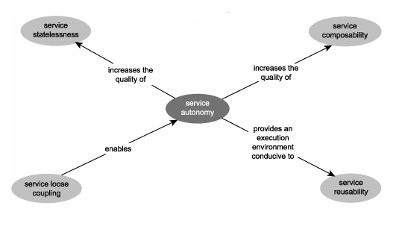

Service statelessness
However, the principle of statelessness is also indirectly supported by the following service-orientation principles:
- Service autonomy provides the ability for a service to control its own execution environment. By removing or reducing dependencies it becomes easier to build statelessness into services, primarily because the service logic can be fully customized to defer state management outside of the service logic boundary.
- Service loose coupling and the overall concept of loose coupling establishes a communication paradigm that is fully realized through messaging. This, in turn, supports service statelessness, as state information can be carried and persisted by the messages that pass through the services.
- Service composability benefits from stateless composition members, as they reduce dependencies and minimize the overhead of the composition as a whole.
- Service reuse becomes more of a reality for stateless services, as availability of the service to multiple requestors is increased and the absence of activity-specific logic promotes a generic service design.

Figure-3.48 Service statelessness and its relationship with other service-orientation principles.
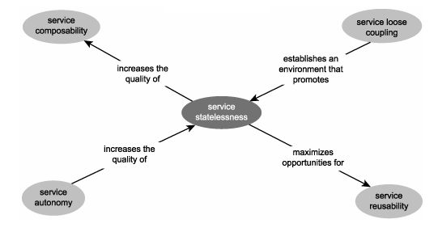

Service discoverability
Designing services so that they are naturally discoverable enables an environment whereby service logic becomes accessible to new potential service requestors. Following are the service-orientation principles:
- Service contracts are what service requestors (or those that create them) actually discover and subsequently assess for suitability. Therefore, the extent of a service's discoverability can typically be associated with the quality or descriptiveness of its service contract.
- Service reusability is what requestors are looking for when searching for services and it is what makes a service potentially useful once it has been discovered. A service that isn't reusable would likely never need to be discovered because it would probably have been built for a specific service requestor in the first place.

Figure-3.49. Service discoverability and its relationship with other service-orientation principles.
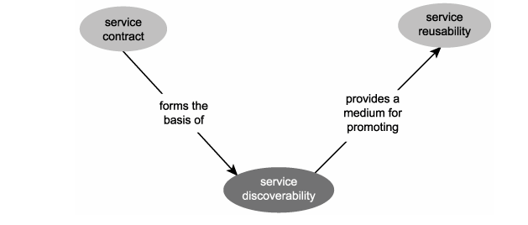

- List the Benefits of a Service-Oriented Architecture (IT2401/MAY/JUN/2012)
A service-oriented architecture has services that developers create in a service layer. The services that they develop have published interfaces. These interfaces support a distinct business domain. Organizations that focus their development effort around the creation of services, will realize many benefits.
- Better Return on Investment
- The creation of a robust service layer has the benefit of a better return on the investment made in the creation of the software. Services map to distinct business domains. For example, a company might create an inventory service that has all of the methods necessary to manage the inventory for the company. By putting the logic into a separate layer, the layer can exist well beyond the lifetime of any system it is composed into.
- For example, if your organization needs to create a credit card authorization service, there are basically two options. Developers will either develop the functionality as part of the application that needs it, or they will develop it as a separate component. If credit card authorization is developed as a separate component and used as a service, then it is likely to outlive the original application.
- Code Mobility
- Since location transparency is a property of a service-oriented architecture, code mobility becomes a reality. The lookup and dynamic binding to a service means that the client does not care where the service is located. Therefore, an organization has the flexibility to move services to different machines, or to move a service to an external provider.
- Focused Developer Roles
- A service-oriented architecture will force an application to have multiple layers. Each layer has a set of specific roles for developers. For instance, the service layer needs developers that have experience in data formats, business logic, persistence mechanisms, transaction control, etc.
- More Security
- The creation of a service layer by definition means that developers have created an additional network interface that can be used by multiple applications. When systems were built using monolithic or client-server methods, security was normally handled on the front-end.
- Companies often did not even implement database security because it is too hard to maintain multiple security lists. Services on the other hand are used by multiple applications, so they have their own security mechanisms. An application will therefore have multi-level authentication at both the client level and at the service level.
- Better Testing/Fewer Defects
- Services have published interfaces that can be tested easily by developers by writing unit tests. Developers can use tools such as JUnit for creating test suites. These test suites can be run to validate the service independently from any application that uses the service. It is also a good practice to run the unit tests during an automated build process. There is no reason for a QA tester to test an application if the unit tests did not complete successfully. More and better testing usually means fewer defects and a higher overall level of quality.
- Support for Multiple Client Types
- As a benefit of a service-oriented architecture, companies may use multiple clients and multiple client types to access a service. A PDA using J2ME may access a service via HTTP, and a SWING client may access the same service via RMI. Since the layers are split into client and service layers, different client types are easier to implement.
- Service Assembly
- The services that developers create will evolve into a catalog of reusable services. Customers will come to understand this catalog as a set of reusable assets that can be combined in ways not conceived by their originators. Everyone will benefit from new applications being developed more quickly as a result of this catalog of reusable services.
- Better Maintainability
- Software archeology is the task of locating and correcting defects in code. By focusing on the service layer as the location for your business logic, maintainability increases because developers can more easily locate and correct defects.
- More Reuse
- Code reuse has been the most talked about form of reuse over the last four decades of software development. Unfortunately, it is hard to achieve due to language and platform incompatibilies. Component or service reuse is much easier to achieve. Run-time service reuse is as easy as finding a service in the directory, and binding to it. The developer does not have to worry about compiler versions, platforms, and other incompatibilities that make code reuse difficult.
- Better Parallelism in Development
- The benefit of multiple layers means that multiple developers can work on those layers independently. Developers should create interface contracts at the start of a project and be able to create their parts independently of one another.
- Better Scalability
- One of the requirements of a service-oriented architecture is location transparency. To achieve location transparency, applications lookup services in a directory and bind to them dynamically at run-time. This feature promotes scalability since a load-balancer may forward requests to multiple service instances without the knowledge of the service client.
- Higher Availability
- Also because of location transparency, multiple servers may have multiple instances of a service running on them. If a network segment or a machine goes down, a dispatcher can redirect requests to another service without the client's knowledge.
- Discuss about three service layers in detail (IT2401/NOV/DEC/2011)
Services layers
Layers interaction in SOA

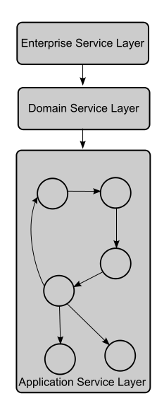
Requirements
SOA, the architecture must meet the following requirements:
- Interoperability among different systems and programming languages that provides the basis for integration between applications on different platforms through a communication protocol. One example of such communication depends on the concept of messages. Using messages across defined message channels decreases the complexity of the end application, thereby allowing the developer of the application to focus on true application functionality instead of the intricate needs of a communication protocol.
- Desire to create a federation of resources. Establish and maintain data flow to a Federated database system. This allows new functionality developed to reference a common business format for each data element.

Service layer abstraction

Problems solved by layering services

What logic should be represented by services?
- Services can be modeled to represent either or both types of logic, as long as the principles of service-orientation can be applied.
- To achieve enterprise-wide loose coupling physically separate layers of services are, in fact, required. When individual collections of services represent corporate business logic and technology-specific application logic, each domain of the enterprise is freed of direct dependencies on the other.
- This allows the automated representation of business process logic to evolve independently from the technology-level application logic responsible for its execution..

How should services relate to existing application logic?
- Applying a service layer on top of legacy application environments may even require that some service-orientation principles be compromised. This is less likely when building solutions from the ground up with service layers in mind, as this affords a level of control with which service-orientation can be directly incorporated into application logic.

How can services best represent business logic?
- Business logic is defined within an organization's business models and business processes. When modeling services to represent business logic, it is most important to ensure that the service representation of this logic is in alignment with existing business models.
- It is also useful to separately categorize services that are designed in this manner. Therefore, we'll refer to services that have been modeled to represent business logic as belonging to the business service layer.

How can services be built and positioned to promote agility?
- The key to building an lively SOA is in minimizing the dependencies each service has within its own processing logic. Services that contain business rules are required to enforce and act upon these rules at runtime. This limits the service's ability to be utilized outside of environments that require these rules. Similarly, controller services that are embedded with the logic required to compose other services can develop dependencies on the composition structure.
- Introducing a parent controller layer on top of more specialized service layers would allow us to establish a centralized location for business rules and composition logic related to the sequence in which services are executed.
- Orchestration is designed specifically for this purpose. It introduces the concept of a process service, capable of composing other services to complete a business process according to predefined workflow logic. Process services establish what we refer to as the orchestration service layer.

Abstraction is the key
The three layers of abstraction we identified for SOA are:
- the application service layer
- the business service layer
- the orchestration service layer
Each of these layers (also shown in Figure 3.51 is introduced individually in the following sections.

Figure 3.51. The three primary service layers.
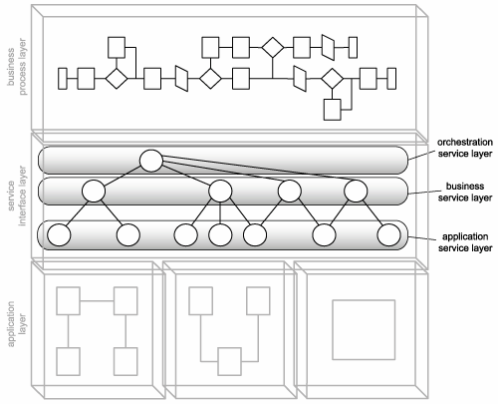

Application service layer
The application service layer establishes the ground level foundation that exists to express technology-specific functionality. Services that reside within this layer can be referred to simply as application services (Figure 3.52). Their purpose is to provide reusable functions related to processing data within new or legacy application environments.

Figure 3.52 The application service layer.
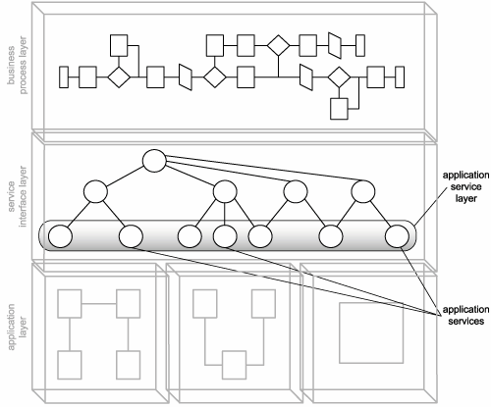

Application services commonly have the following characteristics:
- they expose functionality within a specific processing context
- they draw upon available resources within a given platform
- they are solution-agnostic
- they are generic and reusable
- they can be used to achieve point-to-point integration with other application services
- they are often inconsistent in terms of the interface granularity they expose
- they may consist of a mixture of custom-developed services and third-party services that have been purchased or leased
Typical examples of service models implemented as application services include the following:
- utility service
- wrapper service
- When a separate business service layer exists, there is a strong motivation to turn all application services into generic utility services. This way they are implemented in a solution-agnostic manner, providing reusable operations that can be composed by business services to fulfill business-centric processing requirements.
- Alternatively, if business logic does not reside in a separate layer, application services may be required to implement service models more associated with the business service layer. For example, a single application service also can be classified as a business service if it interacts directly with application logic and contains embedded business rules.
- Services that contain both application and business logic can be referred to as hybrid application services or just hybrid services. This service model is commonly found within traditional distributed architectures.
- Finally, an application service also can compose other, smaller-grained application services (such as proxy services) into a unit of coarse-grained application logic. Aggregating application services is frequently done to accommodate integration requirements. Application services that exist solely to enable integration between systems often are referred to as application integration services or simply integration services. Integration services often are implemented as controllers.
- Because they are common residents of the application service layer, now is a good time to introduce the wrapper service model. Wrapper services most often are utilized for integration purposes. They consist of services that encapsulate ("wrap") some or all parts of a legacy environment to expose legacy functionality to service requestors. The most frequent form of wrapper service is a service adapter provided by legacy vendors. This type of out-of-the-box Web service simply establishes a vendor-defined service interface that expresses an underlying API to legacy logic.
- Another variation of the wrapper service model not discussed in this book is the proxy service, also known as an auto-generated WSDL. This simply provides a WSDL definition that mirrors an existing component interface. It establishes an endpoint on the component's behalf, essentially allowing it to participate in SOAP communication. The proxy service should not be confused with a service proxy, which is used by service requestors to contact service providers.

Example
TLS has a well-defined application services layer. Of the TLS services we've discussed so far in our case study, the following are considered application services:
- Load Balancing Service
- Internal Policy Service
- System Notification Service
Each is a utility service that provides a set of generic, reusable features, and each is capable of acting as a composition member, fulfilling a specific task within a larger unit of automation.
All of the following RailCo services incorporate processing similar to application services:
- Invoice Submission Service
- Order Fulfillment Service
- TLS Subscription Service
Both the Invoice Submission and Order Fulfillment Services are somewhat hybrid, in that each also contains embedded business logic. The TLS Subscription Service can be classified as a pure application service, as it performs a simple, application-centric task. It's questionable whether any RailCo services would be considered utility services because none were designed with any real reusability in mind.

Business service layer
While application services are responsible for representing technology and application logic, the business service layer introduces a service concerned solely with representing business logic, called the business service (Figure 3.53).

Figure 3.53 The business service layer.
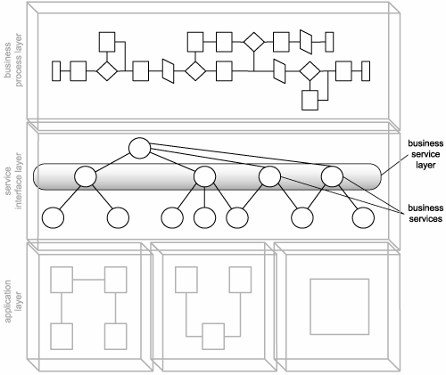

Business services are the lifeblood of contemporary SOA. They are responsible for expressing business logic through service-orientation and bring the representation of corporate business models into the Web services arena.
Application services can fall into different types of service model categories because they simply represent a group of services that express technology-specific functionality. Therefore, an application service can be a utility service, a wrapper service, or something else.
Business services, on the other hand, are always an implementation of the business service model. The sole purpose of business services intended for a separate business service layer is to represent business logic in the purest form possible. This does not, however, prevent them from implementing other service models. For example, a business service also can be classified as a controller service and a utility service.
In fact, when application logic is abstracted into a separate application service layer, it is more than likely that business services will act as controllers to compose available application services to execute their business logic.
Business service layer abstraction leads to the creation of two further business service models:
- Task-centric business service A service that encapsulates business logic specific to a task or business process. This type of service generally is required when business process logic is not centralized as part of an orchestration layer. Task-centric business services have limited reuse potential.
- Entity-centric business service A service that encapsulates a specific business entity (such as an invoice or timesheet). Entity-centric services are useful for creating highly reusable and business process-agnostic services that are composed by an orchestration layer or by a service layer consisting of task-centric business services (or both).
When a separate application service layer exists, these two types of business services can be positioned to compose application services to carry out their business logic.

Example
Of the TLS services we've discussed so far in our case study examples, the following are true business services:
- Accounts Payable Service
- Purchase Order Service
- Ledger Service
- Vendor Profile Service
Each represents a well-defined boundary of business logic, and whenever one of these service's operations needs to perform a task outside of this boundary, it reuses functionality provided in another business or application service.
As we mentioned earlier, RailCo's Invoice Submission and Order Fulfillment Services are hybrid in that they contain both business rules and application-related processing. This type of service is very common in organizations that only incorporate services peripherally. Either way, for modeling purposes, these two services are classified as hybrid application services. Because business logic is not explicitly abstracted, only an application services layer exists within RailCo.

Orchestration service layer (coordination)
Orchestration is more valuable to us than a standard business process, as it allows us to directly link process logic to service interaction within our workflow logic. This combines business process modeling with service-oriented modeling and design. And, because orchestration languages (such as WS-BPEL) realize workflow management through a process service model, orchestration brings the business process into the service layer, positioning it as a master composition controller.
The orchestration service layer introduces a parent level of abstraction that alleviates the need for other services to manage interaction details required to ensure that service operations are executed in a specific sequence (Figure 3.54). Within the orchestration service layer, process services compose other services that provide specific sets of functions, independent of the business rules and scenario-specific logic required to execute a process instance.

Figure 3.54 The orchestration service layer.
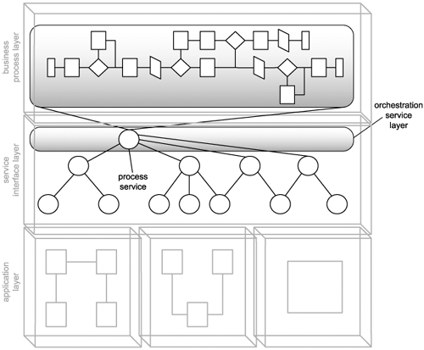

Therefore, all process services are also controller services by their very nature, as they are required to compose other services to execute business process logic. Process services also have the potential of becoming utility services to an extent, if a process, in its entirety, should be considered reusable. In this case, a process service that enables orchestration can itself be orchestrated (making it part of a larger orchestration).

Example
Neither TLS or RailCo employ process services or a separate orchestration layer. As with many organizations, TLS is interested in orchestration but is uncertain as to the technology that supports it and the impact it would have on their current service architecture.

Agnostic services
A key aspect of delivering reusable services is that they introduce service layers that are not limited to a single process or solution environment. It is important to highlight this one point, as it can blur the architectural boundary of a service-oriented solution. An application-level SOA that depends on the use of existing solution-agnostic services also does not have a well defined application boundary. Services providing reusable logic.
- Entity-centric business services are designed to provide a set of features that provide data management related only to their corresponding entities. They are therefore business process-agnostic. The same entity-centric business services can (and should) be reused by different process or task-centric business services.
- Application services ideally are built according to the utility service model. This makes them highly generic, reusable, and very much solution-agnostic. Different service-oriented solutions can (and should) reuse the same application services.
As shown in Figure 3.56, services can be process- and solution-agnostic while still being used as part of a service layer that connects different processes and solutions.
Figure 3.56 Services uniting previously isolated business processes and solution environment

If the services you are delivering collectively represent the logic of an entire solution, then the architectural scope is essentially that of an application-level SOA. An enterprise that invests heavily in agnostic services easily can end up with an environment in which a great deal of reuse is leveraged. This is the point at which building service-oriented solutions can become more of a modeling exercise and less of an actual development project.
- Explain about service layer configuration scenarios (IT2401/MAY/JUN/2012)

We provide here some sample configuration scenarios and briefly discuss the characteristics of each. we will explore scenarios based on the use of the following types of services:
- hybrid application services (services containing both business process and application logic)
- utility application services (services containing reusable application logic)
- task-centric business services (services containing business process logic)
- entity-centric business services (services containing entity business logic)
- process services (services representing the orchestration service layer)
Scenario #1: Hybrid application services only
When Web services simply are appended to existing distributed application environments, or when a Web services-based solution is built without any emphasis on reuse or service-oriented business modeling, the resulting architecture tends to consist of a set of hybrid
application services (Figure 3.57).
Figure 3.57. Hybrid services encapsulating both business and application logic.
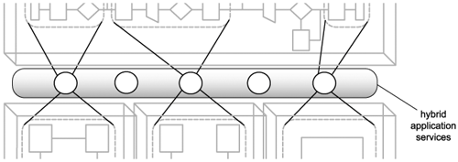
Scenario #2: Hybrid and utility application services
A variation of the previous configuration establishes a Web services-based architecture consisting of hybrid services and reusable application services. In this case, the hybrid services may compose some of the reusable application services. This configuration achieves an extent of abstraction, as the utility services establish a solution-agnostic application layer (Figure 3.58).

Figure 3.58. Hybrid services composing available utility application services.
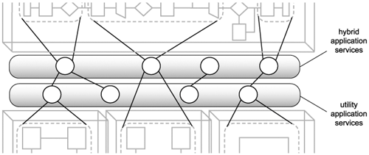

Scenario #3: Task-centric business services and utility application services
This approach results in a more coordinated level of abstraction, given that business process logic is entirely represented by a layer of task-centric business services. These services rely on a layer of application services for the execution of all their business logic (Figure 3.59).

Figure 3.59. Task-centric business services and utility application services cleanly abstracting business and application logic.
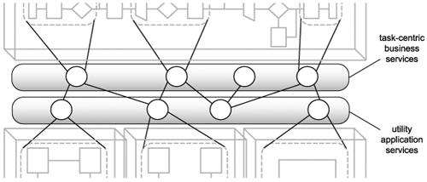
Scenario #4: Task-centric business services, entity-centric business services, and utility application services
Here task-centric services as parent controllers that may compose both entity-centric and application services to carry out business process logic (Figure 3.60).
Figure 3.60 Two types of business services composing application services.
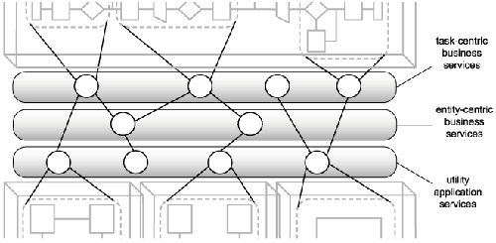
Scenario #5: Process services, hybrid application services, and utility application services

In this scenario, a parent process service composes available hybrid and application services to automate a business process. This is a common configuration when adding an orchestration layer over the top of an older distributed computing architecture that uses Web
services (Figure 3.61).

Figure 3.61. An orchestration layer providing a process service that composes different types of application services
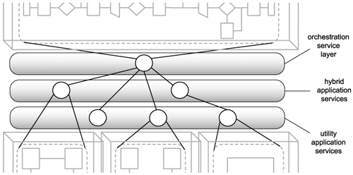

Scenario #6: Process services, task-centric business services, and utility application services

Even though task-centric services also contain business process logic, a parent process service can still be positioned to compose both task-centric and utility application services. Though only partial abstraction is achieved via task-centric services, when combined with the
centralized business process logic represented by the process services, business logic as a whole is still abstracted F(igure 3.62).

Figure 3.62. A process service composing task-centric and utility application services
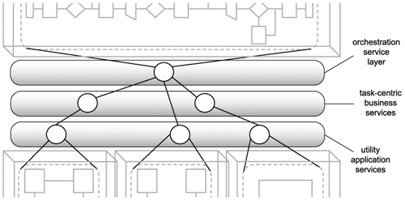

Scenario #7: Process services, task-centric business services, Entity-centric business services, and utility application services
This variation also introduces entity-centric business services, which can result in a configuration that actually consists of four service layers. Sub-processes can be composed by strategically positioned task-centric services, whereas the parent process is managed by the process service, which composes both task-centric and entity-centric services (Figure 3.63).

Figure 3.63. Process and business services composing utility application services.
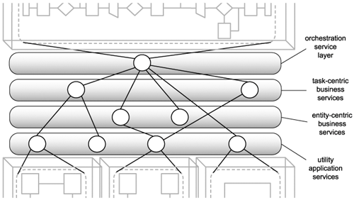

Scenario #8: Process services, entity-centric business services, and utility application services
This SOA model establishes a clean separation of business and application logic, while maximizing reuse through the utilization of solution and business process-agnostic service layers. The process service contains all business process-specific logic and executes this
logic through the involvement of available entity-centric business services, which, in turn, compose utility application logic to carry out the required tasks (Figure 3.64).

Figure 3.64. A process service composing entity-centric services, which compose utility
application services.
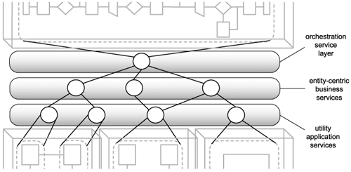

Important question
Two marks
- Define SOA(IT2401/NOV/DEC/2011) (IT2401/MAY/JUN/2012) (IT2401/MAY/JUN/2013) (IT2401/MAY/JUN/2015) (IT2401/MAY/JUN/2016)
- An SOA can refer to an application architecture or the approach used to standardize technical architecture across the enterprise.
- SOA defines how to integrate widely dissimilar applications for a Web-based environment and uses multiple implementation platforms. Rather than defining an API, SOA defines the interface in terms of protocols and functionality. An endpoint is the entry point for such a SOA implementation.

- How do components in an SOA interrelate (IT2401/NOV/DEC/2011)
- An operation sends and receives messages to perform work.
- An operation is therefore mostly defined by the messages it processes.
- A service groups a collection of related operations.
- A service is therefore mostly defined by the operations that comprise it.
- A process instance can compose services.
- A process instance is not necessarily defined by its services because it may only require a subset of the functionality offered by the services.
- A process instance invokes a unique series of operations to complete its automation.
  - Every process instance is therefore partially defined by the service operations it uses. The following Figures -1.28

- List the four SOA characteristics(IT2401/NOV/DEC/2012)
  - Services are discoverable and dynamically bound.
  - Services are self-contained and modular.
  - Services stress interoperability.
  - Services are loosely coupled.
  - Services have a network-addressable interface.
  - Services have coarse-grained interfaces.
  - Services are location-transparent.
  - Services are composable.
  - Service-oriented architecture supports self-healing.

- What is coarse grained service (IT2401/NOV/DEC/2012) (IT2401/MAY/JUN/2015) (IT2401/MAY/JUN/2016)
A service-based system controls the network access to the objects within the service through a set of coarse-grained interfaces. A service may still be implemented as a set of fine-grained objects, but the objects themselves are not accessible over a network connection. A service implemented as objects has one or more coarse-grained objects that act as distributed façades. These objects are accessible over the network and provide access to the internal object state from external consumers of the service. However, objects internal to the service communicate directly with each other within a single machine, not across a network connection.

- Define service layers (IT2401/NOV/DEC/2012) (IT2401/MAY/JUN/2016)
When building various types of services, it becomes evident that they can be categorized depending on: - the type of logic they encapsulate - the extent of reuse potential this logic has - how this logic relates to existing domains within the enterprise As a result, there are three common service classifications that represent the primary service models used in SOA projects: - Entity Services - Task Services - Utility Services

- List the logical components of automation logic (IT2401/MAY/JUN/2013)
  - SOAP messages
  - Web service operations
  - Web services
  - Activities
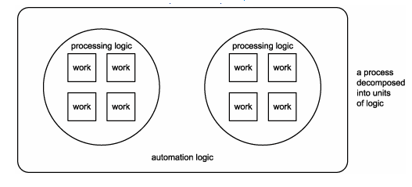

- What is architecture(IT2401/NOV/DEC/2013)
Application architecture is to an application development team what a blueprint is to a team of construction workers. Different organizations document different levels of application architecture.

- Define application architecture(IT2401/MAY/JUN/2014) (IT2401/NOV/DEC/2014)
Application architecture is to an application development team what a blueprint is to a team of construction workers. Different organizations document different levels of
application architecture

- List out some common principles of service orientation (IT2401/NOV/DEC/2014)
  - Standardized Service Contracts
  - Service Loose Coupling
  - Service Abstraction
  - Service Reusability
  - Service Autonomy
  - Service Statelessness
  - Service Discoverability
  - Service Composability
  - Service-Orientation and Interoperability

- Differentiate service orientation and object orientation (IT2401/NOV/DEC/2015)
Object Orientation:
- Assume homogeneous platform and execution environment
- Share classes, not schemas
- Assume cheap, transparent communication
- Are linked: Object identity and lifetime maintained by infrastructure
- Typically require deployment of both client and server in sync
- Are easy to talk about and become a natural path for customers to follow
- Customers have 20+ years of experience and great intuition about what “object oriented is”
Service Orientation:
- Assume heterogeneous platform and execution environment
- Share schemas, not classes
- Assume variable cost, explicit communication
- Are autonomous: Security and failure isolation are a must
- Ease “continuous deployment” of client and server separately
- Builds on ideas from component software, distributed objects, and MOM
- Dominant theme is to manage/reduce sharing between services

- List down the technical benefits of SOA (IT2401/NOV/DEC/2015)
- Better return of investment
- Code Mobility
- Focused Developer Roles
- More Security
- Better Testing/Fewer Defects
- Support for Multiple Client Types
- Service Assembly
- Better Maintainability
- More Reuse
- Better Parallelism in Development
- Better Scalability
- Higher Availability
12. What are the logical components of web service framework (IT2401/MAY/JUN/2012)
Or
What are web service platform elements(IT2401/MAY/JUN/2016)
Web services. This article will move through basics of Web Services, the various Web Services platform elements SOAP (Simple Object Access Protocol), UDDI (Universal Description, Discovery and Integration) and WSDL (Web Services Description Language)

16 Marks

- Explain the common principles of service orientation in detail (IT2401/NOV/DEC/2011) (IT2401/MAY/JUN/2013) (IT2401/MAY/JUN/2015) (IT2401/MAY/JUN/2016)
- Compare SOA to client server and distributed architecture(IT2401/NOV/DEC/2011) (IT2401/NOV/DEC/2012) (IT2401/MAY/JUN/2013) (IT2401/NOV/DEC/2014)
- Discuss about three service layers in detail (IT2401/NOV/DEC/2011)
- Explain the common characteristic of contemporary SOA (IT2401/MAY/JUN/2012)
- List the benefits of SOA(IT2401/MAY/JUN/2012)
- Compare and contrast SOA and distributed internet architecture (IT2401/MAY/JUN/2012) (IT2401/NOV/DEC/2015)
- Explain web service models (IT2401/MAY/JUN/2012)
- Explain about service layer abstraction and orchestration service layer (IT2401/MAY/JUN/2012) (IT2401/NOV/DEC/2014)
- Explain about service layer configuration scenarios (IT2401/MAY/JUN/2012)
- Explain in detail about SOA components and how they are they interrelate (IT2401/NOV/DEC/2012)
- Briefly discuss on application service layer (IT2401/NOV/DEC/2012) (IT2401/NOV/DEC/2014) (IT2401/MAY/JUN/2015) (IT2401/MAY/JUN/2016)
- Discuss about different service layer in detail (IT2401/MAY/JUN/2013)
- Explain briefly about web services as component wrappers(IT2401/NOV/DEC/2013) (IT2401/MAY/JUN/2015) (IT2401/MAY/JUN/2016)
- Describe how SOA can be compared to client server architecture (IT2401/MAY/JUN/2014)
- What do you mean by service contract? Explain its role in SOA (IT2401/NOV/DEC/2015)

- With a neat diagram explain the web service platform (IT2401/NOV/DEC/2015)

A Web service is a software application identified by a URI, whose interfaces and bindings are capable of being defined, described, and discovered as XML artifacts. A Web service supports direct interactions with other software agents using XML-based messages exchanged via Internet-based protocols
- Let us examine this same scenario when the supply chain is split among multiple companies
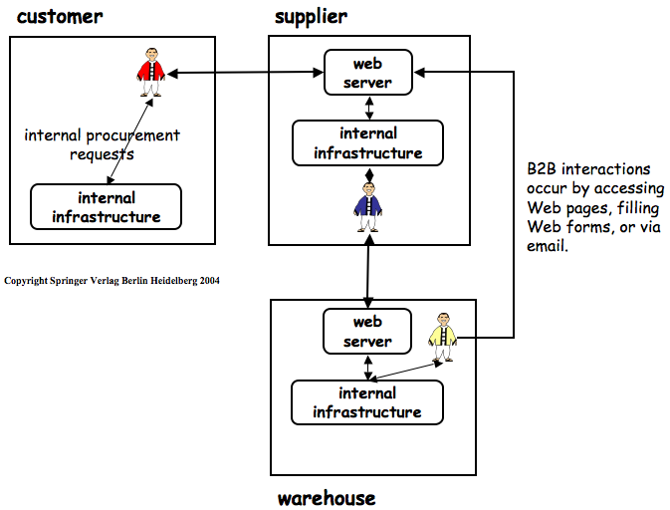
- B2B processes are carried out manually via Web, fax, or e-mail
- Problems facing B2B process automation include
- in cross-organization integration, where does the middleware live?
    - need a third-party organization to host the middleware
    - all other parties must agree to use this middleware
- trust between companies is low (sometimes non-existent)
- businesses want to retain autonomy (not be dependent on other companies)
- confidentiality of business transactions (companies do not want to store them on shared middleware)
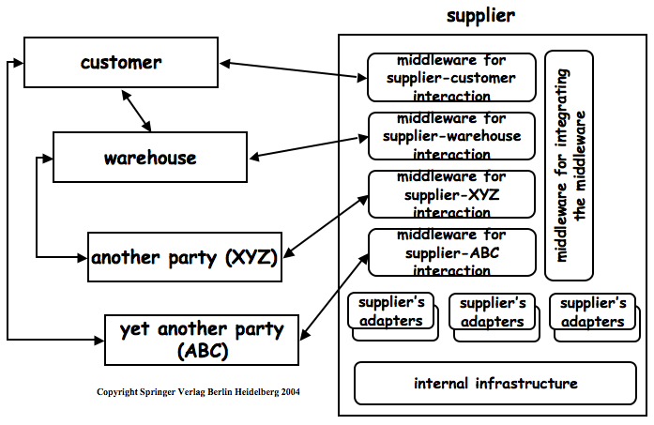
- The emergence of Web technologies with its standard interaction protocol (HTTP) and its standardized data formats (first, HTML, and now XML) has now set the stage to provide conventional middleware services in a B2B environment over the Web via the use of Web services technologies.
- There are three aspects of Web services that enable the resolution of some of the
- Software as Service: A software service is a software object with a stable, published interface that can be invoked by other software objects. In the case of Web services, these invocations occur via Web-based protocols (HTTP or SOAP) using Web-based data formats (XML). Web services assume that services are loosely-coupled (i.e. they have minimal dependencies) and are typically defined, developed, and deployed by different companies. .
- Middleware Protocols: Conventional middleware protocols, such as two-phase commit, were designed based on assumptions that do not hold in cross-organizational interactions. In order to provide conventional middleware services in a Web services setting, these protocols need to be redesigned to work in a peer-to-peer fashion without assuming the need for a centralized manager.
- Standardization: OASIS and the W3C are playing the role of standards organizations attempting to standardize all aspects of the Web Services domain. They are attempting to recreate the success that standardization played in making the Web itself a globally-pervasive technology.
- The following figure summarizes how these aspects will combine to enable B2B integration via Web services
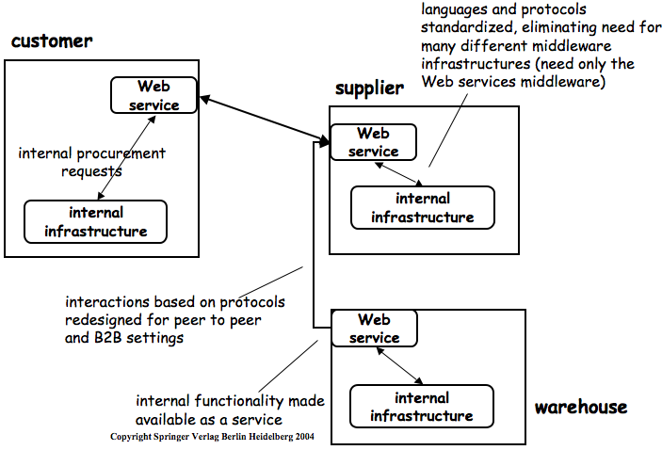
- The ultimate goal of Web services is to make it easy for companies to expose their local information systems in a controlled manner.
- In particular, if this goal is achieved, it would allow Web services to be used to enable EAI across companies or within companies but without the need for adaptors.
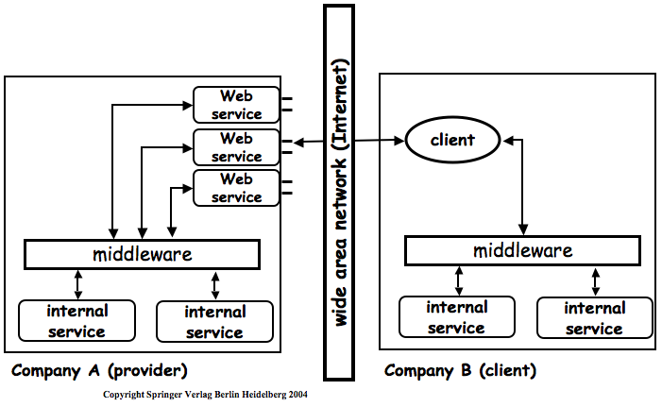
Web service Technologies
- Service Description
  - description is based on interfaces and IDLs. The semantics of the operations in these interfaces and the order in which they are to be invoked are assumed to be known by the team developing the middleware application. The properties of the service are also influenced by the middleware being used and since this is known in advance is not specified explicitly
  - In web services, service description is also based on interfaces but many of the implicit parameters for services of conventional middleware now need to be made explicit in the Web services context
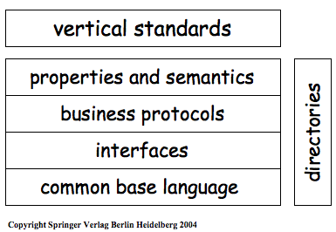
  - Base Language: XML (used by all higher languages)
  - Interfaces: A language used to describe the interface of a Web service. WSDL is the dominant proposal in this area
  - Business Protocols: The order in which operations of a service should be invoked to achieve business-related goals. No clear dominant proposal in this area: two contenders are WSCL and BPEL
  - Properties and Semantics: Specification of non-functional properties. UDDI is the dominant proposal in this area.
  - Verticals: Standards which specify the above information for a particular domain, such as health care or business transactions.
- Service Discovery
  - Service descriptions need to be stored in a service directory to enable clients to find services that they can use
  - This is known as service discovery and UDDI is the dominant specification for defining the APIs of service directories in the Web services world
- Service Interactions
  - Once a client has been connected to a service, standards are needed to specify the ways in which these two entities interact
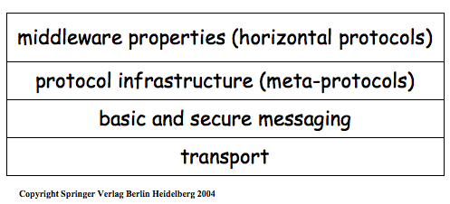
  - Transport: HTTP
  - Messaging: SOAP (specifies the on-the-wire format used to exchange messages between a client and a service)
  - Meta-Protocols: WS-Coordination how to coordinate the interactions between a client and a service
  - Middleware Protocols: How do we add services that conventional middleware provided to a Web Services environment. WS-Transaction is the first protocol being defined in order to add support for transactions when a client needs to access more than one web service with transaction semantics.
- Service Composition
  - What information do we need in order to combine existing services into new services. The services of multiple companies are being combined to create an information display not possible when using the services in isolation
Web service architecture
- Internal: how do we connect a Web service to a company's information systems
- External: how do we connect a client with a Web service
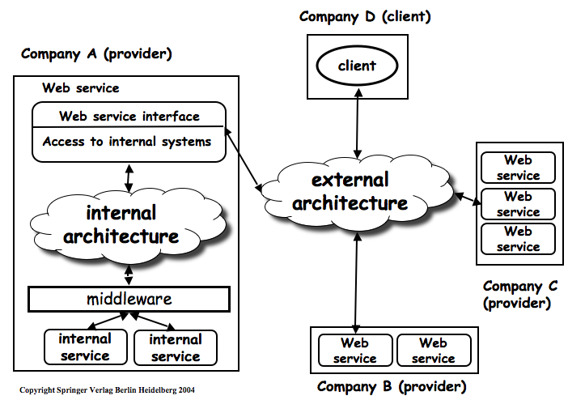
- Internal architecture, Web services are viewed as wrappers of existing information systems. We need a middleware layer that can connect Web services to a company's existing middleware platform.
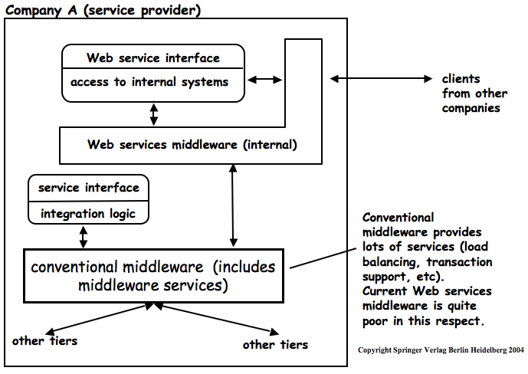
- External architecture, Web services assume the existence of a third-party directory service that is used for service discovery. Once such a service is in place, then the external architecture looks like this:
