UNIT II BUILDING XML- BASED APPLICATIONS
Parsing XML – using DOM, SAX – XML Transformation and XSL – XSL Formatting – Modeling Databases in XML.
  - Introduction to XML Parsing

What is XML Parsing?
Parsing XML refers to going through XML document to access data or to modify data in one or other way.

What is XML Parser?
XML Parser provides way how to access or modify data present in an XML document. Java provides multiple options to parse XML document. Following are various types of parsers which are commonly used to parse XML documents.
- Dom Parser - Parses the document by loading the complete contents of the document and creating its complete hierarchical tree in memory.
- SAX Parser - Parses the document on event based triggers. Does not load the complete document into the memory.
- JDOM Parser - Parses the document in similar fashion to DOM parser but in more easier way.
- StAX Parser - Parses the document in similar fashion to SAX parser but in more efficient way.
- XPath Parser - Parses the XML based on expression and is used extensively in conjuction with XSLT.
- DOM4J Parser - A java library to parse XML, XPath and XSLT using Java Collections Framework , provides support for DOM, SAX and JAXP.
There are JAXB and XSLT APIs available to handle XML parsing in Object Oriented way
What is DOM?
- DOM is a standard application programming interface (API) that makes it easy for programmers to access elements and delete, add, or edit content and attributes.
- "The W3C Document Object Model (DOM) is a platform and language-neutral interface that allows programs and scripts to dynamically access and update the content, structure, and style of a document."
- DOM was proposed by the World Wide Web Consortium (W3C) in August of 1997 in the User Interface Domain. The Activity was eventually moved to the Architecture Domain in November of 2000.
- DOM interfaces are defined independent of any particular programming language. We can write DOM code in any programming language, such as Java, ECMAScript (a standardized version of JavaScript/JScript), or C++.
- There is DOM APIs uses the Object Management Group’s (OMG) Interface Definition Language (IDL) to define DOM in a language-neutral way.
- Language-specific bindings, or DOM interfaces, exist for these languages.
- An implementation is a complete set of APIs for a given programming language that supports the DOM specification. These implementations are well documented and of high quality.
- The DOM is separated into 3 different parts / levels:
  - Core DOM - standard model for any structured document
  - XML DOM - standard model for XML documents
  - HTML DOM - standard model for HTML documents
- The DOM defines the objects and properties of all document elements, and the methods (interface) to access them.

Use of DOM
The main reason for using DOM is to create or modify an XML document programmatically.
Advantages
The DOM is a common interface for manipulating document structures. One of its design goals is that Java code written for one DOM-compliant parser should run on any other DOM-compliant parser without changes.
    - XML DOM Nodes
- In the DOM, everything in an XML document is a node.
- The entire document is a document node
- Every XML element is an element node
- The text in the XML elements are text nodes
- Every attribute is an attribute node
- Comments are comment nodes

Books.xml
<?xml version="1.0" encoding="UTF-8"?>
<bookstore>
<book category="cooking">
<title lang="en">Everyday Italian</title>
<author>Giada De Laurentiis</author>
<year>2005</year>
<price>30.00</price>
</book>
<book category="children">
<title lang="en">Harry Potter</title>
<author>J K. Rowling</author>
<year>2005</year>
<price>29.99</price>
</book>
<book category="web">
<title lang="en">XQuery Kick Start</title>
<author>James McGovern</author>
<author>Per Bothner</author>
<author>Kurt Cagle</author>
<author>James Linn</author>
<author>Vaidyanathan Nagarajan</author>
<year>2003</year>
<price>49.99</price>
</book>
<book category="web" cover="paperback">
<title lang="en">Learning XML</title>
<author>Erik T. Ray</author>
<year>2003</year>
<price>39.95</price>
</book>
</bookstore>
- The root node in the XML above is named <bookstore>. All other nodes in the document are contained within <bookstore>.
- The root node <bookstore> holds four <book> nodes.
- The first <book> node holds four nodes: <title>, <author>, <year>, and <price>, which contains one text node each, "Everyday Italian", "Giada De Laurentiis", "2005", and "30.00".
- Text is Always Stored in Text Nodes
- A common error in DOM processing is to expect an element node to contain text.
- However, the text of an element node is stored in a text node.
- In this example: <year>2005</year>, the element node <year>, holds a text node with the value "2005".
- "2005" is not the value of the <year> element!
    - The XML DOM Node Tree
- The XML DOM views an XML document as a tree-structure. The tree structure is called a node-tree.
- All nodes can be accessed through the tree. Their contents can be modified or deleted, and new elements can be created.
- The node tree shows the set of nodes, and the connections between them. The tree starts at the root node and branches out to the text nodes at the lowest level of the tree:
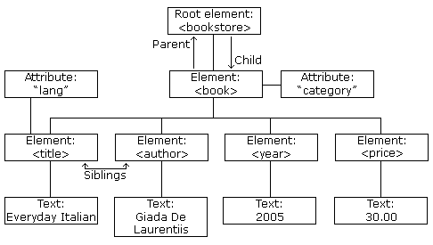
Node Parents, Children, and Siblings
- The nodes in the node tree have a hierarchical relationship to each other.
- The terms parent, child, and sibling are used to describe the relationships. Parent nodes have children. Children on the same level are called siblings (brothers or sisters).
- In a node tree, the top node is called the root
- Every node, except the root, has exactly one parent node
- A node can have any number of children
- A leaf is a node with no children
- Siblings are nodes with the same parent
The following image illustrates a part of the node tree and the relationship between the nodes:
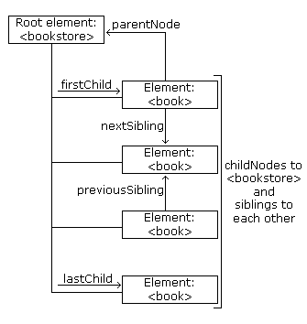
- Because the XML data is structured in a tree form, it can be traversed without knowing the exact structure of the tree and without knowing the type of data contained within.
    - DOM interfaces
Interface | Description
Node | The primary interface for the DOM. It can be an element, attribute, text, and so on, and contains methods for traversing a DOM tree.
NodeList | An ordered collection of Nodes.
NamedNodeMap | An unordered collection of Nodes that can be accessed by name and used with attributes.
Document | An Node representing an entire document. It contains the root Node.
DocumentFragment | A Node representing a piece of a document. It’s useful for extracting or inserting a fragment into a document
Element | A Node representing an XML element
Attr | A Node representing an XML attribute.
CharacterData | A Node representing character data.
Text | A CharacterData node representing text.
Comment. | A CharacterData node representing a comment
DOMException | An exception raised upon failure of an operation.
DOMImplementation | Methods for creating documents and determining whether  an implementation has certain features

    - Interface Relationships
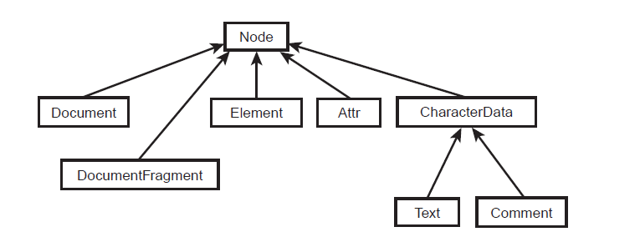

Extended Interfaces
Interface | Description
CDATASection | Text representing CDATA
DocumentType | A node representing document type
Notation | A node with public and system IDs of a notation
Entity | A node representing an entity that’s either parsed or  unparsed
EntityReference | A node representing an entity reference
ProcessingInstruction | A node representing an XML processing instruction

Common DOM methods
- Document.getDocumentElement() - Returns the root element of the document.
- Node.getFirstChild() - Returns the first child of a given Node.
- Node.getLastChild() - Returns the last child of a given Node.
- Node.getNextSibling() - These methods return the next sibling of a given Node.
- Node.getPreviousSibling() - These methods return the previous sibling of a given Node.
- Node.getAttribute(attrName) - For a given Node, returns the attribute with the requested name.
    - Steps to Using DOM
- Import XML-related packages.
- Create a DocumentBuilder
- Create a Document from a file or stream
- Extract the root element
- Examine attributes
- Examine sub-elements

- Import XML-related packages
import org.w3c.dom.*;
import javax.xml.parsers.*;
import java.io.*;
- Create a DocumentBuilder
DocumentBuilderFactory factory =
DocumentBuilderFactory.newInstance();
DocumentBuilder builder = factory.newDocumentBuilder();
- Create a Document from a file or stream
StringBuilder xmlStringBuilder = new StringBuilder();
xmlStringBuilder.append("<?xml version="1.0"?> <class> </class>");
ByteArrayInputStream input = new ByteArrayInputStream(
xmlStringBuilder.toString().getBytes("UTF-8"));
Document doc = builder.parse(input);
- Extract the root element
Element root = document.getDocumentElement();
- Examine attributes
//returns specific attribute
getAttribute("attributeName");
//returns a Map (table) of names/values
getAttributes();
- Examine sub-elements
//returns a list of subelements of specified name
getElementsByTagName("subelementName");
//returns a list of all child nodes
getChildNodes();

Here is the input xml file we need to parse:
<?xml version="1.0"?>
<class>
<student rollno="393">
<firstname>dinkar</firstname>
<lastname>kad</lastname>
<nickname>dinkar</nickname>
<marks>85</marks>
</student>
<student rollno="493">
<firstname>Vaneet</firstname>
<lastname>Gupta</lastname>
<nickname>vinni</nickname>
<marks>95</marks>
</student>
<student rollno="593">
<firstname>jasvir</firstname>
<lastname>singn</lastname>
<nickname>jazz</nickname>
<marks>90</marks>
</student>
</class>

Demo Example:
DomParserDemo.java
package com.tutorialspoint.xml;
import java.io.File;
import javax.xml.parsers.DocumentBuilderFactory;
import javax.xml.parsers.DocumentBuilder;
import org.w3c.dom.Document;
import org.w3c.dom.NodeList;
import org.w3c.dom.Node;
import org.w3c.dom.Element;

public class DomParserDemo {
public static void main(String[] args){

try {
File inputFile = new File("input.txt");
DocumentBuilderFactory dbFactory
= DocumentBuilderFactory.newInstance();
DocumentBuilder dBuilder = dbFactory.newDocumentBuilder();
Document doc = dBuilder.parse(inputFile);
doc.getDocumentElement().normalize();
System.out.println("Root element :"
+ doc.getDocumentElement().getNodeName());
NodeList nList = doc.getElementsByTagName("student");
System.out.println("----------------------------");
for (int temp = 0; temp < nList.getLength(); temp++) {
Node nNode = nList.item(temp);
System.out.println("\nCurrent Element :"
+ nNode.getNodeName());
if (nNode.getNodeType() == Node.ELEMENT_NODE) {
Element eElement = (Element) nNode;
System.out.println("Student roll no : "
+ eElement.getAttribute("rollno"));
System.out.println("First Name : "
+ eElement
.getElementsByTagName("firstname")
.item(0)
.getTextContent());
System.out.println("Last Name : "
+ eElement
.getElementsByTagName("lastname")
.item(0)
.getTextContent());
System.out.println("Nick Name : "
+ eElement
.getElementsByTagName("nickname")
.item(0)
.getTextContent());
System.out.println("Marks : "
+ eElement
.getElementsByTagName("marks")
.item(0)
.getTextContent());
}
}
} catch (Exception e) {
e.printStackTrace();
}
}
}

This would produce the following result:
Root element: class
----------------------------

Current Element :student
Student roll no : 393
First Name : dinkar
Last Name : kad
Nick Name : dinkar
Marks : 85

Current Element :student
Student roll no : 493
First Name : Vaneet
Last Name : Gupta
Nick Name : vinni
Marks : 95

Current Element :student
Student roll no : 593
First Name : jasvir
Last Name : singn
Nick Name : jazz
Marks : 90

  - Creating an XML Document
The XML document produced will be a directory listing in XML. The source code for DocBuilder.java is shown below
DocBuilder.java
package com.madhu.xml;
import java.io.*;
import org.w3c.dom.*;
import javax.xml.parsers.*;
public class DocBuilder {
protected DocumentBuilder docBuilder;
protected Element root;
protected Document doc;
protected PrintWriter writer;
public DocBuilder() throws Exception {
DocumentBuilderFactory dbf = DocumentBuilderFactory.newInstance();
docBuilder = dbf.newDocumentBuilder();
}
public void buildDOM(String startDir) throws Exception {
doc = docBuilder.newDocument();
root = doc.createElement(“directory-listing”);
appendFile(root, new File(startDir));
doc.appendChild(root);
}
public void appendFile(Node parent, File aFile) throws Exception {
if (aFile.isDirectory()) {
Element dirElement = doc.createElement(“directory”);
dirElement.setAttribute(“name”, aFile.getName());
File[] files = aFile.listFiles();
int n = files.length;
for (int i=0; i<n; i+=1) {
appendFile(dirElement, files[i]);
}
parent.appendChild(dirElement);
} else {
Element fileElement = doc.createElement(“file”);
Text fileName = doc.createTextNode(aFile.getName());
fileElement.appendChild(fileName);
parent.appendChild(fileElement);
}
}
public void writeDOM(PrintWriter bw) throws Exception {
writer = bw;
writer.println(“<?xml version=\”1.0\” encoding=\”UTF-8\”?>”);
writeNode(“”, root);
}
public void writeNode(String indent, Node aNode) {
switch (aNode.getNodeType()) {
case Node.TEXT_NODE:
writer.println(indent + aNode.getNodeValue());
break;
case Node.ELEMENT_NODE:
writer.print(indent + “<” + aNode.getNodeName());
NamedNodeMap attrs = aNode.getAttributes();
int n = attrs.getLength();
for (int i=0; i<n; i+=1) {
Node attr = attrs.item(i);
writer.print(“ “ + attr.getNodeName() + “=\””);
writer.print(attr.getNodeValue() + “\””);
}
writer.println(“>”);
Node child = aNode.getFirstChild();
while (child != null) {
writeNode(indent + “\t”, child);
child = child.getNextSibling();
}
writer.println(indent + “</” + aNode.getNodeName() + “>”);
break;
}
}
public static void main(String args[]) throws Exception {
DocBuilder db = new DocBuilder();
db.buildDOM(args[0]);
PrintWriter bw = new PrintWriter(
new FileWriter(args[1]));
db.writeDOM(bw);
bw.close();
}
}

- To create an XML document, we use the DocumentBuilderFactory and the DocumentBuilder interfaces and we will call the newDocument() method. This creates an empty Document object. Then we create elements and attributes as needed and attach them appropriately.
- The bulk of the work can be found in the methods buildDOM() and appendFile().
- Directories and files are treated as elements. The name of a directory becomes an attribute for a directory element, whereas the name of a file is added as a text child node for a file element.
Partial Output from DocBuilder
<?xml version=”1.0” encoding=”UTF-8”?>
<directory-listing>
<directory name=”..”>
<directory name=”com”>
<directory name=”madhu”>
<directory name=”xml”>
<file>
DocBuilder.class
</file>
<file>
SimpleWalker.class
</file>
</directory>
</directory>
</directory>
<directory name=”test”>
<file>
Makefile
</file>
<file>
personal-schema.xml
</file>
<file>
personal.dtd
</file>
<file>
personal.xml
</file>
...
- The Document interface contains the methods needed for creating any type of node. Element nodes contain a method called setAttribute() that conveniently creates and adds an attribute in one step. If an attribute with the same name already exists, its value is replaced.
- writeNode() method handles elements, text nodes, and attributes

  - DOM Traversal and Range
- Traversal and range are features added in DOM Level 2. They are supported by Apache Xerces. We can determine whether traversal is supported by calling the hasFeature() method of the DOMImplementation interface
Traversal
- Traversal is a convenient way to walk through a DOM tree and select specific nodes. This is useful when you want to find certain elements and perform operations on them.
Traversal Interfaces
Interface | Description
NodeIterator | Used to walk through nodes linearly. Represents a subtree as a linear list.
TreeWalker | Represents a subtree as a tree view.
NodeFilter | Can be used in conjunction with NodeIterator and TreeWalker to select specific nodes.
DocumentTraversal | Contains methods to create NodeIterator and TreeWalker instances.

Traversal Example
- By using traversal we want to print out just the names of books in our library. One way to do this is to write code to iterate through every node recursively and look for book elements. We can use NodeIterator to iterate through all the nodes and define a NodeFilter to select only the nodes with the name “book.” When we find a book node, we can get the value of the text content and print it out.
- There are two classes we need to define. The first one, IteratorApp.java, contains the application code. The second one, NameNodeFilter.java, selects nodes with a given name.. Both source files must import org.w3c.dom.traversal in order to reference the traversal interfaces.
IteratorApp.java
package com.madhu.xml;
import java.io.*;
import org.w3c.dom.*;
import org.w3c.dom.traversal.*;
import javax.xml.parsers.*;
public class IteratorApp {
protected DocumentBuilder docBuilder;
protected Document document;
protected Element root;
public IteratorApp() throws Exception {
DocumentBuilderFactory dbf = DocumentBuilderFactory.newInstance();
docBuilder = dbf.newDocumentBuilder();
DOMImplementation domImp = docBuilder.getDOMImplementation();
if (domImp.hasFeature(“Traversal”, “2.0”)) {
System.out.println(“Parser supports Traversal”);
}
}
public void parse(String fileName) throws Exception {
document = docBuilder.parse(new FileInputStream(fileName));
root = document.getDocumentElement();
System.out.println(“Root element is “ + root.getNodeName());
}
public void iterate() {
NodeIterator iter =
((DocumentTraversal)document).createNodeIterator(
root, NodeFilter.SHOW_ELEMENT,
new NameNodeFilter(“book”), true);
Node n = iter.nextNode();
while (n != null) {
System.out.println(n.getFirstChild().getNodeValue());
n = iter.nextNode();
}
}
public static void main(String args[]) throws Exception {
IteratorApp ia = new IteratorApp();
ia.parse(args[0]);
ia.iterate();
}
}

NameNodeFilter.java
package com.madhu.xml;
import org.w3c.dom.*;
import org.w3c.dom.traversal.*;
public class NameNodeFilter implements NodeFilter {
protected String name;
public NameNodeFilter(String inName) {
name = inName;
}
public short acceptNode(Node n) {
if (n.getNodeName().equals(name)) {
return FILTER_ACCEPT;
} else {
return FILTER_REJECT;
}
}
}
- Looking at IteratorApp.java, the traversal code is found in the iterate() method. We can create an instance of NodeIterator from the DocumentTraversal interface. The method for creating a NodeIterator is createNodeIterator(...), which accepts four parameters: the root node, a flag determining which nodes to show, a possible NodeFilter, and a flag determining whether entity references are to be expanded.
- In our example, we start at the document root, because we want to search the entire document. Constants in the NodeFilter interface define which nodes will be visible. The NodeFilter is optional. To define a node filter, we need to implement NodeFilter and fill in one method: acceptNode().
- As we iterate through nodes, the traversal API will call our acceptNode() method, which can return either FILTER_ACCEPT, FILTER_REJECT, or FILTER_SKIP. For node iterators, FILTER_REJECT and FILTER_SKIP do the same thing.
- In our acceptNode() method, we just compare the name of the node and return FILTER_ACCEPT if the node name matches the name supplied when NameNodeFilter was created. We created an instance of NameNodeFilter with the name “book,” so we should find only book elements.
- iterate() method in the IteratorApp class, we can use a while loop to go through the nodes. The method nextNode() will return null when we get to the end of the list. Only element nodes with name “book” are returned. Once we find a book element, we can obtain the text content node by calling getFirstChild() and then calling getNodeValue() on that node.
library.xml—Input XML Document
<?xml version=”1.0” encoding=”UTF-8”?>
<library>
<fiction>
<book>Moby Dick</book>
<book>The Last Trail</book>
</fiction>
<biography>
<book>The Last Lion, Winston Spencer Churchill</book>
</biography>
</library>
Here’s the output from IteratorApp:
Parser supports MutationEvents
Root element is library
Moby Dick
The Last Trail
The Last Lion, Winston Spencer Churchill
- The TreeWalker interface provides many of the same benefits as NodeIterator. The main difference is that TreeWalker presents a tree-oriented view of the nodes instead of a list-oriented view. An iterator allows you to move forward and backward, but a TreeWalker interface allows you to also move to the parent of a node, to one of its children, or to a sibling.

  - Range
- Range interfaces provide a convenient way to select, delete, extract, and insert content. We can determine whether range is supported by calling the hasFeature(...) method of the DOMImplementation interface. There are a number of applications for which the range interfaces are useful.
- A range consists of two boundary points corresponding to the start and the end of the range. A boundary point’s position in a Document or DocumentFragment tree can be characterized by a node and an offset. The node is the container of the boundary point and its position. The container and its ancestors are the ancestor containers of the boundary point and its position. The offset within the node is the offset of the boundary point and its position. If the container is an Attr, Document, DocumentFragment, Element, or EntityReference node, the offset is between its child nodes. If the container is CharacterData, Comment, or ProcessingInstruction node, the offset is between the 16-bit units of the UTF-16 encoded string contained by it.
- The boundary points of a range must have a common ancestor container that is either a Document, DocumentFragment, or Attr node. The content of a range must be entirely within the subtree rooted by a single Document, DocumentFragment, or Attr node. This common ancestor container is known as the root container of the range.
- The tree rooted by the root container is known as the range’s context tree. The container of a boundary point of a range must be an Element, Comment, ProcessingInstruction, EntityReference, CDATASection, Document, DocumentFragment, Attr, or Text node. None of the ancestor containers of the boundary point of a range can be a DocumentType, Entity, or Notation node.
    - Range Interfaces
Interface | Description
Range | This interface describes a range and contains methods to  define, delete, insert content.
DocumentRange | This interface creates a range.
Range Example
If we want to delete the first child node under the root. One way to do this is to write code to iterate through every node under the first child and remove it. We can accomplish the same operation with less code using ranges.
The source code for RangeApp.java is shown here and we must import org.w3c. dom.range in order to refer to the range interfaces.
RangeApp.java
package com.madhu.xml;
import java.io.*;
import org.w3c.dom.*;
import org.w3c.dom.ranges.*;
import javax.xml.parsers.*;
public class RangeApp {
protected DocumentBuilder docBuilder;
protected Document document;
protected Element root;
public RangeApp() throws Exception {
DocumentBuilderFactory dbf = DocumentBuilderFactory.newInstance();
docBuilder = dbf.newDocumentBuilder();
DOMImplementation domImp = docBuilder.getDOMImplementation();
if (domImp.hasFeature(“Range”, “2.0”)) {
System.out.println(“Parser supports Range”);
}
}
public void parse(String fileName) throws Exception {
document = docBuilder.parse(new FileInputStream(fileName));
root = document.getDocumentElement();
System.out.println(“Root element is “ + root.getNodeName());
}
public void deleteRange() {
Range r = ((DocumentRange)document).createRange();
r.selectNodeContents(root.getFirstChild());
r.deleteContents();
}
public static void main(String args[]) throws Exception {
RangeApp ra = new RangeApp();
ra.parse(args[0]);
ra.deleteRange();
}
}
- Here the traversal code is found in the deleteRange() method. We can create an instance of a range from the DocumentRange interface. We obtain a DocumentRange instance similar to the traversal example. If range is supported, the Document instance will also implement DocumentRange. The cast succeeds because range is supported by our implementation (Xerces). If it wasn’t supported, a ClassCastException would be raised at runtime.
- The method for creating a range is createRange(), with no arguments. A number of methods in the Range interface set the range. In the example, we used selectNodeContents() to select all the content under the first child node under the root. We can delete this content using deleteContents().
  - Other DOM Implementations
JDOM
- JDOM is not an acronym. It was originally developed as an open-source API for XML but has been accepted by the Java Community Process (JCP JSR-102). The home of JDOM is www.jdom.org.
- JDOM was designed specifically for Java. In contrast, DOM is purely an interface specification independent of any language. For example, a Java parser can leverage standard
- Java types and collections, such as the String class and the Collections API. The goal of W3C DOM is to be language independent, which works but can add a lot of unnecessary complications.
- Here are some of the guiding principles of JDOM:
  - JDOM should be straightforward for Java programmers.
  - JDOM should support easy and efficient document modification.
  - JDOM should hide the complexities of XML wherever possible, while remaining true to the XML specification.
  - JDOM should integrate with DOM and SAX.
  - JDOM should be lightweight and fast.
  - JDOM should solve 80 percent (or more) of Java/XML problems with 20 percent (or less) of the effort when compare with DOM.
- JDOM is a class-based API, whereas DOM is an interface-based API. There are classes that encapsulate documents, elements, attributes, text, and so on. This simplifies usage by minimizing downcasts. DOM is a strict hierarchy based on a node, which leads to lots of downcasts. Downcasts add complexity to source code and also reduce performance.
- JDOM does not parse XML by itself; rather, it can build JDOM objects from a DOM tree or a SAX parser. In general, it is more efficient to use JDOM’s SAXBuilder class if all you want to do is read XML from a file or stream.
JDOM Example
Let’s create an XML document using JDOM. The source code for JDOMCreate.java appears in
JDOMCreate.java
package com.madhu.xml;
import org.jdom.*;
import org.jdom.output.*;
public class JDOMCreate {
public static void main(String args[]) throws Exception {
Element root = new Element(“library”);
Document doc = new Document(root);
Element fiction = new Element(“fiction”);
Element book = new Element(“book”);
book.setAttribute(“author”, “Herman Melville”);
book.addContent(“Moby Dick”);
fiction.addContent(book);
root.addContent(fiction);
XMLOutputter outputter = new XMLOutputter(“\t”, true);
outputter.output(doc, System.out);
}
}
- Most of the JDOM classes are in the org.jdom package. We only need the org.jdom.output package in order to write the output using XMLOutputter. JDOM code is very simple. To create a document, all we need to do is create elements, using any of the Element class constructors. Once that is done, we can set attributes and add content. The addContent() method is overridden, so you can add text or elements using the same method.
- We must create the Document object given a root element. This is done to make sure the document is always well formed. Once the object graph representing our document is created, we can write it out to a stream using the XMLOutputter class. In the example, we write the document to System.out. We could write it to a file using FileOutputStream as well.
JDOMCreate Output
<?xml version=”1.0” encoding=”UTF-8”?>
<library>
<book author=”Herman Melville”>Moby Dick</book>
</fiction>
</library>
- Notice the nice formatting of the output. Indenting and new lines make the document look as if it was hand-edited. Formatting can be controlled through constructor parameters of the XMLOutputter class. In the example, we specified a Tab character (\t) for indenting and set new lines to true.
- JDOM is not meant to be a parser replacement. JDOM uses existing parsers to avoid reinventing the wheel JDOM distribution includes Apache Xerces
JDOMParse.java
package com.madhu.xml;
import java.io.*;
import org.jdom.*;
import org.jdom.input.*;
import org.jdom.output.*;
public class JDOMParse {
public static void main(String args[]) throws Exception {
SAXBuilder builder = new SAXBuilder();
Document doc = builder.build(new File(args[0]));
XMLOutputter outputter = new XMLOutputter(“\t”, true);
outputter.output(doc, System.out);
}
}
- We can use either a DOM or SAX parser in order to parse a document and produce a JDOM Document object. In practice, SAX parsers tend to be more efficient in terms of memory because the entire document is not read in at once, as is the case with DOM. The SAXBuilder class can build a document given a File object, InputStream, or a number of other sources.

Case Study: Building an XML Data Server
- We can see how DOM works in the real world. We will build a Java servlet that accepts a SQL statement to query a database and returns the results in the form of XML.. HTTP is a simple protocol that any firewall will pass without complaining. HTTP is easy to implement and easy to debug. Most importantly, it’s an open protocol with wide industry support.
- Commercial- quality data servers do a lot more, such as manage scalability through caching and load balancing. Even still, we can build an effective data server for illustration purposes, and scalability can be addressed later.
- A servlet accepts a request from a client and returns results in XML. The servlet acts as the “glue” between the Internet and the database.
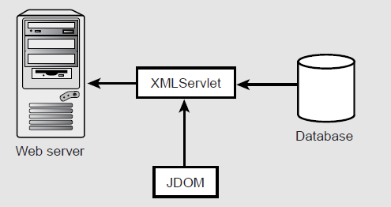
Servlet operation.
- We can use ResultSetMetaData from JDBC to give us this information. The source code for our XML servlet is shown in here .
XMLServlet.java
package com.madhu.xml;
import java.io.*;
import java.util.*;
import java.sql.*;
import javax.servlet.*;
import javax.servlet.http.*;
import org.jdom.*;
import org.jdom.output.*;
public class XMLServlet extends HttpServlet {
protected Connection connection;
public void init() {
try {
Class.forName(“sun.jdbc.odbc.JdbcOdbcDriver”);
connection = DriverManager.getConnection(
“jdbc:odbc:worldfactbook”);
} catch (Exception e) {
e.printStackTrace();
}
}
public void doGet(HttpServletRequest request,
HttpServletResponse response) throws IOException {
ServletConfig config = getServletConfig();
PrintWriter out = response.getWriter();
response.setContentType(“text/xml”);
try {
String sql = request.getParameter(“sql”);
Statement stat = connection.createStatement();
ResultSet rs = stat.executeQuery(sql);
ResultSetMetaData rsMeta = rs.getMetaData();
int rowNumber = 1;
Element root = new Element(“resultset”);
root.setAttribute(“query”, sql);
while (rs.next()) {
Element row = new Element(“row”);
row.setAttribute(“index”, Integer.toString(rowNumber));
int nCols = rsMeta.getColumnCount();
for (int i=1; i<=nCols; i+=1) {
String colName = rsMeta.getColumnName(i);
Element column = new Element(colName);
column.addContent(rs.getString(i));
row.addContent(column);
}
root.addContent(row);
rowNumber += 1;
}
rs.close();
stat.close();
Document doc = new Document(root);
XMLOutputter outputter = new XMLOutputter(“\t”, true);
outputter.output(doc, out);
} catch (Exception e) {
e.printStackTrace(out);
}
}
}

XMLServlet Sample Output
<?xml version=”1.0” encoding=”UTF-8”?>
<resultset query=”select * from people where country like ‘united%’”>
<row index=”1”>
<ID>220</ID>
<Country>United Arab Emirates</Country>
<Population>2369153.0</Population>
<GrowthRate>1.61</GrowthRate>
<BirthsPer1000>18.0</BirthsPer1000>
<DeathsPer1000>3.68</DeathsPer1000>
<NetMigrationPercent>1.82</NetMigrationPercent>
<NetMigration>43118.5846</NetMigration>
<InfantMortalityPer1000>17.17</InfantMortalityPer1000>
<TotalLifeExpectency>74.06</TotalLifeExpectency>
<MaleLifeExpectency>71.64</MaleLifeExpectency>
<FemaleLifeExpectency>76.61</FemaleLifeExpectency>
<TotalLiteracy>79.2</TotalLiteracy>
<MaleLiteracy>78.9</MaleLiteracy>
<FemalLiteracy>79.8</FemalLiteracy>
</row>
<row index=”2”>
<ID>221</ID>
<Country>United Kingdom</Country>
<Population>59511464.0</Population>
<GrowthRate>0.25</GrowthRate>
<BirthsPer1000>11.76</BirthsPer1000>
<DeathsPer1000>10.38</DeathsPer1000>
<NetMigrationPercent>1.07</NetMigrationPercent>
<NetMigration>636772.6648</NetMigration>
<InfantMortalityPer1000>5.63</InfantMortalityPer1000>
<TotalLifeExpectency>77.66</TotalLifeExpectency>
<MaleLifeExpectency>74.97</MaleLifeExpectency>
<FemaleLifeExpectency>80.49</FemaleLifeExpectency>
<TotalLiteracy>99.0</TotalLiteracy>
<MaleLiteracy>0.0</MaleLiteracy>
<FemalLiteracy>0.0</FemalLiteracy>
</row>
<row index=”3”>
<ID>222</ID>
<Country>United States</Country>
<Population>275562673.0</Population>
<GrowthRate>0.91</GrowthRate>
<BirthsPer1000>14.2</BirthsPer1000>
<DeathsPer1000>8.7</DeathsPer1000>
<NetMigrationPercent>3.5</NetMigrationPercent>
<NetMigration>9644693.555</NetMigration>
<InfantMortalityPer1000>6.82</InfantMortalityPer1000>
<TotalLifeExpectency>77.12</TotalLifeExpectency>
<MaleLifeExpectency>74.24</MaleLifeExpectency>
<FemaleLifeExpectency>79.9</FemaleLifeExpectency>
<TotalLiteracy>97.0</TotalLiteracy>
<MaleLiteracy>97.0</MaleLiteracy>
<FemalLiteracy>97.0</FemalLiteracy>
</row>
</resultset>

- The doGet() method will only be called in response to a GET request. If responses to both GET and POST requests are necessary, you can override the service() method instead.
- The SQL query is supplied as part of the query string. We can obtain this string
using the getParameter() method while supplying the name of the parameter. In our example, the parameter name is simply sql. Once we have the SQL, we can issue standard JDBC calls to obtain a result set.
- JDOM to create the DOM tree. JDOM can be easier to use when creating a document. The result set is translated into a DOM tree by using the ResultSet column names as element names. The column names are obtained through ResultSetMetaData. The resulting DOM tree is written to the response output stream using XMLOutputter.

  - SAX Parser

What Is SAX?
SAX is an API that can be used to parse XML documents. A parser is a program that reads data a character at a time and returns manageable pieces of data. For example, a parser for the English language might break up a document into paragraphs, words, and punctuation. In the case of XML, the important pieces of data include elements, attributes, text, and so on.
SAX provides a framework for defining event listeners, or handlers. These handlers are written by developers interested in parsing documents with a known structure. The handlers are registered with the SAX framework in order to receive events. Events can include start of document, start of element, end of element, and so on. The handlers contain a number of methods that will be called in response to these events. Once the handlers are defined and registered, an input source can be specified and parsing can begin.

What SAX Is Not
SAX by itself is just an API, and a number of implementations are available from many of the familiar sources. The most commonly used parsers are Xerces from the Apache XML project and Java API for XML Processing (JAXP) from Sun Microsystems. A good list of parsers can be found at http://www.xmlsoftware.com.
SAX was originally developed in Java, but similar implementations are available in other languages as well. There are implementations for Perl, Python, and C++, for example

Why Do I Need SAX?
SAX is completely free, so it can be embedded in a larger application without royalty fees or even copyright notices. Some SAX parsers can validate a document against a Document Type Definition (DTD) Validating parsers can also tell us specifically where validation has failed.

SAX vs. DOM
DOM | SAX
DOM is an in-memory tree structure of an XML document or document fragment. DOM is a natural object model of an XML document, but it’s not always practical. Large documents can take up a lot of memory | SAX is, in many ways, much simpler than DOM. There is no need to model every possible type of object that can be found in an XML document. This makes the API easy to  understand and easier to use
DOM contains many interfaces, each containing many methods. | SAX is comprised of a handful of classes and interfaces. SAX is a much lowerlevel API when compared with DOM
DOM implementations use SAX parsers under the hood to read in XML documents. | SAX parsers tend to be smaller than DOM implementations
 | SAX is an event-based API. Instead of loading an entire document into memory all at once, SAX parsers read documents and notify a client program when elements, text, comments, and other data of interest are found
The DOM parses XML in space | SAX parses XML in time
DOM parser hands you an entire document and allows you to traverse it any way you like. This can take a lot of memory | SAX can be significantly more efficient for large documents. In fact, you can process documents larger than available system memory, but this is not possible with DOM

Disadvantages
- SAX is not a perfect solution for all problems. For instance, it can be a bit harder to visualize compared to DOM because it is an event-driven model.
- SAX parsing is “single pass,” so we can’t back up and we can back up from a serial data stream.
- We have no random access at all. Handling parent/child relationships can be more challenging as well.
- SAX implementations are read-only parsers. They do not provide the ability to manipulate a document or its structure. DOM is the way to go if you want to manipulate a document
in memory.
- There is no formal specification for SAX. The interfaces and behavior are defined through existing code bases. This means there is no way to validate a SAX parser or to determine whether it works correctly.
SAX Versions
- The first version, SAX 1.0, was released in May 1998. It provided the basic functionality needed to read elements, attributes, text, and to manage errors. There was also some DTD support.
- The current version, SAX 2.0, was released two years later in May 2000. Many of the SAX 2.0 interfaces are departures from SAX 1.0. Older interfaces are included, but deprecated, for backward compatibility. SAX 2.0 also includes support for namespaces and extensibility through features and properties. Documentation is improved as well.

SAX Basics
<?xml version=”1.0” encoding=”UTF-8”?>
<fiction>
<book author=”Herman Melville”>Moby Dick</book>
</fiction>
- If we want to parse this document using SAX, we would build a content handler by creating a Java class that implements the ContentHandler interface in the org.xml.sax package. Convenience adapters are available that simplify some of this.
- Once you have a content handler, we register it with a SAX XMLReader, set up the input source, and start the parser. The methods of content handler will be called when the parser encounters elements, text, and other data. Specifically, the events generated by the preceding example will look something like this:
start document
start element: fiction
start element: book (including attributes)
characters: Moby Dick
end element: book
end element: fiction
end document

SAX Packages
The SAX 2.0 API is comprised of two standard packages and one extension package.
The standard packages are org.xml.sax and org.xml.helpers. The org.xml.sax package
contains the basic classes, interfaces, and exceptions needed for parsing documents.
The org.xml.sax Package
Name | Description
Interfaces  AttributeList | Depreciated This interface has been replaced by the SAX2  Attributes interface, which includes namespace support.
Attributes | Interface for a list of XML attributes.
ContentHandler | Receives notification of the logical content of a document.
DocumentHandler | Deprecated. This interface has been replaced by the SAX2
ContentHandler | interface, which includes namespace support
DTDHandler | Receives notification of basic DTD-related events.
EntityResolver | Basic interface for resolving entities.
ErrorHandler | Basic interface for SAX error handlers
Locator | Interface for associating a SAX event with a documentlocation.
Parser | Deprecated. This interface has been replaced by the SAX2  XML Reader interface, which includes namespace support
XMLFilter | Interface for an XML filter.
XMLReader | Interface for reading an XML document using callbacks.
Classes
HandlerBase | Deprecated. This class works with the deprecated. DocumentHandler interface
InputSource | A single input source for an XML entity.
Exceptions
SAXException | Encapsulates a general SAX error or warning.
SAXNotRecognizedException | Exception class for an unrecognized identifier.
SAXNotSupportedException | Exception class for an unsupported operation.
SAXParseException | Encapsulates an XML parse error or warning.

.
The org.xml.sax.helpers Package
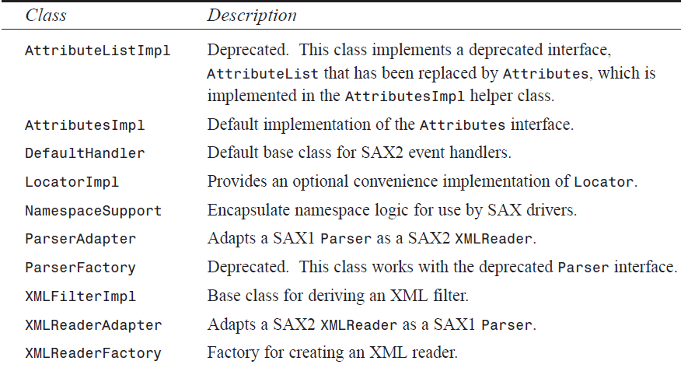
The org.xml.sax.ext Package
Interface | Description
DeclHandler | SAX2 extension handler for DTD declaration events
LexicalHandler | SAX2 extension handler for lexical events

SAX Implementations
- SAX implementations include all the underlying classes needed to parse documents. The SAX API by itself does not include these underlying classes, so we will need to obtain an implementation.
- As in the case of DOM, several high-quality free implementations exist, so cost is not an issue. If we want to validate documents while parsing XML, we will need a validating SAX implementation. Most validating implementations support DTDs, and some even support XML Schema.

SAXDemo.java
package com.madhu.xml;
import java.io.*;
import org.xml.sax.*;
import org.xml.sax.helpers.*;
import javax.xml.parsers.*;
public class SAXDemo extends DefaultHandler {
public void startDocument() {
System.out.println(“***Start of Document***”);
}
public void endDocument() {
System.out.println(“***End of Document***”);
}
public void startElement(String uri, String localName,
String qName, Attributes attributes) {
System.out.print(“<” + qName);
int n = attributes.getLength();
for (int i=0; i<n; i+=1) {
System.out.print(“ “ + attributes.getQName(i) +
“=’” + attributes.getValue(i) + “‘“);
}
System.out.println(“>”);
}
public void characters(char[] ch, int start, int length) {
System.out.println(new String(ch, start, length).trim());
}
public void endElement(String namespaceURI, String localName,
String qName) throws SAXException {
System.out.println(“</” + qName + “>”);
}
public static void main(String args[]) throws Exception {
if (args.length != 1) {
System.err.println(“Usage: java SAXDemo <xml-file>”);
System.exit(1);
}
SAXDemo handler = new SAXDemo();
SAXParserFactory factory = SAXParserFactory.newInstance();
SAXParser parser = factory.newSAXParser();
parser.parse(new File(args[0]), handler);
}
}

.
- We need the org.xml.sax package and the org.xml.helpers package. In addition, we have imported the javax.xml.parsers package. This package is part of JAXP, defined by the Java Community Process (JCP). Although this package is outside the scope of SAX proper, it is helpful in locating and creating a default SAX parser. This package is shipped with Xerces as well as JAXP from Sun Microsystems.
- Our class extends DefaultHandler in order to capture events. DefaultHandler is a convenience adapter class defined in org.xml.sax.helpers. It implements four interfaces: EntityResolver, DTDHandler, ContentHandler, and ErrorHandler.
- We could have implemented ContentHandler alone, but then we would be required to fill in all the methods of ContentHandler, even if we were not interested in all the events.
DefaultHandler defines empty stub methods for all these events. That way, we are free to fill in only the methods we are interested in. All other events are discarded.
- In order to register our handler, we can create a SAXParser instance and call its parse() method with a file and handler instance. The code to do this is located in the main() method of the example.
- In the example, we have defined five methods: startDocument(), endDocument(), startElement(), characters(), and endElement(). These methods will be called in response to related events, and they are defined in the ContentHandler interface, along with a number of others. Once the parse() method is called, our methods will be called in response to events until the end of input is reached or an error occurs.
The ContentHandler Methods
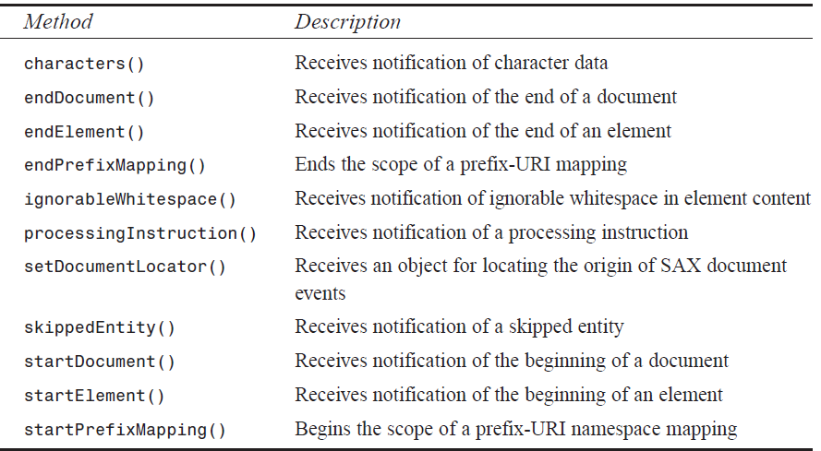
USING SAX
- The startElement() and endElement() methods accept several arguments: namespace
URI, local name, qualified name, and attributes. The first three are defined depending on whether namespaces are used. The characters() method provides an array of characters and locations where valid characters are found in the array. This is done for performance reasons. Typically, a String can be easily created, as shown earlier.

library.xml—Sample XML Document
<?xml version=”1.0” encoding=”UTF-8”?>
<!DOCTYPE library SYSTEM “library.dtd”>
<library>
<fiction>
<book author=”Herman Melville”>Moby Dick</book>
<book author=”Zane Grey”>The Last Trail</book>
</fiction>
<biography>
<book author=”William Manchester”>
The Last Lion, Winston Spencer Churchill
</book>
</biography>
<science>
<book author=”Hecht, Zajac”>Optics</book>
</science>
</library>
To execute SAXDemo, we can enter the following command:
java com.madhu.xml.SAXDemo library.xml
- This command specifies that the input file, library.xml, is located in the current directory.
Output from SAXDemo
***Start of Document***
<library>
<fiction>
<book author=’Herman Melville’>
Moby Dick
</book>
<book author=’Zane Grey’>
The Last Trail
</book>
</fiction>
<biography>
<book author=’William Manchester’>
The Last Lion, Winston Spencer Churchill
</book>
</biography>
<science>
<book author=’Hecht, Zajac’>
Optics
</book>
</science>
</library>
***End of Document***

Validation
- SAX parsers come in two varieties: validating and nonvalidating. Validating parsers can determine whether an XML document is valid based on a Document Type Definition
(DTD) or Schema. The SAX parser shipped with Apache Xerces is a validating parser. In order to use validation, we must turn it on by setting the validation feature to true.
- If we attempt to turn on validation with a nonvalidating parser, a SAXNotSupportedException will be thrown. If the parser does not recognize the feature, a SAXNotRecognizedException will be thrown. In the following example, we will write a simple program to validate an XML document.
- The document is expected to include a reference to its DTD, and the DTD is expected to be accessible. In this example, the DTD will be located on the local hard drive in the same directory as the document itself. SAX parsers are smart enough to understand URLs, so if an HTTP URL is specified, the parser will go out to the network to get the DTD
SAXValidator.java
package com.madhu.xml;
import java.io.*;
import org.xml.sax.*;
import org.xml.sax.helpers.*;
public class SAXValidator extends DefaultHandler {
private boolean valid;
private boolean wellFormed;
public SAXValidator() {
valid = true;
wellFormed = true;
}
public void startDocument() {
System.out.println(“***Start of Document***”);
}
public void endDocument() {
System.out.println(“***End of Document***”);
}
public void error(SAXParseException e) {
valid = false;
}
public void fatalError(SAXParseException e) {
wellFormed = false;
}
public void warning(SAXParseException e) {
valid = false;
}
public boolean isValid() {
return valid;
}
public boolean isWellFormed() {
return wellFormed;
}
public static void main(String args[]) throws Exception {
if (args.length != 1) {
System.err.println(“Usage: java SAXValidate <xml-file>”);
System.exit(1);
}
XMLReader parser = XMLReaderFactory.createXMLReader(
“org.apache.xerces.parsers.SAXParser”);
parser.setFeature(“http://xml.org/sax/features/validation”, true);
SAXValidator handler = new SAXValidator();
parser.setContentHandler(handler);
parser.setErrorHandler(handler);
parser.parse(new InputSource(new FileReader(args[0])));
if (!handler.isWellFormed()) {
System.out.println(“Document is NOT well formed.”);
}
if (!handler.isValid()) {
System.out.println(“Document is NOT valid.”);
}
if (handler.isWellFormed() && handler.isValid()) {
System.out.println(“Document is well formed and valid.”);
}
}
}

ErrorHandler.
ErrorHandler contains three methods that can be used to determine whether a document is well formed and valid.
The ErrorHandler Methods
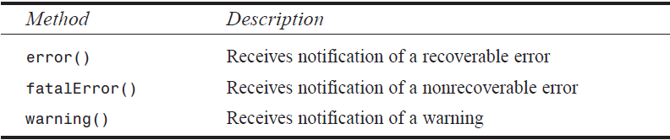
Either error() or warning() will be called if the document is well formed but not valid (that is, it violates the rules of the DTD), and fatalError() will be called if the document is not well formed. In this example, we will set flags for different types of errors and report the results when parsing is finished.

invalid-library.xml—Invalid XML Document
<?xml version=”1.0” encoding=”UTF-8”?>
<!DOCTYPE library SYSTEM “library.dtd”>
<library>
<fictions>
<book author=”Herman Melville”>Moby Dick</book>
<book author=”Zane Grey”>The Last Trail</book>
</fictions>
<biography>
<book author=”William Manchester”>
The Last Lion, Winston Spencer Churchill
</book>
</biography>
<science>
<book author=”Hecht, Zajac”>Optics</book>
</science>
</library>

library.dtd—DTD File
<?xml version=”1.0” encoding=”US-ASCII”?>
<!ELEMENT library (fiction|biography|science)*>
<!ELEMENT fiction (book)+>
<!ELEMENT biography (book)+>
<!ELEMENT science (book)+>
<!ELEMENT book (#PCDATA)>
<!ATTLIST book author CDATA #REQUIRED>

Output from SAXValidator
***Start of Document***
***End of Document***
Document is NOT valid.

SAX 2.0 features:
• http://xml.org/sax/features/namespaces
true: Performs namespace processing.
• http://xml.org/sax/features/namespace-prefixes
true: Reports the original prefixed names and attributes used for namespace declarations.
• http://xml.org/sax/features/string-interning
true: All element names, prefixes, attribute names, namespace URIs, and local names are internalized using java.lang.String.intern.
• http://xml.org/sax/features/validation
true: Reports all validation errors (implies external-general-entities and externalparameter-
entities).
• http://xml.org/sax/features/external-general-entities
true: Includes all external general (text) entities.
• http://xml.org/sax/features/external-parameter-entities
true: Includes all external parameter entities, including the external DTD subset.

Handling Errors
ErrorHandler methods supply a SAXParseException object that can also give us position information.
SAXErrors.java
package com.madhu.xml;
import java.io.*;
import org.xml.sax.*;
import org.xml.sax.helpers.*;
public class SAXErrors extends DefaultHandler {
private Locator locator;
public void startDocument() {
System.out.println(“***Start of Document***”);
}
public void endDocument() {
System.out.println(“***End of Document***”);
}
public void setDocumentLocator(Locator inLocator) {
System.out.println(“***Got Locator***”);
locator = inLocator;
int line = locator.getLineNumber();
int column = locator.getColumnNumber();
String publicID = locator.getPublicId();
String systemID = locator.getSystemId();
System.out.println(“Line “ + line + “, column “ + column);
if (publicID != null) {
System.out.println(“Public ID “ + publicID);
}
if (systemID != null) {
System.out.println(“System ID “ + systemID);
}
}
public void printLocation(SAXParseException e) {
int line = e.getLineNumber();
int column = e.getColumnNumber();
String publicID = e.getPublicId();
String systemID = e.getSystemId();
System.out.println(“Line “ + line + “, column “ + column);
if (publicID != null) {
System.out.println(“Public ID “ + publicID);
}
if (systemID != null) {
System.out.println(“System ID “ + systemID);
}
}
public void error(SAXParseException e) {
printLocation(e);
System.out.println(“Recoverable error: “ + e.getMessage());
Exception ex = e.getException();
if (ex != null) {
System.out.println(“Embedded exception: “ + ex.getMessage());
}
}
public void fatalError(SAXParseException e) {
printLocation(e);
System.out.println(“Non-recoverable error: “ + e.getMessage());
Exception ex = e.getException();
if (ex != null) {
System.out.println(“Embedded exception: “ + ex.getMessage());
}
}
public void warning(SAXParseException e) {
printLocation(e);
System.out.println(“Warning: “ + e.getMessage());
Exception ex = e.getException();
if (ex != null) {
System.out.println(“Embedded exception: “ + ex.getMessage());
}
}
public static void main(String args[]) throws Exception {
if (args.length != 1) {
System.err.println(“Usage: java SAXErrors <xml-file>”);
System.exit(1);
}
XMLReader parser = XMLReaderFactory.createXMLReader(
“org.apache.xerces.parsers.SAXParser”);
parser.setFeature(“http://xml.org/sax/features/validation”, true);
SAXErrors handler = new SAXErrors();
parser.setContentHandler(handler);
parser.setErrorHandler(handler);
parser.parse(new InputSource(new FileReader(args[0])));
}
}
Output from SAXErrors
***Got Locator***
Line 1, column 1
***Start of Document***
Line 4, column 12
Recoverable error: Element type “fictions” must be declared.
Line 16, column 11
Recoverable error: The content of element type “library” must match
[ic:ccc]”(fiction|biography|science)*”.
***End of Document***

Entity References
SAX parsers will resolve entity references automatically. In the following example, we will define an entity for hardcover books. It will be referenced as &hc; and defined in our DTD. If we use an HTTP URL to define the entity, the SAX parser will go out to the network to resolve it. What we want to do here is resolve the entity using a local file. We can accomplish this using an EntityResolver.

SAXEntity.java
package com.madhu.xml;
import java.io.*;
import org.xml.sax.*;
import org.xml.sax.helpers.*;
public class SAXEntity extends DefaultHandler {
public SAXEntity() {
}
public void startDocument() {
System.out.println(“***Start of Document***”);
}
public void endDocument() {
System.out.println(“***End of Document***”);
}
public void startElement(String uri, String localName,
String qName, Attributes attributes) {
System.out.print(“<” + qName);
int n = attributes.getLength();
for (int i=0; i<n; i+=1) {
System.out.print(“ “ + attributes.getQName(i) +
“=’” + attributes.getValue(i) + “‘“);
}
System.out.println(“>”);
}
public void characters(char[] ch, int start, int length) {
System.out.println(new String(ch, start, length).trim());
}
public void endElement(String namespaceURI, String localName,
String qName) throws SAXException {
System.out.println(“</” + qName + “>”);
}
public InputSource resolveEntity(String publicId, String systemId) {
try {
if (systemId.equals(“http://www.madhu.com/xml/hardcover.txt”)) {
return new InputSource(
new FileReader(“hardcover.txt”));
}
} catch (IOException e) {
}
return null; // for default behavior
}
public static void main(String args[]) throws Exception {
if (args.length != 1) {
System.err.println(“Usage: java SAXEntity <xml-file>”);
System.exit(1);
}
XMLReader parser = XMLReaderFactory.createXMLReader(
“org.apache.xerces.parsers.SAXParser”);
parser.setFeature(“http://xml.org/sax/features/validation”, true);
SAXEntity handler = new SAXEntity();
parser.setContentHandler(handler);
parser.setEntityResolver(handler);
parser.parse(new InputSource(new FileReader(args[0])));
}
}
USING SAX
EntityResolver is also implemented by DefaultHandler. EntityResolver contains only one method, resolveEntity(), which will be called with the system ID and public ID, depending on how the entity is defined. Once we determine what the entity is, we must return an InputSource pointing to where the entity resides.
InputSource is a class defined in package org.xml.sax. InputSource can be created given an InputStream or Reader. If an entity with our ID is referenced, we will return an InputSource pointing to a local file named hardcover.txt. In all other cases, null is returned, meaning use the default behavior and resolve all other entities automatically.
entity-ref.xml—XML Document with Entity Reference
<?xml version=”1.0” encoding=”UTF-8”?>
<!DOCTYPE library SYSTEM “library.dtd”>
<library>
<fiction>
<book author=”Herman Melville”>Moby Dick</book>
<book author=”Zane Grey”>The Last Trail</book>
</fiction>
<biography>
<book author=”William Manchester”>
The Last Lion, Winston Spencer Churchill &hc;
</book>
</biography>
<science>
<book author=”Hecht, Zajac”>Optics &hc;</book>
</science>
</library>

library.dtd—DTD with Entity Reference Definition
<?xml version=”1.0” encoding=”US-ASCII”?>
<!ELEMENT library (fiction|biography|science)*>
<!ELEMENT fiction (book)+>
<!ELEMENT biography (book)+>
<!ELEMENT science (book)+>
<!ELEMENT book (#PCDATA)>
<!ATTLIST book author CDATA #REQUIRED>
<!ENTITY hc SYSTEM “http://www.madhu.com/xml/hardcover.txt”>

Output from SAXEntity
***Start of Document***
<library>
<fiction>
<book author=’Herman Melville’>
Moby Dick
</book>
<book author=’Zane Grey’>
The Last Trail
</book>
</fiction>
<biography>
<book author=’William Manchester’>
The Last Lion, Winston Spencer Churchill
(hardcover)
</book>
</biography>
<science>
<book author=’Hecht, Zajac’>
Optics
(hardcover)
</book>
</science>
</library>
***End of Document***
Lexical Events
We can capture comments, CDATA, and DTD references by using an extension interface called LexicalHandler.
LexicalHandler is part of the org.xml.sax.ext package, which is not necessarily supported by all SAX implementations. Xerces, of course, provides support for the extension package.
SAXLexical.java
package com.madhu.xml;
import java.io.*;
import org.xml.sax.*;
import org.xml.sax.ext.*;
import org.xml.sax.helpers.*;
public class SAXLexical extends DefaultHandler implements LexicalHandler {
public SAXLexical() {
}
public void startDocument() {
System.out.println(“***Start of Document***”);
}
public void endDocument() {
System.out.println(“***End of Document***”);
}
public void startElement(String uri, String localName,
String qName, Attributes attributes) {
System.out.print(“<” + qName);
int n = attributes.getLength();
for (int i=0; i<n; i+=1) {
System.out.print(“ “ + attributes.getQName(i) +
“=’” + attributes.getValue(i) + “‘“);
}
System.out.println(“>”);
}
public void characters(char[] ch, int start, int length) {
System.out.println(new String(ch, start, length).trim());
}
public void endElement(String namespaceURI, String localName,
String qName) throws SAXException {
System.out.println(“</” + qName + “>”);
}
public void startDTD(String name, String publicId,
String systemId) throws SAXException {
System.out.print(“*** Start DTD, name “ + name);
if (publicId != null) {
System.out.print(“ PUBLIC “ + publicId);
}
if (systemId != null) {
System.out.print(“ SYSTEM “ + systemId);
}
System.out.println(“ ***”);
}
public void endDTD() throws SAXException {
System.out.println(“*** End DTD ***”);
}
public void startEntity(String name) throws SAXException {
System.out.println(“*** Start Entity “ + name + “ ***”);
}
public void endEntity(String name) throws SAXException {
System.out.println(“*** End Entity “ + name + “ ***”);
}
public void startCDATA() throws SAXException {
System.out.println(“*** Start CDATA ***”);
}
public void endCDATA() throws SAXException {
System.out.println(“*** End CDATA ***”);
}
public void comment(char[] ch, int start, int length)
throws SAXException {
System.out.println(“<!— “ +
new String(ch, start, length) + “ —>”);
}
public static void main(String args[]) throws Exception {
if (args.length != 1) {
System.err.println(“Usage: java SAXLexical <xml-file>”);
System.exit(1);
}
XMLReader parser = XMLReaderFactory.createXMLReader(
“org.apache.xerces.parsers.SAXParser”);
parser.setFeature(“http://xml.org/sax/features/validation”, true);
SAXLexical handler = new SAXLexical();
parser.setContentHandler(handler);
parser.setProperty(“http://xml.org/sax/properties/lexical-handler”,
handler);
parser.parse(new InputSource(new FileReader(args[0])));
}
}

The LexicalHandler Methods
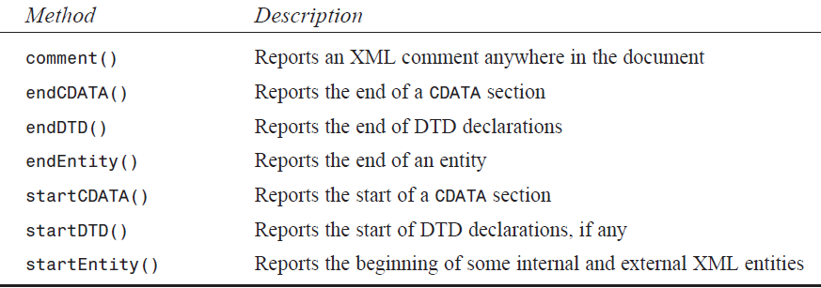
- In the main() method, notice that in order to register a lexical handler, we must call setProperty(). setProperty() method accepts a String property name and an Object property. This avoids the direct reference to LexicalHandler in the API. The property, in this case, is the handler itself. A sample XML document, comment.xml, is used for testing and is shown
comment.xml—Sample XML Document
<?xml version=”1.0” encoding=”UTF-8”?>
<!DOCTYPE library SYSTEM “library.dtd”>
<!— A short list of books in a library —>
<library>
<fiction>
<book author=”Herman Melville”>Moby Dick</book>
<book author=”Zane Grey”>The Last Trail</book>
</fiction>
<biography>
<book author=”William Manchester”>
The Last Lion, Winston Spencer Churchill
</book>
</biography>
<science>
<book author=”Hecht, Zajac”>Optics</book>
</science>
</library>
Output from SAXLexical
***Start of Document***
*** Start DTD, name library SYSTEM library.dtd ***
*** Start Entity [dtd] ***
*** End Entity [dtd] ***
*** End DTD ***
<!— A short list of books in a library —>
<library>
<fiction>
<book author=’Herman Melville’>
Moby Dick
</book>
<book author=’Zane Grey’>
The Last Trail
</book>
</fiction>
<biography>
<book author=’William Manchester’>
The Last Lion, Winston Spencer Churchill
</book>
</biography>
<science>
<book author=’Hecht, Zajac’>
Optics
</book>
</science>
</library>
***End of Document***

  - XML Transformation and XSL
    - XSL Technologies
XSL has two independent languages. They are
- The XSL Transformation Language (XSLT)
- The XSL Formatting Object Language (XSL-FO)
XSLT is used to convert an XML document to another format. XSL-FO provides a way of describing the presentation of an XML document. Both technologies use a supporting XML technology, XPath defines a standard mechanism for accessing elements
    - XSLT for Document Publishing
- XSL technology has an important role in the field of document publishing. Using XSL, we can convert the book list to an HTML file, PDF document, or other format. The key to this example is the XML document, which serves as a single data source. By applying an XSL style sheet, we render a new view of the data.
- We can also extend this example to support wireless Internet clients. A growing number of mobile phones and PDAs support the Wireless Application Protocol (WAP). These WAP enabled devices contain a mini browser for rendering Wireless Markup Language (WML) documents. To support the wireless Internet clients, we have to do is design an appropriate XSL style sheet to convert the XML document to WML. This process is illustrated in this Figure.
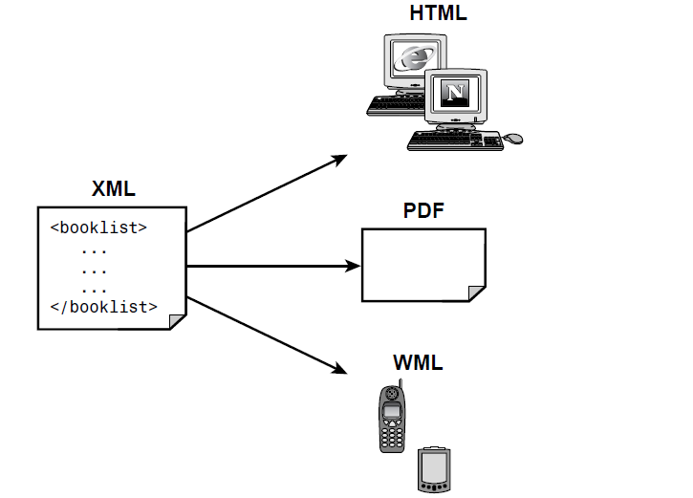
- XSLT provides the mechanism for converting an XML document to another format. This is accomplished by applying an XSLT style sheet to the XML document. The style sheet contains conversion rules for accessing and transforming the input XML document to a different output format. An XSLT processor is responsible for applying the rules defined in the style sheet to the input XML document.
- The process is illustrated in this Figure
Sending data to the XSLT processor.
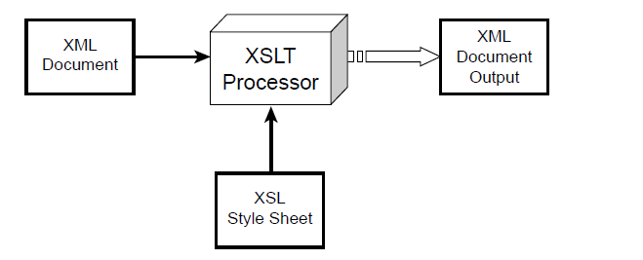
    - Getting Started with XSLT
We will convert an XML document to an HTML document. The XML document contains a list of books
book.xml
<?xml version=”1.0”?>
<?xml-stylesheet type=”text/xsl” href=”book_view.xsl”?>
<book>
<author>Michael Daconta et al</author>
<title>XML Development with Java 2</title>
<category>Java</category>
<price currency=”USD”>44.99</price>
<summary>
XML Development with Java 2 provides the information and techniques a Java developer will need to integrate XML into Java-based applications.
</summary>
</book>
Converting book.xml to an HTML table.
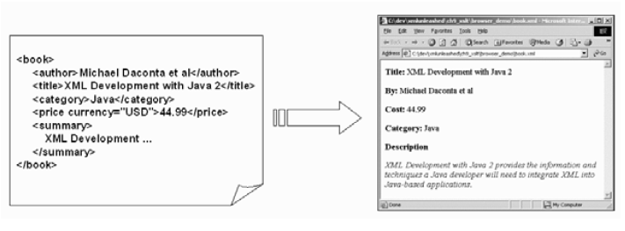
Step- 1: Creating the XML Document
The XML document, book.xml, contains elements for the author, title, price, summary, and
book.xml
<?xml version=”1.0”?>
<book>
<author>Michael Daconta et al</author>
<title>XML Development with Java 2</title>
<category>Java</category>
<price currency=”USD”>44.99</price>
<summary>
XML Development with Java 2 provides the information and techniques a Java developer will need to integrate XML into Java-based applications.
</summary>
</book>
In this example, we will apply the style sheet in a client-side Web browser. The XML document makes a reference to a style sheet using the following code:
<?xml-stylesheet type=”text/xsl” href=”book_view.xsl”?>
Step – 2: Creating the XSL Style Sheet
The next step is to create the XSL style sheet. XSL style sheets are XML documents; as a result, they must be well formed. An XSL style sheet has the following general structure:
<?xml version=”1.0”?>
<xsl:stylesheet xmlns:xsl=”URI” version=”1.0”>
<!--XSL-T CONVERSION RULES-->
</xsl:stylesheet>
- The <xsl:stylesheet> element defines how the XSLT processor should process the current XSL document. The xmlns attribute is the namespace definition. The XSL Transformation engine reads the xmlns attribute and determines whether it supports the given namespace. The xmlns attribute specifies the XSL prefix. All XSL elements and types in the document use the prefix.
- The xmlns attribute value contains a Uniform Resource Identifier (URI), which serves as a generic method for identifying entities on the World Wide Web. It is important to note that the XSLT processor will not connect to the URI; it simply compares the URI against a collection of URIs that it supports.
- The XSLT 1.0 specification defines the following URI for the XSL namespace:
http://www.w3.org/1999/XSL/Transform
- The “1999” in the URI indicates the year the URI was allocated by the World Wide Web Consortium (W3C). It does not relate to the version of XSLT that is being used. The XSLT version reference is specified using the version attribute of the <xsl:stylesheet> element. The version attribute is required.
- The XSL style sheet contains HTML text and XSL elements. The HTML text forms the basis of the desired output page. The XSL elements are template rules for the XSLT processor. A template is associated with a given element in the XML document. In our example, a template is defined to match on the <book> element using the following code:
<xsl:template match=”/book”>
<!--static text and xsl rules -->
</xsl:template>
- XSLT defines the <xsl:value-of> element for retrieving data from a XML document. The <xsl:value-of> element contains a select attribute. This attribute value is the name of the actual XML element you want to retrieve. For example, the following code will retrieve the title of the book:
<xsl:value-of select=”title” />
book_view.xsl
<?xml version=”1.0”?>
<xsl:stylesheet xmlns:xsl=”http://www.w3.org/1999/XSL/Transform” version=”1.0”>
<xsl:template match=”/book”>
<html><body>
<b>Title: </b> <xsl:value-of select=”title” />
<p/>
<b>By: </b> <xsl:value-of select=”author” />
<p/>
<b>Cost: </b> <xsl:value-of select=”price” />
<p/>
<b>Category: </b> <xsl:value-of select=”category” />
<p/>
<b>Description</b>
<p/>
<i><xsl:value-of select=”summary” /></i>
</body></html>
</xsl:template>
</xsl:stylesheet>
Step -3: The XSLT Processor
- XSLT processors are widely available. Here is the list of the most popular XSLT 1.0–compliant processors.
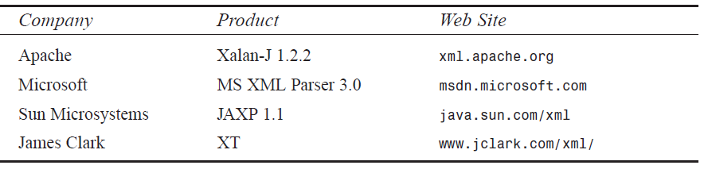Many other XSLT processors are available at www.xslt.com. The main difference
- For example, the parsers from Apache, Sun Microsystems, and James Clark provide a Java API. The Microsoft parser provides an API for Visual Basic and Visual C++. The Apache parser also provides a C++ API; however, development on the C++ version of Xalan has been suspended.
- Two techniques are available for performing the XSLT processing: client-side processing and server-side processing.
      - Client side XSLT Processing
- Client-side XSLT processing commonly occurs in a Web browser. The Web browser includes an XSLT processor and retrieves the XML document and XSL style sheet, as shown in Figure
Processing XSLT in a Web browser
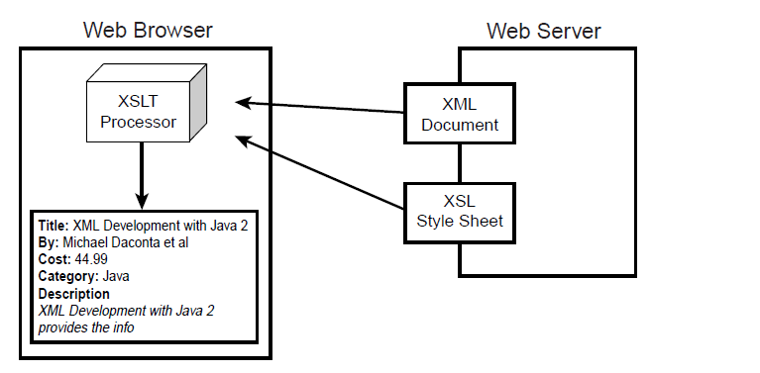
- The client-side technique offloads the XSLT processing to the client machine. This minimizes the workload on the Web server. However, the disadvantage is that the Web browser must provide XSLT support. Microsoft Internet Explorer 5.x has very limited support for XSLT 1.0. The previous version of the Netscape browser, 4.x, provides no support for XSLT.
- Microsoft Internet Explorer 5.x provides very limited support for XSLT 1.0. A number of XSLT elements are not supported, such as <xsl:sort>, <xsl:if>, and <xsl:number>, among others. the XSLT 1.0 specification.
- The client-side technique is applicable when you’re deploying an application in a controlled environment. For example, in a corporate environment, the system administrators can install the latest version of the Web browser that conforms to the XSLT 1.0 specification.
- .
Implementing Client-Side XSLT Processing
- For client-side processing, the XML document requires a special processing instruction to reference the XSL style sheet. The processing instruction is <?xml-stylesheet>, and it has two attributes: type and href. The type attribute specifies the content type of the document to be retrieved (in this case, text/xsl). The href attribute is a URL reference to the style sheet. The href attribute supports absolute and relative URL references.
The following code example uses a relative URL reference for the style sheet book_view.xsl:
- The updated version of the book.xml document. This version contains the special processing instruction to reference an XSL style sheet.
<?xml version=”1.0”?>
<?xml-stylesheet type=”text/xsl” href=”book_view.xsl”?>
<book>
<author>Michael Daconta et al</author>
<title>XML Development with Java 2</title>
<category>Java</category>
<price currency=”USD”>44.99</price>
<summary>
XML Development with Java 2 provides the information
and techniques a Java developer will need to integrate
XML into Java-based applications.
</summary>
</book>
- No changes are required to the XSL style sheet. The XSL style sheet is accessible by the reference in the XML document. In this example, the style sheet is located in the same directory as the XML document.
book_view.xsl
<?xml version=”1.0”?>
<xsl:stylesheet xmlns:xsl=”http://www.w3.org/1999/XSL/Transform” version=”1.0”>
<xsl:template match=”/book”>
<html><body>
<b>Title: </b> <xsl:value-of select=”title” />
<p/>
<b>By: </b> <xsl:value-of select=”author” />
<p/>
<b>Cost: </b> <xsl:value-of select=”price” />
<p/>
<b>Category: </b> <xsl:value-of select=”category” />
<p/>
<b>Description</b>
<p/>
<i><xsl:value-of select=”summary” /></i>
</body></html>
</xsl:template>
</xsl:stylesheet>
Start the Web browser and open the file book.xml. The XML document, book.xml, references the style sheet, book_view.xsl. When the book.xml file is loaded in the browser, the style sheet is applied and the output is rendered in the browser,
XSLT rendered in a Web browser.
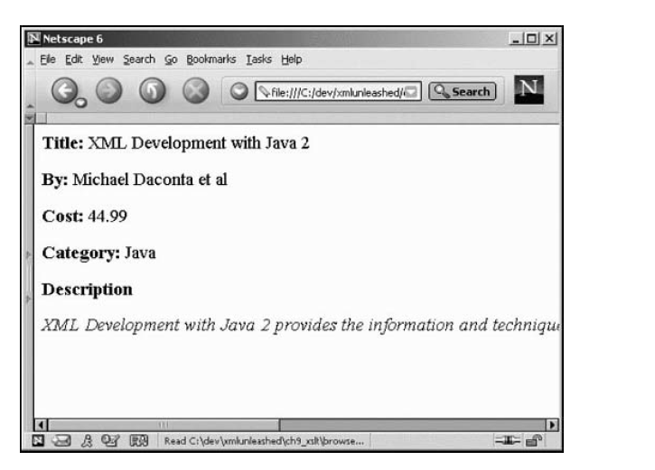

      - Server side XSLT Processing
- Server-side XSLT processing occurs on the Web server or application server. A serverside process such as an Active Server Page (ASP), JavaServer Page (JSP), or Java servlet will retrieve the XML document and XSL style sheet and pass them to an XSLT processor. The output of the XSLT processor is sent to the client Web browser for presentation. The output is generally a markup language, such as HTML, that is understood by the client browser. The application interaction is illustrated in Figure here .
Processing XSLT on the server side
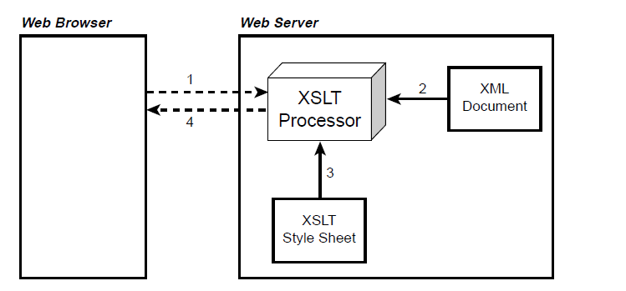
An advantage of the server-side technique is browser independence. Also, by utilizing the server-side technique, the application can support a diverse collection of clients. The application can detect the user-agent, such as a WAP-enabled mobile phone, and send back a document containing a Wireless Markup Language (WML) tag. The WAP-enabled phone can render the content using the built-in WML mini-browser
Implementing Server-Side XSLT Processing
- We implement the server-side processing technique. A number of server-side technologies are available, including Common Gateway Interface (CGI), ColdFusion, Hypertext Processor (PHP), and so on. This chapter focuses on server-side processing with Microsoft’s Active Server Pages (ASP) and Sun Microsystems’ JavaServer Pages (JSP).
ASP: Server-Side XSLT Processing
In order to develop using ASP, you will need the IIS Web server and the latest version of the Microsoft XML parser. The required components are listed below:
• Microsoft IIS Web Server 5.0. This version of IIS is included with Microsoft Windows 2000 Professional. We can also use IIS 4.0 or Personal Web Server (PWS); however, we will have to install the Windows NT Option Pack 4.
• Microsoft XML Parser 3.0. If you have IE 6 installed on your server machine, then MS XML Parser 3.0 is included.
An ASP file accesses the Microsoft XML parser as a server object. The following ASP code creates an input source for the XML document and XSL style sheet. Once the documents
are loaded, the XML document is transformed based on the rules in the style sheet. The output of the document is returned to the Web browser using the Response server object.
book_test.asp.
<%@ Language=VBScript %>
<%
set xml = Server.CreateObject(“Microsoft.XMLDOM”)
xml.load(Server.MapPath(“book.xml”))
set xsl = Server.CreateObject(“Microsoft.XMLDOM”)
xsl.load(Server.MapPath(“book_view.xsl”))
Response.Write(xml.transformNode(xsl))
%>
A Web browser rendering HTML
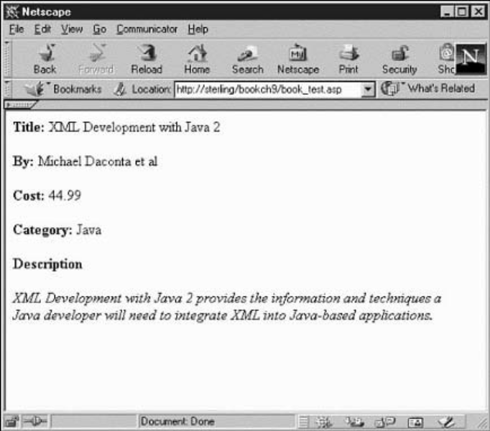
JSP: Server-Side XSLT Processing
Sun Microsystems provides a server-side technology that is very similar to ASP. In order to perform the serverside processing with JSP, we will need to install the Java Software Development Kit (SDK) along with a compliant JSP server container. Here’s a list of required components:
• Sun Microsystems’ Software Development Kit (SDK) 1.3 (or higher).
• Apache Tomcat Server 4. Apache Tomcat 4 is the official reference implementation for JSP 1.2 and Java Servlets 2.3. If your application server already supports JSP 1.1 or higher, there is no requirement to install Tomcat. This is accomplished by editing the file <tomcat_install_dir>\
conf\server.xml. Move to the section where the <Context> elements are listed and then add the following entry:
<Context path=”/bookch9”
docBase=”<install_dir>/ch9_xsl/public_html”
debug=”0”
reloadable=”true” />
- The Apache <jakarta:apply> tag provides the XSLT processing. The JSP code example shown in book_test.jsp.
book_test.jsp
<%@ taglib uri=”http://jakarta.apache.org/taglibs/xsl-1.0” prefix=”jakarta” %>
<jakarta:apply xml=”book.xml” xsl=”book_view.xsl” />
- The first line in this example informs the JSP server to use the tag library that is identified by the URI http://jakarta.apache.org/taglibs/xsl-1.0. This URI is defined in the Web application’s deployment description. The URI is actually mapped to the file jakarta-xsl.tld, located in the directory <install_dir>\ch9_xsl\public_html\WEBINF.
- The file jakarta-xsl.tld is the Tag Library Descriptor (TLD). The TLD file provides a description of the custom tags available in the class library. It also provides a mapping between the custom tag name and the tag handler class. The tag handler class is located in the directory <install_dir>\ch9_xsl\public_html\WEB-INF\lib.
- The next line of code is the actual <jakarta:apply> tag. This tag has two attributes— one defines the XML input source and the other defines the XSL style sheet. The results of the XSLT process are returned to the Web browser.
    - Advanced Features of XSLT
- Looping
The XSLT element <xsl:for-each> is used for looping through a list of elements. This is very useful when you have a collection of related items and if we would like to process them in a sequential fashion. The <xsl:for-each> element is commonly used in the Web development world to convert an XML document to an HTML table.
Here’s the syntax for <xsl:for-each>:
<xsl:for-each select=node-set-expression>
<!-- content -->
</xsl:for-each>
The <xsl:for-each> element has a required attribute: select. The value of the select attribute is an expression. The expression contains an XPath expression for selecting the appropriate elements from the list.
let’s create an XML document that contains a list of books. This could describe the books available at an e-commerce site or a list of books available in your company’s technical library. booklist.xml
<?xml version=”1.0”?>
<booklist>
<book>
<author>Michael Daconta et al</author>
<title>XML Development with Java 2</title>
<category>Java</category>
<price currency=”USD”>37.99</price>
</book>
<book>
<author>Mark Grand</author>
<title>Patterns in Java</title>
<category>Java</category>
<price currency=”USD”>44.99</price>
</book>
<book>
<author>Richard Monson-Haefel</author>
<title>Enterprise JavaBeans</title>
<category>Java</category>
<price currency=”USD”>34.95</price>
</book>
<book>
<author>Chad Darby et al</author>
<title>Professional Java E-Commerce</title>
<category>Java</category>
<price currency=”USD”>59.95</price>
</book>
<book>
<author>E. Lynn Harris</author>
<title>Any Way The Wind Blows</title>
<category>Fiction-Romance</category>
<price currency=”USD”>19.95</price>
</book>
<book>
<author>E. Lynn Harris</author>
<title>Invisible Life</title>
<category>Fiction-Romance</category>
<price currency=”USD”>16.95</price>
</book>
<book>
<author>E. Lynn Harris</author>
<title>And This Too Shall Pass</title>
<category>Fiction-Romance</category>
<price currency=”USD”>18.95</price>
</book>
<book>
<author>Tom Clancy</author>
<title>Executive Orders</title>
<category>Fiction-Thriller</category>
<price currency=”USD”>7.99</price>
</book>
<book>
<author>Tom Clancy</author>
<title>Hunt for Red October</title>
<category>Fiction-Thriller</category>
<price currency=”USD”>27.95</price>
</book>
<book>
<author>Tom Clancy</author>
<title>The Sum of All Fears</title>
<category>Fiction-Thriller</category>
<price currency=”USD”>7.99</price>
</book>
</booklist>

- Now, let’s design an XSL style sheet to convert the XML document to an HTML table. The <xsl:for-each> element loops over a list of items. This example performs a loop for each <book> element in the <booklist> element. This process is described in the select attribute with the expression booklist/book. See the following code snippet:
<xsl:for-each select=”booklist/book” >
<!-- insert table rows and table data -->
</xsl:for-each>
booklist_loop.xsl
<?xml version=”1.0”?>
<xsl:stylesheet xmlns:xsl=”http://www.w3.org/1999/XSL/Transform” version=”1.0”>
<xsl:template match=”/”>
<html><body>
<h3>Looping Example</h3>
<hr></hr>
<table border=”1” cellpadding=”5”>
<tr>
<th>Author</th>
<th>Title</th>
<th>Category</th>
<th>Price</th>
</tr>
<!-- Perform loop for each book in the book list -->
<xsl:for-each select=”booklist/book” >
<tr>
<td> <xsl:value-of select=”author” /> </td>
<td> <xsl:value-of select=”title” /> </td>
<td> <xsl:value-of select=”category” /> </td>
<td> <xsl:value-of select=”price” /> </td>
</tr>
</xsl:for-each>
</table>
</body></html>
</xsl:template>
</xsl:stylesheet>

book_test.jsp
<%@ taglib uri=”http://jakarta.apache.org/taglibs/xsl-1.0” prefix=”jakarta” %>
<jakarta:apply xml=”/loop/booklist.xml” xsl=”/loop/booklist_loop.xsl” />
To view the test file, start the Tomcat server. In the Web browser, open http:// localhost:8080/bookch9/loop/booklist_test.jsp.
9 The result of applying the style sheet to the XML document.
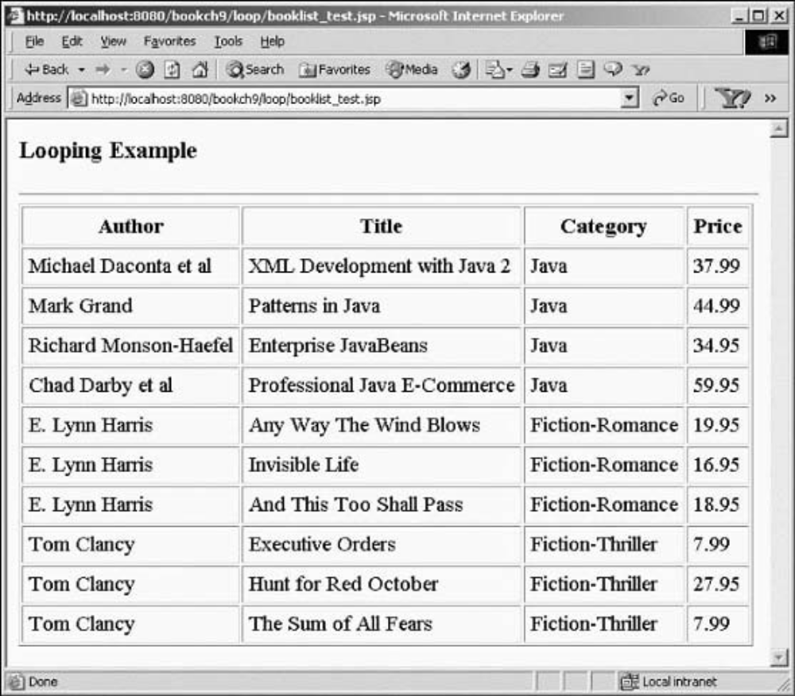
- Sorting
In XSLT, the <xsl:sort> element is used for sorting the XML data. It is possible to sort based on a single key or multiple keys. The syntax for the <xsl:sort> element is shown here:
<xsl:sort
select = string-expression
order = { “ascending” | “descending” }
data-type = { “text” | “number” }
case-order = {“upper-first” | “lower-first” }
lang = { nmtoken } />
The <xsl:sort> element is used in conjunction with the <xsl:for-each> element. For example, the following code snippet sorts the book titles in alphabetical order:
<!-- Sort by the book title -->
<xsl:for-each select=”booklist/book” >
<xsl:sort select=”title” />
<!-- insert table rows and table data -->
</xsl:for-each>
- Sort Order: Ascending or Descending?
By default, the information is sorted in ascending order. Set the order attribute to descending for a descending sort. The following code snippet sorts the titles in descending order:
<!-- Sort by the book title, descending -->
<xsl:for-each select=”booklist/book”>
<xsl:sort select=”title” order=”descending”/>
<!-- insert table rows and table data -->
</xsl:for-each>
It is important to note that the <xsl:sort> element assumes that the sort key is a text element. If we need to sort numerical data, we have to set the data-type attribute to number. If we don’t set the data-type attribute, the XSLT processor will use the default value, text. When sorting numerical data, the default value of text will not generate the desired output. To demonstrate this point, let’s attempt to sort the books in booklist.xml by price. The following code snippet purposefully omits the data-type attribute:
<xsl:for-each select=”booklist/book”>
<xsl:sort select=”price” />
<tr>
<td> <xsl:value-of select=”author” /> </td>
<td> <xsl:value-of select=”title” /> </td>
<td> <xsl:value-of select=”category” /> </td>
<td> <xsl:value-of select=”price” /> </td>
</tr>
</xsl:for-each>
9
Incorrect sorting of XML data by price.
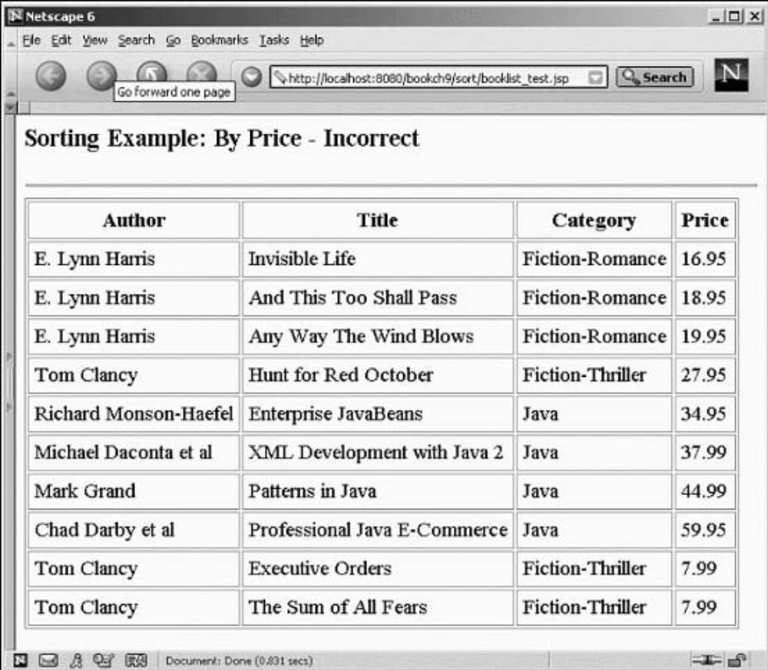
Notice that the prices are not sorted in an ascending order. To achieve numerical sorting, you have to specify <xsl:sort select=”price” datatype=” number” />.
booklist_sort.xsl
<?xml version=”1.0”?>
<xsl:stylesheet xmlns:xsl=”http://www.w3.org/1999/XSL/Transform” version=”1.0”>
<xsl:template match=”/”>
<html><body>
<h3>Sorting Example: By Price</h3>
<hr></hr>
<table border=”1” cellpadding=”5”>
<tr>
<th>Author</th>
<th>Title</th>
<th>Category</th>
<th>Price</th>
</tr>
<!-- Perform loop for each book in the book list -->
<xsl:for-each select=”booklist/book” >
<xsl:sort select=”price” order=”ascending” data-type=”number” />
<tr>
<td> <xsl:value-of select=”author” /> </td>
<td> <xsl:value-of select=”title” /> </td>
<td> <xsl:value-of select=”category” /> </td>
<td> <xsl:value-of select=”price” /> </td>
</tr>
</xsl:for-each>
</table>
</body></html>
</xsl:template>
</xsl:stylesheet>

XML data correctly sorted by price.
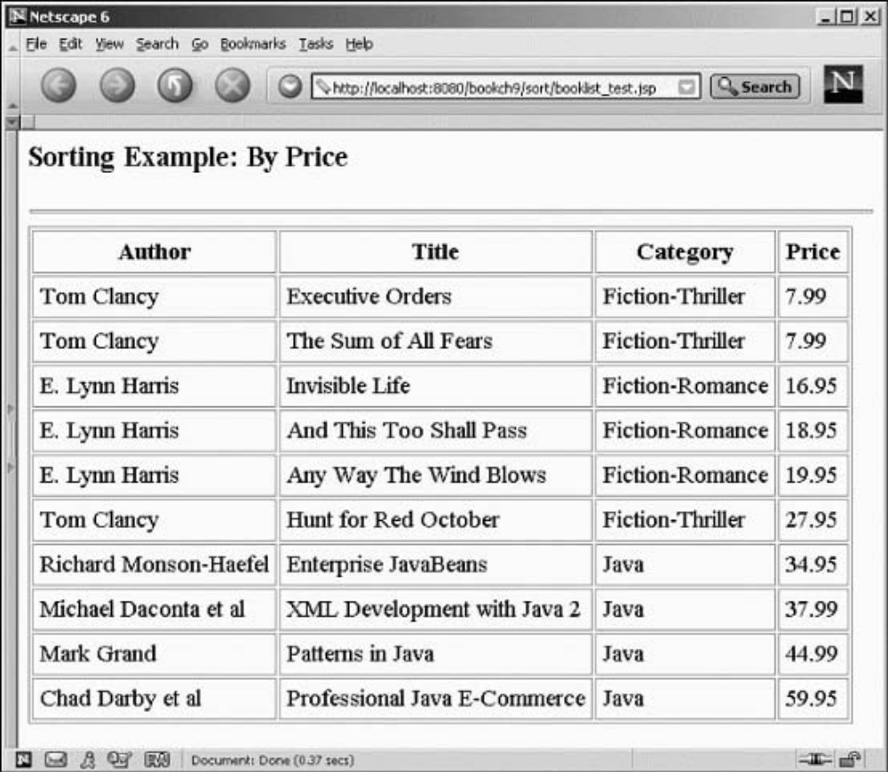

- Sorting by Case
The case-order attribute is used to specify whether uppercase or lowercase has precedence during the sort. For example, if the case-order attribute is set to upper-case, then
a b A B
is sorted as follows:
A a B b
If the lower-case attribute value is applied, then
a b A B
is sorted like this:
a A b B
The case-order attribute should only be used when the data-type attribute is set to text.
- Sorting with Multiple Keys
We want to sort using multiple keys. For example, we could sort the books by category and then by price. This is accomplished by inserting multiple <xsl:sort> elements within an <xsl:for-each> element.
Sorts by category and then by price: booklist_sort_categoryprice.xsl
<?xml version=”1.0”?>
<xsl:stylesheet xmlns:xsl=”http://www.w3.org/1999/XSL/Transform” version=”1.0”>
<xsl:template match=”/”>
<html><body>
<h3>Sorting Example: By Price</h3>
<hr></hr>
<table border=”1” cellpadding=”5”>
<tr>
<th>Author</th>
<th>Title</th>
<th>Category</th>
<th>Price</th>
</tr>
<!-- Perform loop for each book in the book list -->
<xsl:for-each select=”booklist/book” >
<xsl:sort select=”category” />
<xsl:sort select=”price” data-type=”number” />
<tr>
<td> <xsl:value-of select=”author” /> </td>
<td> <xsl:value-of select=”title” /> </td>
<td> <xsl:value-of select=”category” /> </td>
<td> <xsl:value-of select=”price” /> </td>
</tr>
</xsl:for-each>
</table>
</body></html>
</xsl:template>
</xsl:stylesheet>

- Conditionals
During an XSLT transformation, the style sheet can perform conditional tests on the data. XSLT contains a very simple if-then conditional. The syntax for the <xsl:if> element is shown here:
<xsl:if test=Boolean-expression>
<!-- content -->
</xsl:if>
The test attribute refers to a Boolean expression. If the Boolean expression evaluates to true, the content within the <xsl:if> element is included in the output.
The following code snippet performs a test for Fiction-Thriller books:
<xsl:for-each select=”booklist/book” >
<tr>
<xsl:if test=”category=’Fiction-Thriller’”>
<xsl:attribute name=”bgcolor”>red</xsl:attribute>
</xsl:if>
<td> <xsl:value-of select=”author” /> </td>
<td> <xsl:value-of select=”title” /> </td>
<td> <xsl:value-of select=”category” /> </td>
<td> <xsl:value-of select=”price” /> </td>
</tr>
</xsl:for-each>
The <xsl:attribute> element creates a new attribute for the parent element. In this example,
the parent is the <tr> element. If the conditional is true, the <tr> element will have the attribute bgcolor and its value set to red. The end result is <tr bgcolor=”red”>.

Filters
In relation to conditional tests, XSLT can also filter the data based on a given expression.When data is selected using the <xsl:for-each> element, the expression can contain a filter. For example, you can filter the data to contain only Java books. The following code snippet performs the desired operation:
<xsl:for-each select=”booklist/book[category=’Java’]” >
<tr>
<td> <xsl:value-of select=”author” /> </td>
<td> <xsl:value-of select=”title” /> </td>
<td> <xsl:value-of select=”category” /> </td>
<td> <xsl:value-of select=”price” /> </td>
</tr>
</xsl:for-each>
  - XSL for Business-to-Business (B2B) Communication

XSLT can also be used in for B2B communication—the process of exchanging data between two different companies. Developers can leverage XML to describe the data in a vendor-independent fashion. In the ideal case, both companies will agree upon a standard vocabulary for describing the data using a DTD or schema. The vocabulary is composed of the XML element names used in the XML document. However, in certain cases one of the companies might like to use a different vocabulary. This is where XSL enters the picture.
Case study
Hot Shot Training, and a software development company, AcmeSoft. The computer training company maintains a database for the students that have attended its courses. The training company has developed an XML application that produces the list of students for a given class.
The management team at AcmeSoft would like to retrieve this list from the training company’s
XML application. However, once the data is retrieved, AcmeSoft would like to store the data in a different XML format using its own XML element names.
Converting XML data in B2B communication.
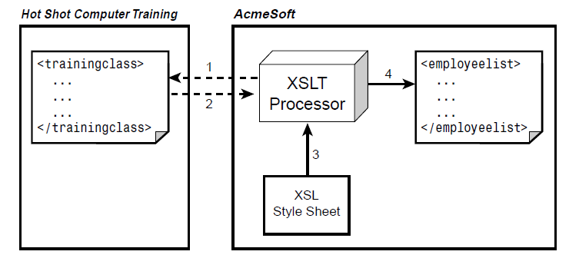
- The XML application at the training company is accessible using the HTTP protocol.
- Step-1: Request the XML document from the training company.
- Step 2: XML document is retrieved.
- Step 3: Document is transformed using the supplied XSLT style sheet.
- Step 4: Finally, the desired output document
A sample output of the XML document is shown here:
<?xml version=”1.0”?>
<trainingclass>
<title>J2EE Essentials</title>
<start_date>24 Sep 2001</start_date>
<end_date>28 Sep 2001</end_date>
<location>Philadelphia, PA</location>
<student>
<first_name>Riley</first_name>
<last_name>Scott</last_name>
<email>riley@acmesoft.web</email>
</student>
<student>
<first_name>Torrance</first_name>
<last_name>Lee</last_name>
<email>torrance.lee@acmesoft.web</email>
</student>
</trainingclass>

The development team at AcmeSoft has a different collection of element names to describe a training class. The desired output of the converted XML document for AcmeSoft is shown here:
<?xml version=”1.0”?>
<employeelist>
<course_title>J2EE Essentials</course_title>
<course_date start=”24 Sep 2001” end=”28 Sep 2001” />
<location>Philadelphia, PA</location>
<employee>
<name>
<first>Riley</first>
<last>Scott</last>
</name>
<email>riley.scott@acmesoft.web</email>
</employee>
<employee>
<name>
<first>Torrance</first>
<last>Lee</last>
</name>
<email>torrance.lee@acmesoft.web</email>
</employee>
</employeelist>
- Creating the XSL Style Sheet
The XSL style sheet will contain the template for the <employeelist> document, and the XSL elements will be leveraged to retrieve the data from the <trainingclass> document. The transformation is fairly straightforward, except for one area. The training company describes the date for the class using the elements <start_date> and <end_date>, as shown here:
<start_date>24 Sep 2001</start_date>
<end_date>28 Sep 2001</end_date>
AcmeSoft stores the date as a single element with two attributes for the start and end:
<course_date start=”24 Sep 2001” end=”28 Sep 2001” />
In this case, <xsl:attribute> can be used to create attributes for <course_date>:
<course_date>
<xsl:attribute name=”start”><xsl:value-of select=”start_date”/>
➥</xsl:attribute>
<xsl:attribute name=”end”><xsl:value-of select=”end_date”/></xsl:attribute>
</course_date>
The <xsl:attribute> element creates attributes for the parent element. In this example, the parent element is course_date. This transformation will result in the following code:
train2employee.xsl
<?xml version=”1.0”?>
<xsl:stylesheet xmlns:xsl=”http://www.w3.org/1999/XSL/Transform” version=”1.0”>
<xsl:template match=”/trainingclass”>
<employeelist>
<course_title><xsl:value-of select=”title” /></course_title>
<!-- create attributes for the start and end course dates -->
<course_date>
<xsl:attribute name=”start”>
<xsl:value-of select=”start_date”/>
</xsl:attribute>
<xsl:attribute name=”end”>
<xsl:value-of select=”end_date”/>
</xsl:attribute>
</course_date>
<location><xsl:value-of select=”location” /></location>
<!-- Perform a loop for each student in the training class -->
<xsl:for-each select=”student”
<employee>
<name>
<first><xsl:value-of select=”first_name”/></first>
<last><xsl:value-of select=”last_name”/></last>
</name>
<email><xsl:value-of select=”email”/></email>
</employee>
</xsl:for-each>
</employeelist>
</xsl:template>
</xsl:stylesheet>

Using the XSLT Processor
- For most B2B applications, the source XML document is retrieved by another application. This may be a standalone application or a component of a larger B2B application. In the case of a standalone application, the necessary code to perform the XSLT processing needs to be developed. For example, a Visual Basic or Visual C++ application can use the XSLT processor available with the Microsoft XML API.
- Java application can use the XSLT processor available with the Apache Xalan API. The Apache Xalan API is available at http://xml.apache.org.
- Here’s the code for a standalone Java application that uses the Apache Xalan API. The input XML document and the input XSL style sheet can be referenced using filenames
or URLs.
import org.apache.xalan.xslt.*;
/**
* Usage: java XslTester <input XML> <input XSL> <output file>
*/
public class XslTester{
public static void main(String[] args) {
try {
// Verify the correct arguments are passed in
if (args.length != 3) {
System.out.println(“Usage: java XslTester <input XML> <input XSL>
➥<output file>”);
System.exit(1);
}
System.out.println(“Processing: “ + args[0] + “ and “ + args[1]);
// Step 1: Get a reference to the XSLT Processor
XSLTProcessor myEngine = XSLTProcessorFactory.getProcessor();
// Step 2: Get the XML input document
XSLTInputSource xmlSource = new XSLTInputSource(args[0]);
// Step 3: Get the XSL style sheet
XSLTInputSource xslStylesheet = new XSLTInputSource(args[1]);
// Step 4: Setup the output target
XSLTResultTarget xmlOutput = new XSLTResultTarget(args[2]);
// Step 5: Now process it!
myEngine.process(xmlSource, xslStylesheet, xmlOutput);
System.out.println(“Created => “ + args[2]);
System.out.println(“Done!”);
}
catch (Exception exc) {
exc.printStackTrace();
}
}
}

- The first task of the main method is verifying the correct number of parameters. Next, the application retrieves a reference to the XSLT processing engine using the factory method XSLTProcessorFactory.getProcessor(). The application then retrieves the input XML document and XSL style sheet based on the first two command-line arguments. The result target for the XSLT translation is configured to use the filename supplied as the third command-line argument. Finally, the XSLT processing engine is invoked using the objects xmlSource, xslStylesheet, and xmlOutput.
Running the Example
This example requires the Java Development Kit version 1.3 or higher. Follow these steps to test it:
  - Open an MS-DOS window.
  - Move to the directory <install_dir>\ch9_xsl\b2b\.
  - Set up the Java classpath by typing setpaths.
  - Execute the application by typing the following:
java XslTester trainingclass.xml train2employee.xsl testoutput.xml
  - View the testoutput.xml file in a text editor.
<?xml version=”1.0” encoding=”UTF-8”?>
<employeelist>
<course_title>J2EE Essentials</course_title>
<course_date start=”24 Sep 2001” end=”28 Sep 2001”/>
<location>Philadelphia, PA</location>
<employee>
<name>
<first>Riley</first>
<last>Scott</last>
</name>
<email>riley@acmesoft.web</email>
</employee>
<employee>
<name>
<first>Torrance</first>
<last>Lee</last>
</name>
<email>torrance.lee@acmesoft.web</email>
</employee>
</employeelist>
  - XSL Formatting Objects
- The XSL technology is also composed of XSL Formatting Objects (XSL-FO). XSL-FO was designed to assist with the printing and displaying of XML data. The main importance is on the document layout and structure. This includes the dimensions of the output document, including page headers, footers, and margins. XSL-FO also allows the developer to define the formatting rules for the content, such as font, style, color, and positioning.
- XSL-FO is a sophisticated version of Cascading Style Sheets (CSS). In fact, XSL-FO borrows a lot of the terminology and elements from CSS.
- XSL-FO documents are well-formed XML documents. An XSL-FO formatting engine processes XSL-FO documents.
- We can use two techniques for creating XSL-FO documents.
  - The first is to simply develop the XSL-FO file with the included data.
  - The second technique is to dynamically create the XSL-FO file using an XSLT translation.
    - XSL-FO Formatting Engines
- The current W3C Candidate Recommendation for XSL-FO is 15 October 2001 and is available at http://www.w3.org/TR/2001/REC-xsl-20011015.We can use the Apache XSL-FOP to generate PDF documents from XML.
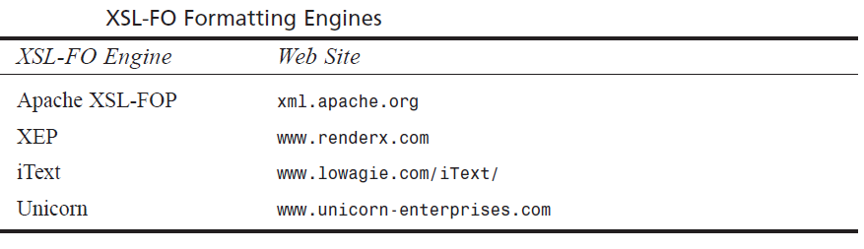

- we will create a simple XSL-FO document. Once the document is created, we will use the Apache XSL-FOP formatter to convert the document to a PDF file.
Apache XSL-FOP generating PDF documents.
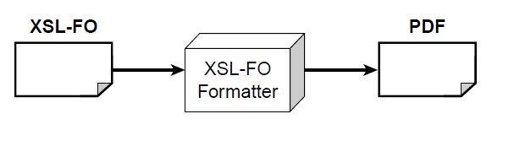
    - Basic Document Structure
- An XML-FO document follows the syntax rules of XML; as a result, it is well formed. XSL-FO elements use the following namespace:
http://www.w3.org/1999/XSL/Format
The following code snippet shows the basic document setup for XSL-FO:

<?xml version=”1.0” encoding=”utf-8”?>
<fo:root xmlns:fo=”http://www.w3.org/1999/XSL/Format”>
<!-- layout master set -->
<!-- page masters: size and layout -->
<!-- page sequences and content -->
</fo:root>
- The element <fo:root> is the root element for the XSL-FO document. An XSL-FO document can contain the following components:
  - Page master
  - Page master set
  - Page sequences
- Page Master: <fo:page-master>
The page master describes the page size and layout. For example, we could use an 8.5X11-inch page or an A4 letter. The page master contains the dimensions for a page, including width, height, and margins. The page master is similar to a slide master in Microsoft PowerPoint. The components of the page master are shown in Figure
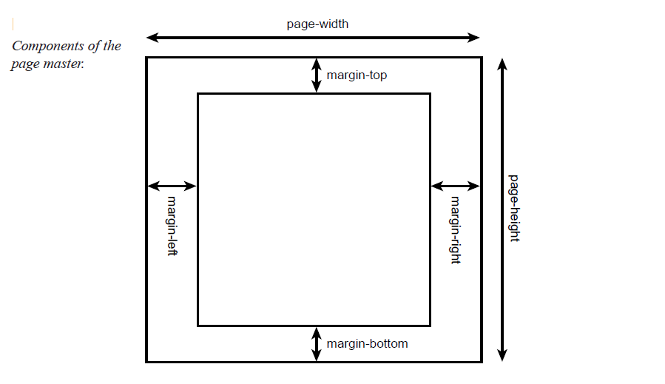
The <fo:simple-page-master> element defines the layout of a page. The following code snippet describes a U.S. letter:
<fo:simple-page-master master-name=”simple”
page-height=”11in”
page-width=”8.5in”
margin-top=”1in”
margin-bottom=”1in”
margin-left=”1.25in”
margin-right=”1.25in”>
</fo:simple-page-master>

The attributes for <fo:simple-page-master>. The attributes define the height and width of the page, along with the size of the margins. The dimensions in this example are listed in inches (in).
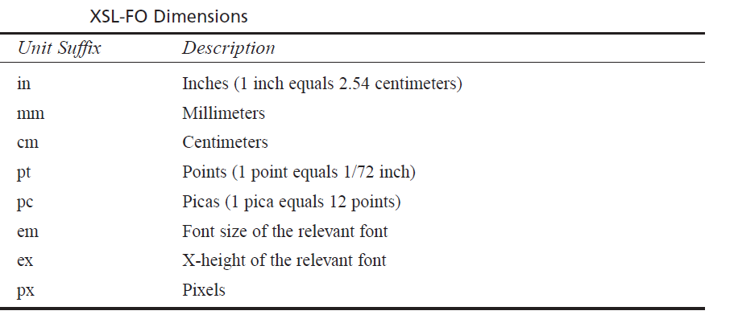
To set the page height to 210 millimeters, use the following syntax:
page-height=”210mm”
The <fo:simple-page-master> element can also be used to describe an A4 letter (height 210 mm and width 297 mm):
<fo:simple-page-master master-name=”A4-example”
page-height=”210mm”
page-width=”297mm”
margin-top=”0.5in”
margin-bottom=”0.5in”
margin-left=”0.5in”
margin-right=”0.5in”>
</fo:simple-page-master>

Each page is divided into five regions. Regions serve as containers for the document content. The regions are depicted below
Five regions of a page.
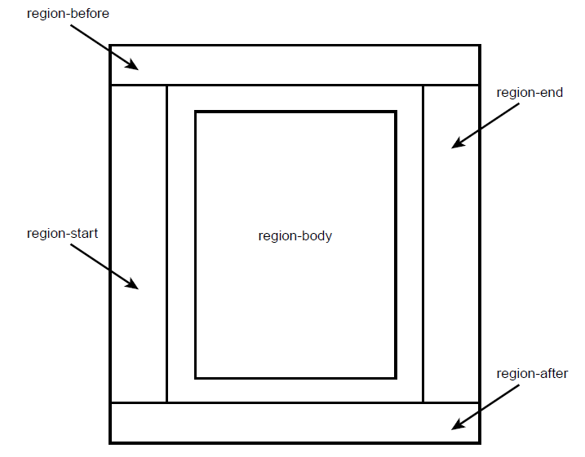
The region-before and region-after areas are commonly used for page headers and footers. The region-body area is the center of the page and contains the main content. The region-start and region-end sections are commonly used for left and right sidebars, respectively. During the definition of a page master, we have to specify the size of the regions using the following elements:
  - <fo:region-before>
  - <fo:region-after>
  - <fo:region-body>
  - <fo:region-start>
  - <fo:region-end>
The following example defines the dimensions for <fo:region-body>, <fo:regionbefore>,
and <fo:region-after>:
<fo:simple-page-master master-name=”simple”
page-height=”11in”
page-width=”8.5in”>
<fo:region-body margin-top=”0.5in”/>
<fo:region-before extent=”0.5in”/>
<fo:region-after extent=”0.5in”/>
</fo:simple-page-master>
The extent attribute has a different meaning, depending on the region. For <fo:regionend> and <fo:region-start>, the extent attribute specifies the width. For <fo:regionbefore> and <fo:region-after>, it specifies the height.
- Page Master Set: <fo:page-master-set>
A document can be composed of multiple pages, each with its own dimensions. The page master set refers to the collection of page masters.
In the following code example, a page master set is defined that contains one page set:

<fo:layout-master-set>
<fo:simple-page-master master-name=”simple”
page-height=”11in”
page-width=”8.5in”
margin-top=”1in”
margin-bottom=”1in”
margin-left=”1.25in”
margin-right=”1.25in”>
<fo:region-body margin-top=”0.5in”/>
<fo:region-before extent=”3cm”/>
<fo:region-after extent=”1.5cm”/>
</fo:simple-page-master>
</fo:layout-master-set>

- Page Sequences: <fo:page-sequence>
- A page sequence defines a series of printed pages. Each page sequence refers to a page master for its dimensions. The page sequence contains the actual content for the document.
- The <fo:page-sequence> element contains <fo:static-content> and <fo:flow> elements.
- The <fo:static-content> element is used for page headers and footers. For example, we can define a header for the company name and page number, and this information will appear on every page.
- The <fo:flow> element contains a collection of text blocks. The <fo:flow> element is similar to a collection of paragraphs.
- A body of text is defined using the <fo:block> element . The <fo:block> element is a child element of <fo:flow>. The <fo:block> element contains free-flowing text that will wrap to the next line in a document if it overflows.
PDF document for Ez Books Online.
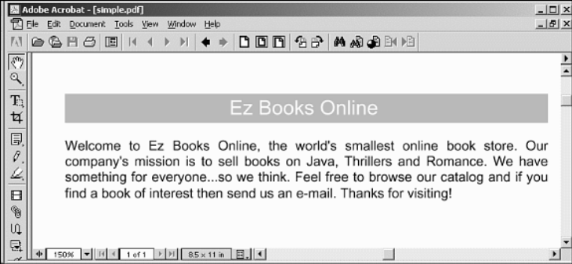

The following code fragment defines a page sequence. This sequence uses the simple page master. Also, the <fo:flow> element contains two <fo:block> elements. Here’s the code:
<fo:page-sequence master-name=”simple”>
<fo:flow flow-name=”xsl-region-body”>
<!-- this defines a level 1 heading with orange background -->
<fo:block font-size=”18pt”
font-family=”sans-serif”
line-height=”24pt”
space-after.optimum=”15pt”
background-color=”orange”
color=”white”
text-align=”center”
padding-top=”3pt”>
Ez Books Online
</fo:block>
<!-- Paragraph that contains info about the company -->
<fo:block font-size=”12pt”
font-family=”sans-serif”
line-height=”15pt”
space-after.optimum=”14pt”
text-align=”justify”>
Welcome to Ez Books Online, the world’s smallest online book store.
Our company’s mission is to sell books on Java, Thrillers and Romance.
We have something for everyone...so we think. Feel free to browse our
catalog and if you find a book of interest then send us an e-mail.
Thanks for visiting!
</fo:block>
</fo:flow>
</fo:page-sequence>

- The <fo:flow> element has to specify a region for its content. In this example, the content is placed in the main body region.
- The first <fo:block> element defines a heading with an orange background.
- The second <fo:block> element contains information about the company. The text for <fo:block> is free flowing. The text will automatically wrap. Ample space is provided at the end of the paragraph using the space-after.optimum attribute.
Now let’s integrate the new elements into the basic document structure.
simple.fo
<?xml version=”1.0” encoding=”utf-8”?>
<fo:root xmlns:fo=”http://www.w3.org/1999/XSL/Format”>
<!-- layout master set -->
<fo:layout-master-set>
<!-- page masters: size and layout -->
<fo:simple-page-master master-name=”simple”
page-height=”11in”
page-width=”8.5in”
margin-top=”1in”
margin-bottom=”1in”
margin-left=”1.25in”
margin-right=”1.25in”>
<fo:region-body margin-top=”0.5in”/>
<fo:region-before extent=”3cm”/>
<fo:region-after extent=”1.5cm”/>
</fo:simple-page-master>
</fo:layout-master-set>
<!-- page sequences and content -->
<fo:page-sequence master-name=”simple”>
<fo:flow flow-name=”xsl-region-body”>
<!-- this defines a level 1 heading with orange background -->
<fo:block font-size=”18pt”
font-family=”sans-serif”
line-height=”24pt”
space-after.optimum=”15pt”
background-color=”orange”
color=”white”
text-align=”center”
padding-top=”3pt”>
Ez Books Online
</fo:block>
<!-- Paragraph that contains info about the company -->
<fo:block font-size=”12pt”
font-family=”sans-serif”
line-height=”15pt”
space-after.optimum=”14pt”
text-align=”justify”>
Welcome to Ez Books Online, the world’s smallest online book store.
Our company’s mission is to sell books on Java, Thrillers and Romance.
We have something for everyone...so we think. Feel free to browse our
catalog and if you find a book of interest then send us an e-mail.
Thanks for visiting!
</fo:block>
</fo:flow>
</fo:page-sequence>
</fo:root>

- Generating a PDF Document
Now that we have the XSL-FO document simple.fo, let’s convert it to a PDF file. We are using the open-source Apache-FOP formatting engine. It is included in the source code download for this chapter. Apache-FOP requires the Java Development Kit from Sun Microsystems. The Adobe Acrobat Reader is required to view the PDF documents.
Follow these steps to generate a PDF document from simple.fo:
- Open an MS-DOS window.
- Move to the directory <install_dir>\ch9_xsl\xsl_fo\.
- Set up the Java classpath by typing setpaths.
- Execute Apache-FOP by typing fop simple.fo simple.pdf. The Apache-FOP formatter now reads the input file simple.fo and generates the output file simple.pdf.
- View the simple.pdf file in Adobe Acrobat Reader.

- Page Headers and Footers
The <fo:static-content> element defines content that should appear on every page. The <fo:static-content> element is commonly used to set up page headers and footers. The <fo:static-content> element is a component of <fo:page-sequence>. In this example, we’ll define a page header that contains the company name and current page number. We’ll also define a footer that lists the company’s Web site. This example is also composed of multiple pages to illustrate the fact that the header and footer are repeated on each page.
The header is defined using the following code fragment:
<!-- header -->
<fo:static-content flow-name=”xsl-region-before”>
<fo:block text-align=”end”
font-size=”10pt”
font-family=”serif”
line-height=”14pt” >
Ez Books Catalog - page <fo:page-number/>
</fo:block>
</fo:static-content>

The content for the header is placed in xsl-region-before, which is the top of the page in this example. The <fo:block> element uses the text-align attribute to place the text at the end of the region. This example uses the English language, so the text is right justified. The current page number is determined using the <fo:page-number> element.
The footer is defined using the following code fragment:
<!-- footer -->
<fo:static-content flow-name=”xsl-region-after”>
<fo:block text-align=”center”
font-size=”10pt”
font-family=”serif”
line-height=”14pt” >
Visit our website http://www.ezbooks.web
</fo:block>
</fo:static-content>

The footer content is placed at the bottom of the page in xsl-region-after. A message containing the company’s Web site is listed in the footer. New pages are generated using <fo:block break-before=”page”>.
The following code fragment generates a page break before the content is rendered. The static content, header, and footer will also appear on the new page. Here’s the code:

<!-- insert page break for second page -->
<fo:block break-before=”page”>
A page break is inserted before this block.
Notice we have the headers and footers
in place. This was accomplished with the
fo-static-content elements. We can continue
on...business as usual.
</fo:block>

complete code for header_footer.fo.

<?xml version=”1.0” encoding=”utf-8”?>
<fo:root xmlns:fo=”http://www.w3.org/1999/XSL/Format”>
<fo:layout-master-set>
<!-- layout information -->
<fo:simple-page-master master-name=”simple”
page-height=”11in”
page-width=”8.5in”
margin-top=”1in”
margin-bottom=”1in”
margin-left=”1.25in”
margin-right=”1.25in”>
<fo:region-body margin-top=”0.5in”/>
<fo:region-before extent=”0.5in”/>
<fo:region-after extent=”0.5in”/>
</fo:simple-page-master>
</fo:layout-master-set>
<fo:page-sequence master-name=”simple”>
<!-- header -->
<fo:static-content flow-name=”xsl-region-before”>
<fo:block text-align=”end”
font-size=”10pt”
font-family=”serif”
line-height=”14pt” >
Ez Books Catalog - page <fo:page-number/>
</fo:block>
</fo:static-content>
<!-- footer -->
<fo:static-content flow-name=”xsl-region-after”>
<fo:block text-align=”center”
font-size=”10pt”
font-family=”serif”
line-height=”14pt” >
Visit our website http://www.ezbooks.web
</fo:block>
</fo:static-content>
<!-- body -->
<fo:flow flow-name=”xsl-region-body”>
<!-- this defines a level 1 heading with orange background -->
<fo:block font-size=”18pt”
font-family=”sans-serif”
line-height=”24pt”
space-after.optimum=”15pt”
background-color=”orange”
color=”white”
text-align=”center”
padding-top=”3pt”>
Ez Books Online
</fo:block>
<!-- Paragraph that contains info about the company -->
<fo:block font-size=”12pt”
font-family=”sans-serif”
line-height=”15pt”
space-after.optimum=”14pt”
text-align=”justify”>
Welcome to Ez Books Online, the world’s smallest online book store.
Our company’s mission is to sell books on Java, Thrillers and Romance.
We have something for everyone...so we think. Feel free to browse our
catalog and if you find a book of interest then send us an e-mail.
Thanks for visiting!
</fo:block>
<!-- insert page break for second page -->
<fo:block break-before=”page”>
A page break is inserted before this block.
Notice we have the headers and footers in place.
This was accomplished with the fo-static-content elements.
We can continue on...business as usual.
</fo:block>
<!-- insert page break for third page -->
<fo:block break-before=”page”>
Information on our third page. Again...notice the page number is
incrementing for us...automagically. Wouldn’t it be great to generate
this XSL-FO page dynamically? Hold
tight, dynamic demos are coming up!
</fo:block>
</fo:flow>
</fo:page-sequence>
</fo:root>

PDF document with header and footer.
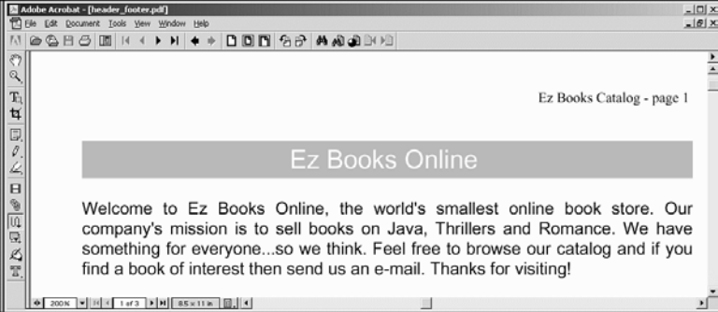
- Graphics
XSL-FO also allows for the insertion of external graphic images. The graphic formats supported are dependent on the XSL-FO formatting engine. The Apache-FOP formatting engine supports the popular graphics formats: GIF, JPEG, and BMP.
The following code fragment inserts the image smiley.jpg:

<fo:block text-align=”center”>
<fo:external-graphic src=”smiley.jpg” width=”200px” height=”200px”/>
</fo:block>

Inserting a graphic image in a PDF document.
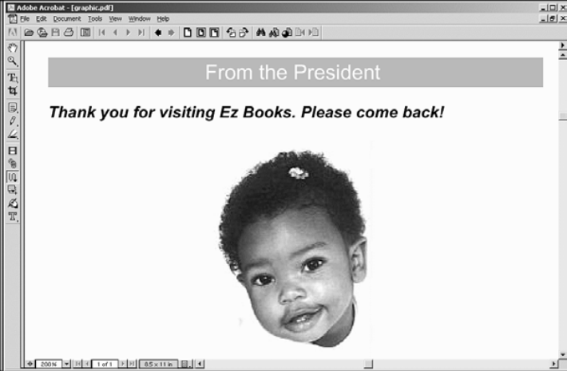
- Tables
XSL-FO has rich support for structuring tabular data. In fact, there are many similarities between HTML tables and XSL-FO tables.
Comparing HTML Table Elements and XSL-FO Table Elements
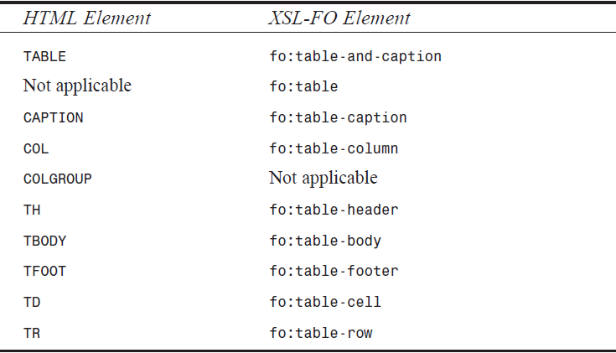
Creating a table in a PDF document.
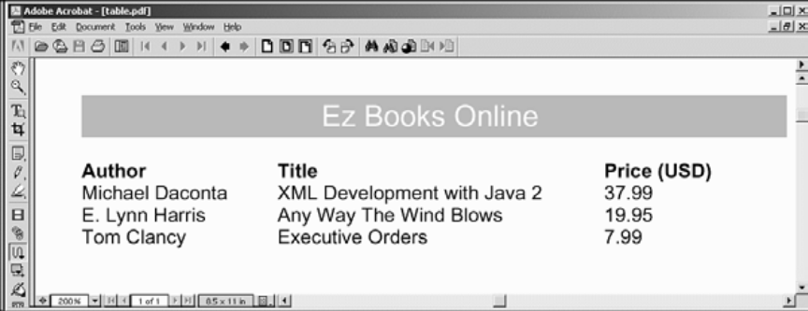
The following code fragment defines the basic structure of the table:
table.fo.

<?xml version=”1.0” encoding=”utf-8”?>
<fo:root xmlns:fo=”http://www.w3.org/1999/XSL/Format”>
<fo:layout-master-set>
<!-- layout information -->
<fo:simple-page-master master-name=”simple”
page-height=”11in”
page-width=”8.5in”
margin-top=”1in”
margin-bottom=”1in”
margin-left=”1.25in”
margin-right=”1.25in”>
<fo:region-body margin-top=”0.5in”/>
<fo:region-before extent=”3cm”/>
<fo:region-after extent=”1.5cm”/>
</fo:simple-page-master>
</fo:layout-master-set>
<fo:page-sequence master-name=”simple”>
<fo:flow flow-name=”xsl-region-body”>
<!-- this defines a level 1 heading with orange background -->
<fo:block font-size=”18pt”
font-family=”sans-serif”
line-height=”24pt”
space-after.optimum=”15pt”
background-color=”orange”
color=”white”
text-align=”center”
padding-top=”3pt”>
Ez Books Online
</fo:block>
<!-- table start -->
<fo:table>
<!-- define column widths -->
<fo:table-column column-width=”120pt”/>
<fo:table-column column-width=”200pt”/>
<fo:table-column column-width=”80pt”/>
<fo:table-header>
<fo:table-row>
<fo:table-cell>
<fo:block font-weight=”bold”>Author</fo:block>
</fo:table-cell>
<fo:table-cell>
<fo:block font-weight=”bold”>Title</fo:block>
</fo:table-cell>
<fo:table-cell>
<fo:block font-weight=”bold”>Price
(USD)</fo:block>
</fo:table-cell>
</fo:table-row>
</fo:table-header>
<fo:table-body>
<fo:table-row>
<fo:table-cell>
<fo:block>Michael Daconta</fo:block>
</fo:table-cell>
<fo:table-cell>
<fo:block>XML Development with Java 2</fo:block>
</fo:table-cell>
<fo:table-cell>
<fo:block>37.99</fo:block>
</fo:table-cell>
</fo:table-row>
<fo:table-row>
<fo:table-cell>
<fo:block>E. Lynn Harris</fo:block>
</fo:table-cell>
<fo:table-cell>
<fo:block>Any Way The Wind Blows</fo:block>
</fo:table-cell>
<fo:table-cell>
<fo:block>19.95</fo:block>
</fo:table-cell>
</fo:table-row>
<fo:table-row>
<fo:table-cell>
<fo:block>Tom Clancy</fo:block>
</fo:table-cell>
<fo:table-cell>
<fo:block>Executive Orders</fo:block>
</fo:table-cell>
<fo:table-cell>
<fo:block>7.99</fo:block>
</fo:table-cell>
</fo:table-row>
</fo:table-body> </fo:table>
<!-- table end -->
</fo:flow>
</fo:page-sequence>
</fo:root>

    - Generating XSL-FO Tables Using XSLT
Imagine the size of the document if we wanted to list 500 books. The document would be extremely large and verbose. We can use XSLT to automatically generate the XSL-FO document. The file, booklist.xml, contains a list of the books. We can develop an XSL style sheet that will automatically construct the XSL-FO document.
Generating XSL-FO tables with XSLT.
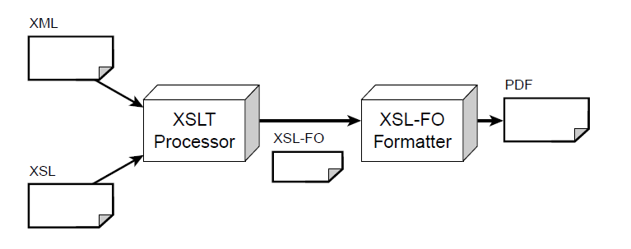
After reviewing the XSL-FO document for the book table, you can see that the dynamic portion is the construction of each table row. We can use the element <xsl:for-each> to loop over each book and build the table row.
booklist_table.xsl
<?xml version=”1.0”?>
<xsl:stylesheet xmlns:xsl=”http://www.w3.org/1999/XSL/Transform”
xmlns:fo=”http://www.w3.org/1999/XSL/Format”
version=”1.0”>
<xsl:template match=”/”>
<fo:root xmlns:fo=”http://www.w3.org/1999/XSL/Format”>
<fo:layout-master-set>
<!-- layout information -->
<fo:simple-page-master master-name=”simple”
page-height=”11in”
page-width=”8.5in”
margin-top=”1in”
margin-bottom=”2in”
margin-left=”1.25in”
margin-right=”1.25in”>
<fo:region-body margin-top=”0.5in”/>
<fo:region-before extent=”3cm”/>
<fo:region-after extent=”1.5cm”/>
</fo:simple-page-master>
</fo:layout-master-set>
<!-- end: defines page layout -->
<fo:page-sequence master-name=”simple”>
<fo:flow flow-name=”xsl-region-body”>
<!-- this defines a level 1 heading with orange background -->
<fo:block font-size=”18pt”
font-family=”sans-serif”
line-height=”24pt”
space-after.optimum=”15pt”
background-color=”orange”
color=”white”
text-align=”center”
padding-top=”3pt”>
Ez Books Online
</fo:block>
<!-- table start -->
<fo:table border-style=”solid” border-width=”.1mm” >
<!-- define column widths -->
<fo:table-column column-width=”120pt”/>
<fo:table-column column-width=”200pt”/>
<fo:table-column column-width=”80pt”/>
<fo:table-header>
<fo:table-row >
<fo:table-cell border-style=”solid” border-width=”.1mm”>
<fo:block font-weight=”bold”>Author</fo:block>
</fo:table-cell>
<fo:table-cell border-style=”solid” border-width=”.1mm”>
<fo:block font-weight=”bold”>Title</fo:block>
</fo:table-cell>
<fo:table-cell border-style=”solid” border-width=”.1mm”>
<fo:block font-weight=”bold”>Price (USD)</fo:block>
</fo:table-cell>
</fo:table-row>
</fo:table-header>
<fo:table-body>
<!-- Perform loop for each book in the book list -->
<xsl:for-each select=”booklist/book” >
<fo:table-row>
<fo:table-cell border-style=”solid” border-width=”.1mm”>
<fo:block><xsl:value-of select=”author” /></fo:block>
</fo:table-cell>
<fo:table-cell border-style=”solid” border-width=”.1mm”>
<fo:block><xsl:value-of select=”title” /></fo:block>
</fo:table-cell>
<fo:table-cell border-style=”solid” border-width=”.1mm”>
<fo:block><xsl:value-of select=”price” /></fo:block>
</fo:table-cell>
</fo:table-row>
</xsl:for-each>
</fo:table-body>
</fo:table>
<!-- table end -->
</fo:flow>
</fo:page-sequence>
</fo:root>
</xsl:template>
</xsl:stylesheet>

Generating a PDF Document
This example involves a two-step process. The first step involves XSLT processing the booklist.xml document with booklist_table.xsl. The second step involves converting the output of the XSLT conversion to a PDF file using XSL-FO.The Apache-FOP product can perform both of these steps internally. All we have to do is provide the XML document and XSL style sheet.
Follow these steps to generate the PDF document:
      - Open an MS-DOS window.
      - Move to the directory <install_dir>\ch9_xsl\xsl_fo\dynamic\table.
      - Set up the Java classpath by typing setpaths.
      - Execute Apache-FOP by typing the following:
fop -xml booklist.xml -xsl booklist_table.xsl dyntable.pdf
      - View the dyntable.pdf file in Adobe Acrobat Reader.
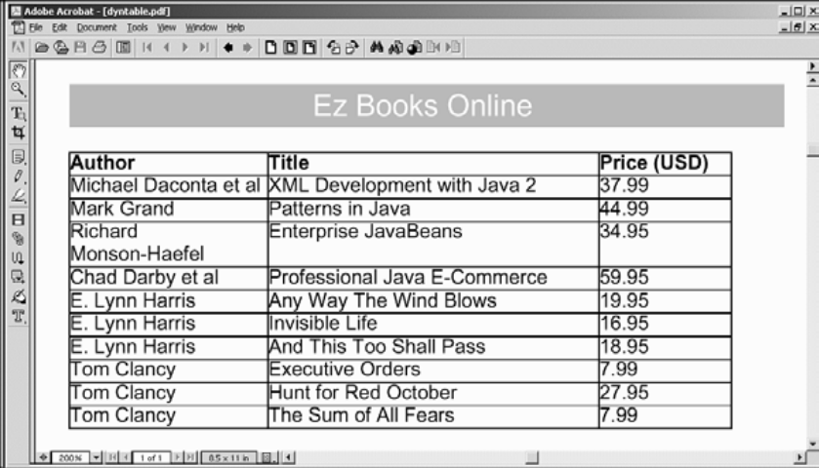

    - Web Application Integration: Java Servlets, XSLT, and XSL-FO
We will develop a Java servlet to pass an XML document and XSL style sheet to the Apache-FOP formatting engine. The XML document is booklist.xml. The XSL style sheet, booklist_table.xsl, contains the XSL-FO template code to generate a table. The servlet will respond with the PDF document generated by the Apache-FOP formatting engine.
Web application integration: Java servlets, XSLT, and XSL-FO.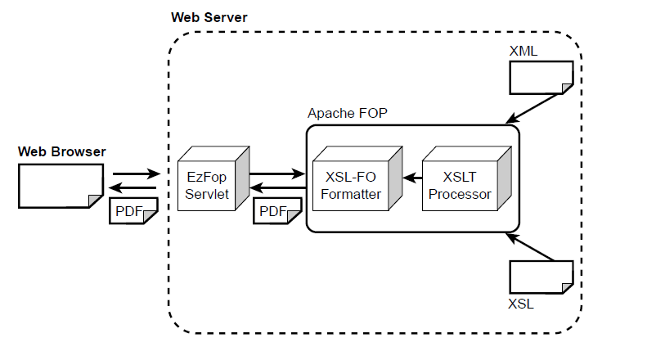
  - XML Database Solutions
A large number of XML database solutions are available, they are: database mapping and native XML support.
    - XML Database Mapping
The first type of XML database solution provides a mapping between the XML document and the database fields. The system dynamically converts SQL result sets to XML documents. Depending on the sophistication of the product, it may provide a graphical tool to map the database fields to the desired XML elements. Other tools support a configuration file that defines the mapping. These tools continue to store the information in relational database management system (RDBMS) format. They simply provide an XML conversion process that is normally implemented as a server-side Web application.
Mapping XML documents to database fields.
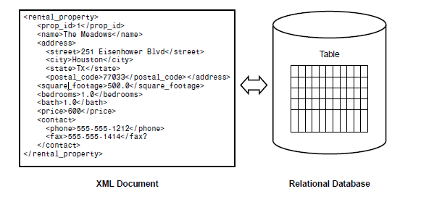
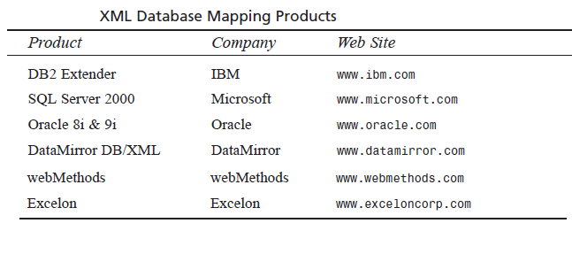

    - Native XML Support
The second type of XML database solution actually stores the XML data in the document in its native format. Each product uses its own proprietary serialization technique to store the data. However, when the data is retrieved, it represents an XML document.
Native XML databases.
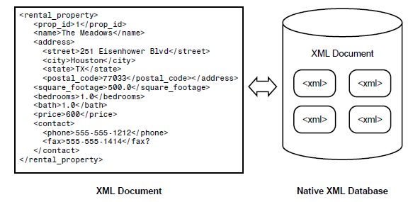
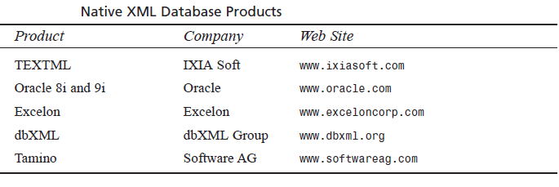
  - Modeling Databases in XML
Here we will see how to model a database in XML using Java. When we model a database, we provide an external representation of the database contents. For our sample program, we’ll utilize a database that contains information on rental properties. We’ll model the rental property database as an XML document.

Desired output for rental properties.
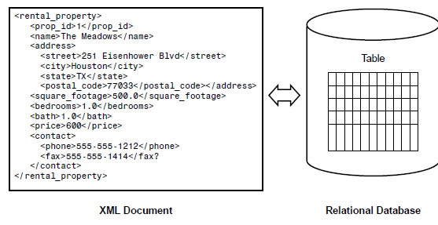
- One possible solution is to use Java servlets and JDBC. Java servlets are server-side components that reside in a Web server or application server. Java servlets are commonly used to handle requests from Web browsers using the HTTP protocol.
- A key advantage to using servlets is the thin-client interface. The servlets handle the request on the server side and respond by generating an HTML page dynamically. This lowers the requirement on the client browser. The browser only has to provide support of HTML. As a result, there is zero client-side administration.
- We can develop a servlet that uses JDBC. The servlet will make the appropriate query to the database and use Java Database Connectivity (JDBC) API result set metadata to create the elements.
- XML data binding features of Java Architecture for XML Binding (JAXB). JAXB provides a framework for representing XML documents as Java objects. Using the JAXB framework, we can guarantee that the documents processed by our system are well formed. Also, we have the option of validating the XML data against a schema.
In the JAXB framework, we can parse XML documents into a suitable Java object. This technique is referred to as unmarshaling. The JAXB framework also provides the capability to generate XML documents from Java objects, which is referred to as marshaling.
JAXB marshaling and unmarshaling.
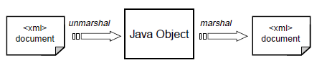
JAXB is easier to use and a more efficient technique for processing XML documents than the SAX or DOM API. Using the SAX API, you have to create a custom content handler for each XML document structure. Also, during the development of the content, you have to create and manage your own state machine to keep track of your place in the document. For very complex XML documents, Using JAXB, an application can parse an XML document by simply unmarshaling the data from an input stream.
JAXB is similar to DOM in that we can create XML documents programmatically and perform validation. However, the hindrance with DOM is the complex API. If we have an XML tree, using the DOM API, we have to traverse through the tree to retrieve elements.
However, with JAXB, we retrieve the data from the XML document by simply calling a method on an object. JAXB allows us to define Java objects that map to XML documents, so we can easily retrieve data. The JAXB framework also ensures the type safety of the data.
JAXB binding schema and generate the appropriate Java classes.
- Review the database schema.
- Construct the desired XML document.
- Define a schema for the XML document.
- Create the JAXB binding schema.
- Generate the JAXB classes based on the schema.
- Develop a Data Access Object (DAO).
- Develop a servlet for HTTP access.
The rental property application architecture.

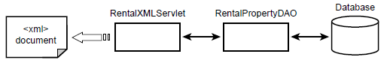
RentalXMLServlet communicates with RentalDAO to retrieve information from the database. Once the information is retrieved by RentalDAO, RentalXMLServlet generates an XML document.
Step-1: Reviewing the Database Schema
Rental Property Database Schema
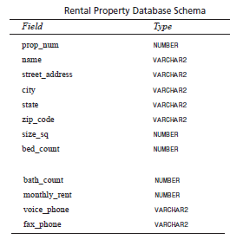
Step-2: Constructing the Desired XML Document
The desired output XML document describes the rental property. However, the XML document does not use the exact field names listed in the database schema. Instead, the XML document provides a custom mapping of the database fields to XML element names. Table 10.4 contains the mapping.
XML Database Mapping
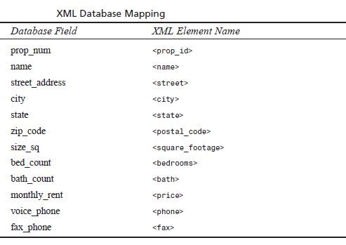
A rental property is described with a root element of <rental_property>, as shown in the following code:
<rental_property>
<prop_id>1</prop_id>
<name>The Meadows</name>
<address>
<street>251 Eisenhower Blvd</street>
<city>Houston</city>
<state>TX</state>
<postal_code>77033</postal_code>
</address>
<square_footage>500.0</square_footage>
<bedrooms>1.0</bedrooms>
<bath>1.0</bath>
<price>600</price>
<contact>
<phone>555-555-1212</phone>
<fax>555-555-1414</fax>
</contact>
</rental_property>

The <address> element contains the subelements <street>, <city>, <state>, and <postal_code>. The <contact> element contains the <phone> and <fax> elements for the voice number and fax number, respectively.
The collection is modeled using a <rental_property_list> element, as shown here:
<rental_property_list>
<rental_property> … </rental_property>
<rental_property> … </rental_property>
… …
</rental_property_list>
Step 3: Defining a Schema for the XML Document
We will define the Document Type Definition (DTD). The DTD schema format was chosen because JAXB 1.0 (early access) only supports DTDs. In the future, JAXB is supposed to support the formal XML Schema definition.
rental_property.dtd
<!ELEMENT rental_property_list (rental_property)*>
<!ELEMENT rental_property (prop_id, name, address, square_footage,
➥bedrooms, bath, price, contact)>
<!ELEMENT prop_id (#PCDATA)>
<!ELEMENT name (#PCDATA)>
<!ELEMENT address (street, city, state, postal_code)>
<!ELEMENT street (#PCDATA)>
<!ELEMENT city (#PCDATA)>
<!ELEMENT state (#PCDATA)>
<!ELEMENT postal_code (#PCDATA)>
<!ELEMENT square_footage (#PCDATA)>
<!ELEMENT bedrooms (#PCDATA)>
<!ELEMENT bath (#PCDATA)>
<!ELEMENT price (#PCDATA)>
<!ELEMENT contact (phone, fax)>
<!ELEMENT phone (#PCDATA)>
<!ELEMENT fax (#PCDATA)>

Step-4: Creating the JAXB Binding Schema
We need to define the JAXB binding schema. The JAXB binding schema is an XML document that contains instructions on how to bind a DTD to a Java class. Using the JAXB binding schema, we can define the names of the generated Java classes, map element names to specific properties in the Java class, and provide the mapping rules for attributes.
The following code example informs the JAXB system that the element <rental_property_list> should be mapped to a Java class and that it is the root element for the XML document:
<element name=”rental_property_list” type=”class” root=”true”/>
There’s no requirement to define a mapping for every element in the XML document. JAXB uses a default binding schema that will create properties in the Java class based on the XML element name.
The binding schema also allows us to define a conversion rule for elements. For example, the numerical data for the rental property, such as price, square footage, and number of rooms, is always represented in the DTD as text data (#PCDATA). This is one of the limitations of the DTD format. However, by using JAXB, we can specify that a given element should be converted to a Java primitive type or class.
We inform JAXB to convert the values of <square_footage>, <bedrooms>, and <bath> to the double type; also, <price> is converted to an instance of the java.math.
BigDecimal class:
<element name=”square_footage” type=”value” convert=”double”/>
<element name=”bedrooms” type=”value” convert=”double”/>
<element name=”bath” type=”value” convert=”double”/>
<element name=”price” type=”value” convert=”BigDecimal”/>
<conversion name=”BigDecimal” type=”java.math.BigDecimal”/>
We can also use the binding schema to define enumerated types, constructors, and interfaces. However, in the JAXB 1.0 early access version, constructors are not yet implemented.
The binding schema includes a section for controlling the output of the generated Java source code. For example, we can inform the system to use a given package name.
rental_property.xjs
<?xml version=”1.0” encoding=”ISO-8859-1” ?>
<!DOCTYPE xml-java-binding-schema SYSTEM
➥”http://java.sun.com/dtd/jaxb/1.0-ea/xjs.dtd”>
<xml-java-binding-schema version=”1.0-ea”>
<options package=”xmlunleashed.ch10.jaxb”/>
<element name=”rental_property_list” type=”class” root=”true”>
<content property=”list”/>
</element>
<element name=”square_footage” type=”value” convert=”double”/>
<element name=”bedrooms” type=”value” convert=”double”/>
<element name=”bath” type=”value” convert=”double”/>
<element name=”price” type=”value” convert=”BigDecimal”/>
<conversion name=”BigDecimal” type=”java.math.BigDecimal”/>
</xml-java-binding-schema>

Step-5: Generating the JAXB Classes Based on Schemas
. JAXB provides a schema compiler for generating the Java source files. The schema compiler takes as input the DTD and the JAXB binding schema. Figure 10.6 illustrates the process We pass our DTD (rental_property.dtd) and binding schema (rental_property.xjs) to the JAXB schema compiler with the xjc command.
Generating Java classes with the JAXB compiler.

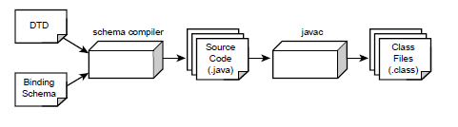
java com.sun.tools.xjc.Main rental_property.dtd
➥rental_property.xjs -d source_code
This command generates source code in the source code directory. The following files are generated:
• RentalPropertyList.java. This file models the <rental_property_list> element.
• RentalProperty.java. This file models the <rental_property> element.
• Address.java. This file models the <address> subelement.
• Contact.java. This file models the <contact> subelement.

Rental property UML Diagram
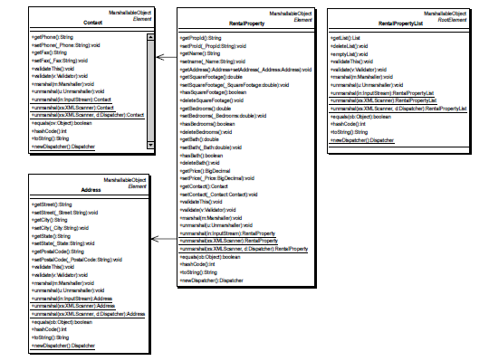
Step-6: Developing a Data Access Object (DAO)
A Data Access Object (DAO) provides access to the backend database. The goal of the DAO design pattern is to provide a higher level of abstraction for database access. The DAO encapsulates the complex JDBC and SQL calls. The DAO provides access to the backend database via public methods. The DAO converts a result set to a collection of objects. The objects model the data stored in the database.
Data Access Object design pattern.
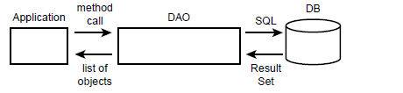
By using a DAO, the implementation details of the database are hidden from the application clients. The implementation details include the database schema and database vendor. This follows closely with the design principle of encapsulation. A benefit of using the DAO is improved application maintenance. If the database schema changes, such as a column name being modified, we only have to update the DAO. No modifications are required to the client programs. Also, if we decide to change the database implementation from Sybase to Oracle, modifications are only required to the DAO. The clients can continue to use the DAO without any modification. The DAO design pattern is widely used in the industry and is documented in Sun’s J2EE Patterns Catalog, found at java.sun.com/j2ee.
Here we’ll create a DAO called RentalPropertyDAO. This version of the DAO will only provide the method getRentalProperties().
RentalPropertyDAO interaction diagram.
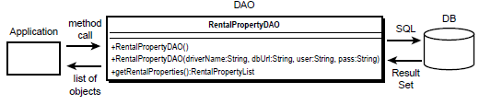
Let’s examine the components of the RentalPropertyDAO source code. The class definition
and constructor for RentalPropertyDAO are shown here:
public class RentalPropertyDAO {
/**
* The database connection
*/
protected Connection myConn;
/**
* Constructor for DAO. Setup the database connection.
➥* Use the default properties.
*/
public RentalPropertyDAO()
throws DAOException {
this(“sun.jdbc.odbc.JdbOdbcDriver”,
➥”jdbc:odbc:RentalPropertyDSN”,
➥”test”, “test”);
}
/**
* Constructor for DAO. Setup the database connection.
*/
public RentalPropertyDAO(String driverName, String dbUrl,
➥String user, String pass)
throws DAOException {
try {
// Load the driver
log(“Loading driver: “ + driverName);
Class.forName(driverName);
// Get a connection
log(“Connecting to the database: “ + dbUrl);
log(“User id: “ + user);
myConn = DriverManager.getConnection (dbUrl, user, pass);
log(“DB connection successful at “ + new java.util.Date());
}
catch (Exception exc) {
throw new DAOException(exc);
}
}
…
}

RentalPropertyDAO can be constructed by using the default constructor. In this case, the DAO will use default properties for the JDBC driver name, the JDBC database URL, and the user ID and password. This constructor shields the client code for knowing the details of the database implementation. The typical JDBC steps are followed to load a database driver and to obtain a connection to the database.
Once the RentalPropertyDAO Data Access Object is constructed, clients can retrieve data from the database by calling the getRentalProperties()method. The code for getRentalProperties() is shown here:
/**
* Get a list of rental properties from the database
*
* @return a list of RentalProperty objects
* @exception SQLException thrown for SQL errors
*/
public RentalPropertyList getRentalProperties() throws DAOException {
RentalPropertyList theRentalPropertyList = new RentalPropertyList();
List theList = theRentalPropertyList.getList();
try {
Statement myStmt = myConn.createStatement();
String rentalSql = “SELECT prop_num, name, street_address, “
➥+ “city, state, zip_code, “
➥+ “size, sq, bed_count, bath_count, “
➥+ “monthly_rent, voice_phone, “
+ “fax_phone FROM rental_properties”;
ResultSet myRs = myStmt.executeQuery(rentalSql);
RentalProperty tempProperty = null;
// build a collection of JAXB RentalProperty objects
while (myRs.next()) {
tempProperty = createRentalProperty(myRs);
theList.add(tempProperty);
}
// be sure to validate the new list
theRentalPropertyList.validate();
myRs.close();
myStmt.close();
}
catch (Exception exc) {
throw new DAOException(exc);
}
return theRentalPropertyList;
}

This method queries the database and returns a collection of RentalProperty objects. After the SQL is executed, the method processes the result set to build a collection of RentalProperty objects. Because the early access version of JAXB does not support the code generation of constructors, we’ve created a simple constructor method in RentalPropertyDAO.
The code for the createRentalProperty()method is shown here:
/**
* Create a JAXB RentalProperty object based on the result set.
* This method provides the mapping between database schema and object
*/
protected RentalProperty createRentalProperty(
➥ResultSet theRs) throws DAOException {
RentalProperty theProperty = new RentalProperty();
Address theAddress = new Address();
Contact theContact = new Contact();
try {
// set the rental property number and name
theProperty.setPropId(theRs.getString(“prop_num”));
theProperty.setName(theRs.getString(“name”));
// set the address
theAddress.setStreet(theRs.getString(“street_address”));
theAddress.setCity(theRs.getString(“city”));
theAddress.setState(theRs.getString(“state”));
theAddress.setPostalCode(theRs.getString(“zip_code”));
theProperty.setAddress(theAddress);
// set the square footage, bedrooms, bath count and rent
theProperty.setSquareFootage(theRs.getDouble(“size_sq”));
theProperty.setBedrooms(theRs.getDouble(“bed_count”));
theProperty.setBath(theRs.getDouble(“bath_count”));
theProperty.setPrice(new BigDecimal(
➥theRs.getDouble(“monthly_rent”)));
// set the contact information
theContact.setPhone(theRs.getString(“voice_phone”));
theContact.setFax(theRs.getString(“fax_phone”));
theProperty.setContact(theContact);
}
catch (SQLException exc) {
throw new DAOException(exc);
}
return theProperty;
}

The createRentalProperty()method creates an instance of a RentalProperty object using the default constructor. It then populates the object based on information from the result set. This method actually handles the mapping between the database fields and the XML elements.
Step-7: Developing a Servlet for HTTP Access
The DAO is capable of retrieving information from a database and providing a collection of objects. JAXB framework, these objects can be marshaled into XML. Now we need to provide an HTTP interface for RentalPropertyDAO so that a Web browser can interact with our system. Java servlets provides support for the HTTP protocol.
The servlet is responsible for creating an instance of RentalPropertyDAO. The servlet reads JDBC parameters from the web.xml configuration file and constructs RentalPropertyDAO accordingly. An extract from the web.xml file is shown here (make note of the definitions for the parameters driverName, dbUrl, user, and pass) :
<servlet>
<servlet-name>RentalXMLServlet</servlet-name>
<servlet-class>xmlunleashed.ch10.RentalXMLServlet</servlet-class>
<init-param>
<param-name>driverName</param-name>
<param-value>sun.jdbc.odbc.JdbcOdbcDriver</param-value>
</init-param>
<init-param>
<param-name>dbUrl</param-name>
<param-value>jdbc:odbc:RentalPropertyDSN</param-value>
</init-param>
<init-param>
<param-name>user</param-name>
<param-value>test</param-value>
</init-param>
<init-param>
<param-name>pass</param-name>
<param-value>test</param-value>
</init-param>
<load-on-startup/>
</servlet>

Testing the Application
To test the application:
• Sun Microsystems’ Software Development Kit (SDK) 1.3 (or higher).
• Apache Tomcat Server 4..
• Microsoft Internet Explorer 6 or Netscape 6.
The Java SDK provides the compilation and runtime tools for the Java platform. The Tomcat server is the servlet container. The servlet container provides an execution environment for the Java servlets. Finally, the Web browser is for viewing the output of the servlets.
Once Tomcat 4 is installed, we need to add a new Web application that points to the source code directory. Move to the section where the <Context> elements are listed and then add the following entry:
<Context path=”/bookch10”
docBase=”<install_dir>/ch10_xmldb/public_html”
debug=”0”
reloadable=”true” />

TWO MARKS
- How is XML parsing done with SAX? (IT 2353/NOV/DEC 2011)
SAX is an API that can be used to parse XML documents. A parser is a program that reads data a character at a time and returns manageable pieces of data. For example, a parser for the English language might break up a document into paragraphs, words, and punctuation. In the case of XML, the important pieces of data include elements, attributes, text, and so on.
SAX provides a framework for defining event listeners, or handlers. These handlers are written by developers interested in parsing documents with a known structure. The handlers are registered with the SAX framework in order to receive events. Events can include start of document, start of element, end of element, and so on. The handlers contain a number of methods that will be called in response to these events. Once the handlers are defined and registered, an input source can be specified and parsing can begin.
- What is the purpose of XSLT? (IT 2353/NOV/DEC 2011)
XSLT is used to convert an XML document to another format. XSL-FO provides a way of describing the presentation of an XML document. Both technologies use a supporting XML technology, XPath defines a standard mechanism for accessing elements
- What is XML parse tree (CS6501/Nov/Dec/2015)
- What is DOM
- DOM is a standard application programming interface (API) that makes it easy for programmers to access elements and delete, add, or edit content and attributes.
- "The W3C Document Object Model (DOM) is a platform and language-neutral interface that allows programs and scripts to dynamically access and update the content, structure, and style of a document."
- DOM was proposed by the World Wide Web Consortium (W3C) in August of 1997 in the User Interface Domain. The Activity was eventually moved to the Architecture Domain in November of 2000.
- DOM interfaces are defined independent of any particular programming language. We can write DOM code in any programming language, such as Java, ECMAScript (a standardized version of JavaScript/JScript), or C++.
- There is DOM APIs uses the Object Management Group’s (OMG) Interface Definition Language (IDL) to define DOM in a language-neutral way.
- Language-specific bindings, or DOM interfaces, exist for these languages.
- An implementation is a complete set of APIs for a given programming language that supports the DOM specification. These implementations are well documented and of high quality.

- What are the parts of DOM
  - Core DOM - standard model for any structured document
  - XML DOM - standard model for XML documents
  - HTML DOM - standard model for HTML documents

- What is meant by XML DOM nodes
- In the DOM, everything in an XML document is a node.
- The entire document is a document node
- Every XML element is an element node
- The text in the XML elements are text nodes
- Every attribute is an attribute node
- Comments are comment nodes

Books.xml
<?xml version="1.0" encoding="UTF-8"?>
<bookstore>
<book category="cooking">
<title lang="en">Everyday Italian</title>
<author>Giada De Laurentiis</author>
<year>2005</year>
<price>30.00</price>
</book>
</bookstore>
- The root node in the XML above is named <bookstore>. All other nodes in the document are contained within <bookstore>.
- The root node <bookstore> holds four <book> nodes.
- The first <book> node holds four nodes: <title>, <author>, <year>, and <price>, which contains one text node each, "Everyday Italian", "Giada De Laurentiis", "2005", and "30.00".
- Text is Always Stored in Text Nodes
- A common error in DOM processing is to expect an element node to contain text.
- However, the text of an element node is stored in a text node.
- In this example: <year>2005</year>, the element node <year>, holds a text node with the value "2005".
- "2005" is not the value of the <year> element!

- Draw the XML node tree for an sample XML document
- What are the events in SAX
- List out the difference between SAX vs. DOM
DOM | SAX
DOM is an in-memory tree structure of an XML document or document fragment. DOM is a natural object model of an XML document, but it’s not always practical. Large documents can take up a lot of memory | SAX is, in many ways, much simpler than DOM. There is no need to model every possible type of object that can be found in an XML document. This makes the API easy to  understand and easier to use
DOM contains many interfaces, each containing many methods. | SAX is comprised of a handful of classes and interfaces. SAX is a much lowerlevel API when compared with DOM
DOM implementations use SAX parsers under the hood to read in XML documents. | SAX parsers tend to be smaller than DOM implementations
 | SAX is an event-based API. Instead of loading an entire document into memory all at once, SAX parsers read documents and notify a client program when elements, text, comments, and other data of interest are found
The DOM parses XML in space | SAX parses XML in time
DOM parser hands you an entire document and allows you to traverse it any way you like. This can take a lot of memory | SAX can be significantly more efficient for large documents. In fact, you can process documents larger than available system memory, but this is not possible with DOM

- List out the various XSLT processor
- What is meant by XSL-FO
The XSL technology is also composed of XSL Formatting Objects (XSL-FO). XSL-FO was designed to assist with the printing and displaying of XML data. The main importance is on the document layout and structure. This includes the dimensions of the output document, including page headers, footers, and margins. XSL-FO also allows the developer to define the formatting rules for the content, such as font, style, color, and positioning.
XSL-FO is a sophisticated version of Cascading Style Sheets (CSS). In fact, XSL-FO borrows a lot of the terminology and elements from CSS.
XSL-FO documents are well-formed XML documents. An XSL-FO formatting engine processes XSL-FO documents.
We can use two techniques for creating XSL-FO documents.
The first is to simply develop the XSL-FO file with the included data.
The second technique is to dynamically create the XSL-FO file using an XSLT translation.
- List the advanced features of XSLT
Looping
Sorting
Sort order: ascending or descending
Sorting by case
Sorting with multiple keys
Conditionals
Filters

16 MARKS
- Explain XPATH nodes in detail. (IT 2353/NOV/DEC 2011)
- Discuss briefly the various XML Dom methods (CS432\APRIL/MAY 2010)
- Design an XML to maintain book details to do the following: (i) Separate Data (ii) Exchange Data (iii) Store Data (iv) Create new language.(IT1451/may/June/2009)
- Explain how XSLT transforms the document from one (word) type to other type HTML (IT2353/May/June/2014)
- Elaborate DOM in XML (IT1451/april/may/2011)
- Explain XML parser and validation (CS6501/Nov/Dec/2015)
- Write about XML DOM nodes in detail
- Write about XML DOM interface in detail
- Explain SAX parser in detail with an example
- Elaborate XSLT processing in detail with an example
- Explain the advanced features of XSLT
- Explain the basic document structure of XSL- FO with an example
- Explain steps involved in modeling a database in XML with example

